Version A4

Wiltshire Council Permit Scheme
Year 2 Evaluation

Document Content
1 Introduction 6
1.1 The role of a permit scheme 6
1.2 Regulatory requirement for a permit scheme evaluation 6
2 Executive summary 7
2.2 Analysis of work 7
2.3 Analysis of coordination 7
2.4 Analysis of permit conditions 8
2.5 Analysis of permit compliance 8
2.6 Analysis of parity treatment 8
2.7 Review of permit fees and cost-benefit 8
2.8 Summary 9
3 Analysis of works 10
3.1 Applications for work 10
3.2 Application lead time 11
3.3 Work undertaken 12
3.4 Work category and activity types 13
3.5 Analysis of duration 15
3.5.2 Work exceeding planned duration 16
3.5.3 Work at traffic-sensitive times 17
3.6 Use of traffic management 19
4 Analysis of work coordination 20
4.1 Responses to permit applications 20
4.2 Collaborative works 21
4.3 Changes during the life of a permit 22
4.4 Variations to permits 24
4.5 Requests for work duration extensions 25
4.5.2 Other variations from Promoters 26
4.5.3 Variations issued by the Council 26
5 Analysis of permit conditions 27
5.1 Use of permit conditions 27
5.2 Conditions for Date & Time Constraints 28
5.3 Conditions for Material and Plant Storage 29
5.4 Conditions for Road Occupation 30
5.5 Conditions for Portable Traffic Signals 30
5.6 Conditions for Traffic Management Changes 31
5.7 Conditions for Work Methodology 31
5.8 Conditions for Consultation and Publicity 32
5.9 Conditions for the Environment (Noise) 32
5.10 Local Conditions 32
5.11 Summary 32
6 Analysis of permit compliance 33
6.1 Offences for working without a valid permit or breach of condition 33
7 Analysis of parity treatment 34
8 Review of permit fees 37
9 Analysis of cost and benefit 38
9.1 Cost-benefit-analysis framework 38
9.2 Scale and characteristics of works 38
9.3 Impact of works 39
9.3.2 Quantification of benefit of permit scheme 39
9.3.3 Scheme Operating Costs 40
9.3.4 Promoter Costs 41
9.4 Appraisal Results 41
9.5 Emissions savings 42
10 Annex A: Evaluation methodology 43
10.1 Source data for analysis 43
10.2 Work phases 43
10.3 Duration analysis and adjustment 43
10.4 Economic cost-benefit analysis 45
10.5 Period of analysis 45
10.6 Defining Promoters 45
11 Annex B: Glossary and common terms 46
12 Annex C: HAUC Performance Indicators 48
12.1 TPI 1 Works Phases Started (Base Data) 48
12.2 TPI2 Works Phases Completed (Base Data) 48
12.3 TPI3 Days of Occupancy Phases Completed 48
12.4 TPI4 Average Duration of Works 48
12.5 TPI5 Phases Completed involving Overrun 48
12.6 TPI6 Number of deemed permit applications 49
12.7 TPI7 Number of Phase One Permanent Registrations 49
13 Annex D: References 50

Foreword

Key findings of the evaluation
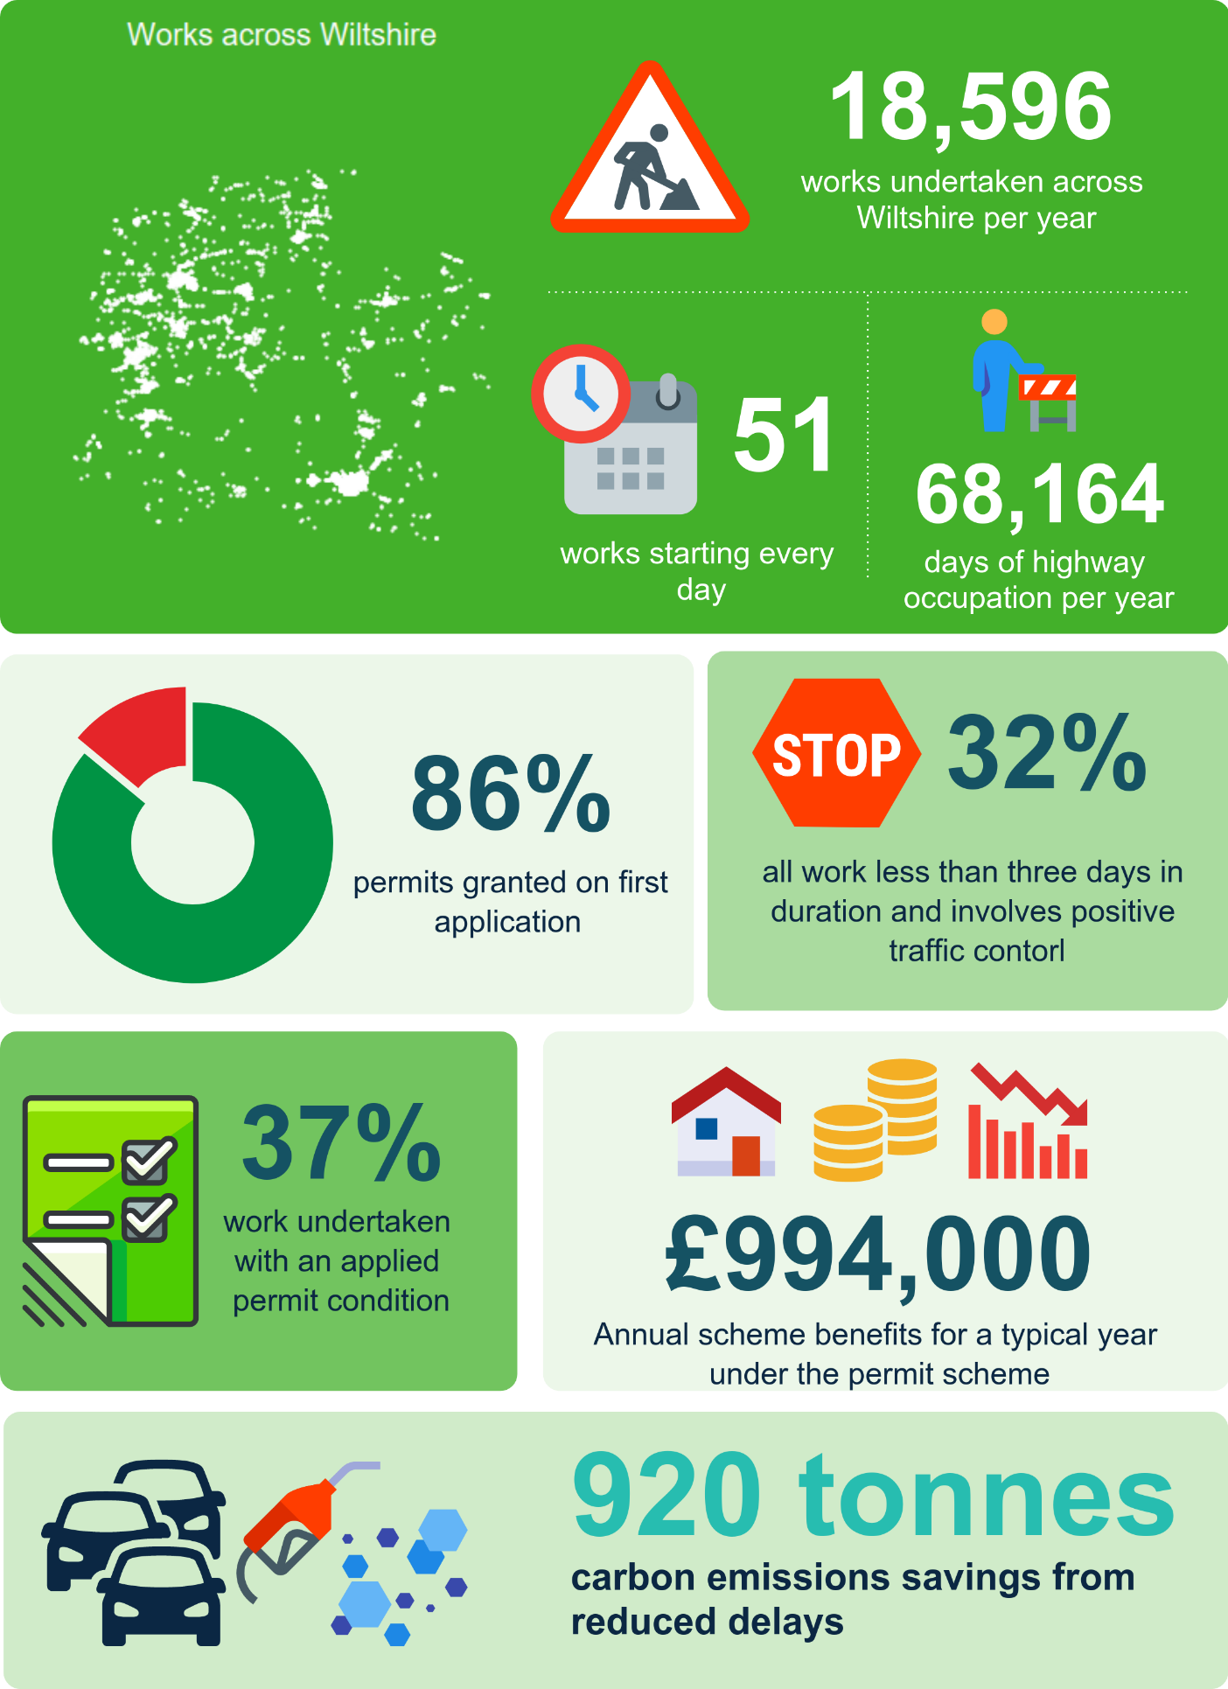
Figures quoted are based on an average for permit scheme years one and two unless otherwise stated.
- Introduction
  - The role of a permit scheme
      - In 1991 the New Roads and Street Works Act (NRSWA) placed a duty on the Council, as a highway authority, to coordinate activities (works) of all kinds on the highway under the control of that Authority.
      - In 2004 the Traffic Management Act (TMA) and associated secondary legislation widened the NRSWA coordination duty. The scope of this increased duty has the following main considerations and Part 3 of the TMA allows for an Authority [the Council] to introduce a permit scheme to support the delivery of this duty.
      - The powers under a permit scheme enable the Council to take a more active involvement in the planning and coordination of works, from the initial planning stages through to completion. This includes:
- organisations book occupation for work instead of giving notice, essentially obtaining a permit for their works;
- any variation to the work needs to be agreed, before and after works have started, including extensions to the duration;
- the Council can apply conditions to work to impose constraints; and
- sanctions with fixed penalty notices for working without a permit or in breach of conditions (of the permit).
      - In June 2020 the Council introduced the Wiltshire Council Permit Scheme. The scheme was brought into legal effect through an Order created by the Council under the provisions of the Traffic Management Permit Scheme (England) Regulations.
  - Regulatory requirement for a permit scheme evaluation
      - An amendment to the 2007 Permit Scheme Regulations saw the introduction of a new regulation (16A) which makes a provision for the content and timing of permit scheme evaluations
      - This regulation states that permit schemes [should] be evaluated following the first, second and third anniversary of the scheme’s commencement and then following every third anniversary. The regulation further states that, in its evaluation, the Permit Authority [Council] shall include consideration of:
- whether the fee structure needs to be changed in light of any surplus or deficit;
- the costs and benefits (whether or not financial) of operating the scheme; and
- whether the permit scheme is meeting key performance indicators where these are set out in the Guidance.
      - This report has been developed by the Council to provide an evaluation for year two (June 2021 to May 2022) of the Permit Scheme and includes the provisions set out within the regulations.
      - The regulations reference key performance indicators set out in Statutory Guidance. Annex A of the Guidance contains a list of Key Performance Indicators. Annex C of this report contains the performance indicator results for each permit scheme year (as available).
- Executive summary
      - The Year 1 evaluation demonstrated that the Council has successfully introduced a permit scheme and established a foundation to deliver benefits from the scheme in future years. Whilst the COVID pandemic continued to limit how effectively the Councils teams could work together, the levels of performance demonstrated in Year 1 continued.
  - Analysis of work
      - The Year 2 evaluation does not show any significant overall changes in works by Promoters, with the volume of applications and subsequent works remaining similar to Year 1. There is an observed increased in Telecoms sector work, with smaller proportionate decrease across the other sectors.
      - Of the work undertaken in Year 2, 62% of workdays were for planned short duration (less than 3 days) minor work and 17% for Immediate (urgent or emergency) work. Analysis of activity types shows in Year 2:
- 21% of workdays were for highway repairs and maintenance;
- 60% of workdays were for utility repair and maintenance;
- 7% of workdays were for utility asset work; and
- 5% of workdays were for remedial work to repair defects.
      - Average duration of work continued a decreasing trend except for the high-volume minor work. Considering the increase across five years of analysis is only 0.2 of a day this is not seen as a major concern. The introduction of Street Manager in July 2020 and associated changes to the recording of work start and stop times did provide greater insight into work durations. However, to compare changes in specific works per sector will require a longer period of analysis. This analysis can be included in the Year 3 and the Year 6 evaluation.
      - The duration of additional days of unplanned work and the average extended duration of work has continued to decrease under the Scheme, with less than 1% of work undertaken exceeding the planned duration. Requests for durations extensions (during work) have also decreased in Year 2. On average 93% of requests are granted which suggests the justification and impact of the extension is accepted.
  - Analysis of coordination
      - The coordination of work, including level of applications granted, remains similar in Year 2 to Year 1. The reason for rejected applications also remains similar in Year 2, comprising:
- missing or conflicting information, including conditions;
- clash of work, location and coordination issues;
- proposed traffic management, including missing or incorrect details, or unsuitable arrangements.
      - Whilst changes to work during the planning stage can be observed, such as conditions being added to permits, duration reductions and traffic management changes, it is not always possible to associate these directly with permit scheme controls.

  - Analysis of permit conditions
      - Permit conditions continue to be applied to work, with 37% of work undertaken in Year 2 having an applied condition. Analysis shows that many conditions are added during the planning stage when the initial application does not contain the required condition. Overall 31% of the permit conditions are added after application.
      - The conditions being applied to permits remains similar to Year 1, and mostly cover:
- The timing of work;
- Road occupation and traffic management; and
- Advanced publicity of work
      - To ensure the effective application of conditions the Council need to undertake a thorough review in the use of conditions, to ensure there is a systemic understanding and application of the conditions. Once this complete the Council can review and demonstrate that conditions are being applied to best effect, for example advanced publicity for all road closures or timing constraints for work designated as outside traffic sensitive times. This analysis will be considered within the Year 3 evaluation.
  - Analysis of permit compliance
      - The level of permit offences in Year 2 has also remained similar to Year 1, with the proportion of offences at less than 1% of all work undertaken. This would suggest that overall compliance to the Scheme in Wiltshire is high.
      - An effective permit compliance inspection regime must align to the application of conditions. Therefore, the work planned in Year 3 to ensure conditions are effectively applied to work must be complemented by an effective permit regime to ensure Promoters are not breaching these conditions.
  - Analysis of parity treatment
      - To ensure the permit scheme is applied without discrimination there is a new area of analysis for the permit scheme evaluation in Year 2. Whilst this analysis shows differences between sectors, such as the permit applications granted as a total of all applications received, it does not highlight any specific areas of concern.
  - Review of permit fees and cost-benefit
      - In Year 2 the Council sustained a deficit in the administration of the Scheme, and as such need to consider a scheme variation to adjust the fee structure to recover this deficit and ensure all costs are covered in future years. It is expected that this variation will be undertaken in Year 3 and then reviewed no later than the sixth-year anniversary of the scheme (2016/27) by which point the Council should have recovered their full costs.
      - A cost-benefit analysis considers the societal impact of works, including delays and inconvenience, and a reduction in these impacts as a result of the permit scheme. When setting the costed benefits against the cost of running the scheme, the analysis show that the permit scheme is demonstrating a positive benefit to Wiltshire, with a benefit-to-cost ratio of 3.3:1 (classified as high value for money).

  - Summary
      - The Year 2 evaluation demonstrates clearly that the Scheme is being operated efficiently, with many processes and controls resulting in quantifiable changes to the planning and delivery of work. Many of the analysis show positive indicators or trends towards a permit scheme benefits, however there is still work required by the Council to ensure the scheme is being as effective as it is efficient.
      - The evaluation contains many recommendations for further changes and developments in the operation of the Scheme (refer to table below). Any changes from this should start to materialise in Year 3 and the operation of the Scheme matures.
Reference | Summary of recommendation
3.5.2 | Monitor the durations of Minor work to ensure average durations do not increase significantly and remain below the 3 days allowed.
3.5.4 | Review and challenge durations of Immediate work to ensure durations are kept to a minimum.
3.5.12 | Review the use of conditions for traffic-sensitive work to ensure they are applied correctly to ensure compliance with the working arrangements within the permit.
4.1.5 | Ensure the application process is used effectively to explore collaboration opportunities or reduce excessive planned durations.
4.3.6 | Review the use of rejection codes and the outcome, as a quantifiable change, from the use of these.
4.3.8 | Investigate changes being made during the planning stage to ascertain how and why these are being applied, and where possible identify the action causing the change.
5.11.1 | Undertake further reviews and training for permit conditions, to ensure a clear understanding on the use and benefit, including the use of conditions in conjunction with each other.
5.11.1 | Share their understanding of conditions with Promoters to ensure there is a systemic understanding and application.
6.1.2 | Review their compliance inspection regime to ensure that all condition types are being inspected.
7.1.4 | Consider increasing the proportion of Highway Authority works inspected for permit compliance to meet the Promoter average.
8.1.5 | Undertake a scheme variation to adjust the permit fee levels to recover their deficit and ensure further income levels are sufficient for the operating cost.
- Analysis of works
  - Applications for work
      - All registerable works require an application to the Council to obtain a permit. Prior to the introduction of the permit scheme, the Council was notified of these works.
      - Throughout this evaluation the term application refers to both the initial notice or permit application and the three-month advance notice application (PAA) for a Major work, unless stated otherwise. Non-statutory forward planning notices are not included.
The charts below show the volume of notice and permit applications received for each Year (top) which are delineated by sector (bottom).
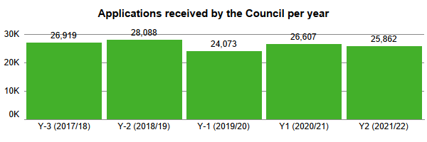
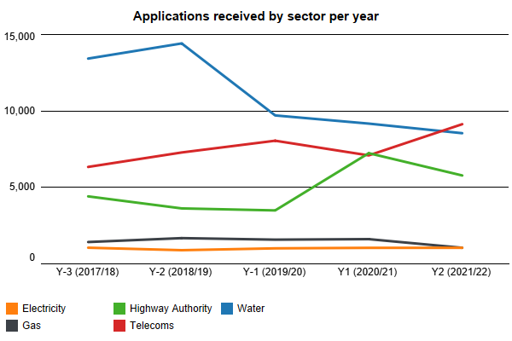
      - Across the five years of analysis the overall volume of applications has remained similar. There are noticeable changes within the sectors, mainly Telecoms increasing and other sectors decreasing. These variations can be mainly attributed to changing work programmes and demands, such as broadband fibre rollout for the telecoms sector.
  - Application lead time
      - For the Council to effectively carry out the coordination of works, including the advanced publicity of works, it is essential that applications are submitted with sufficient lead time based on the work category, as set out within primary legislation.
- Major and Standard work requires an application lead time of 10 working days prior to the proposed work start date. Major work also requires a 3-month advanced notice, which becomes a provisional advanced authorisation under a permit scheme.
- Minor works require 3 working days lead time.
- Immediate works can be submitted after works start and must be received within 2 hours of works start or by 10:00 on the next working day if work started outside of non-working hours.
      - The charts below show the aggregate average application lead time across the period of analysis, together with a linear trend model (line) which is computed from a natural log of lead time for each of the observed 26 points (months). This analysis only includes applications that were submitted within the correct lead time – applications not submitted within the correct lead time are analysed further in this section.
The charts below show a trend line based on the average application lead time, per month, for the period between Year -3 and 2. The charts are delineated into work category and for advanced authorisation (3-month notice or PAA applications) for Major work and notice or permit applications for the work categories.
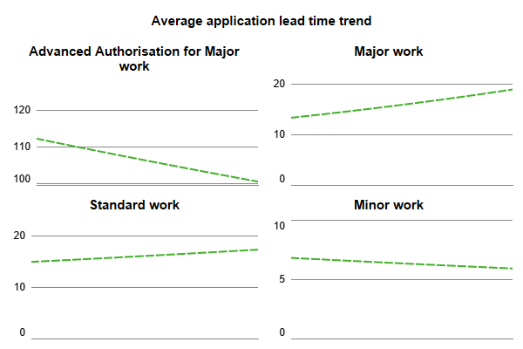
      - The average lead time for Major and Standard permit applications is increasing and towards almost double the required time (10 days). The 3-month (PAA) advanced authorisation for Major work is showing a decreasing trend and close to the minimum required (90 day).
      - The high-volume minor works are showing a slight decreasing trend over the period of analysis; however the average remains above 5 days which is 2 days more than the minimum required (3 days).
The chart below shows the proportion of applications received in time (of total received) for planned work (excluding Immediate work category), in accordance with the minimum lead time.
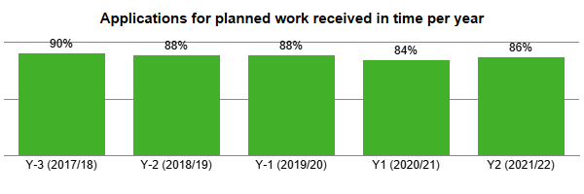
The chart below shows the proportion of requests for an early start granted by the Council (as a % of total received) in Years 1 and 2 delineated by work category. Any instances of an application being superseded, cancelled or auto-granted (deemed) have been removed, leaving any remaining as either granted or rejected.
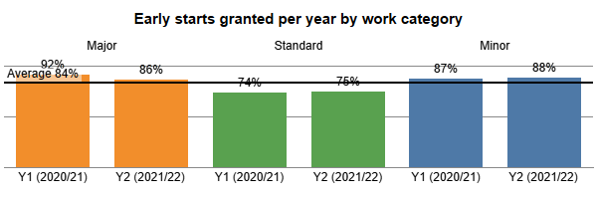
      - Overall, the applications received in time (in accordance with the minimum required) for planned work has decreased slightly since the start of the permit scheme. There are differences between the volume of early start requests being granted by work category, although these have remained consistent over the two years. This would demonstrate careful consideration given to works without the correct lead time for impact and the justification provided for the decreased lead time.
  - Work undertaken
      - Works are only treated as ‘undertaken’ when they have reached a stage of ‘in progress’, i.e. work has started. Not all applications for work or where a permit has been obtained (granted) result in work undertaken.
      - On average across the two years of the permit scheme 82% of applications for planned work (not emergency or urgent work) result in an actual work undertaken, the remaining are primarily cancelled (12%) or no work start is recorded (6%). This means in Year 2 the Council reviewed and processed 883 advanced authorisations for Major work and 3,196 permit applications that were not used for a work.
      - This not only represents a significant waste of Council resource, but also permit fees incurred by the Promoters for the processing of a permit that is not utilised. Whilst the Council recognise this issue there is no solution, they can consider improving the utilisation of granted permits. The introduction of a permit scheme has not changed the overall proportion of applications resulting in work undertaken.
The chart below shows the total volume of work undertaken per year, where the year is defined by the date of the initial application not the actual start date of work.
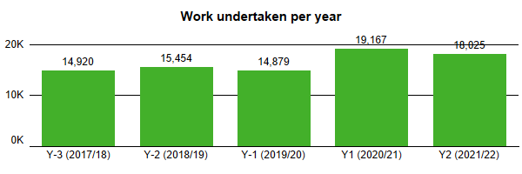
The chart below shows the total volume of work undertaken per year, where the year is defined by the date of the initial application, for each of the main sector types (colour legend).
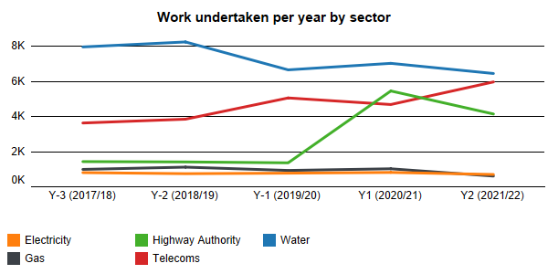
      - The overall volume of work undertaken has increased since the start of the permit scheme compared to previous years. One of the main contributors to this is Highway Authority work, which should be viewed as an increase in work recorded by the Council, for parity treatment, not necessarily an overall increase in work undertaken.
      - Changes in other sectors can be explained by changes in work programmes, as new projects close or start, such as fibre broadband rollout in the telecoms sector
  - Work category and activity types
      - Works are delineated into four distinct categories (refer to the glossary) and can also be broadly defined as planned or reactive (urgent or emergency). Analysis of work categories provides a standard across sectors and periods.
      - Since the introduction of Street Manager in July 2020 Promoters have been able to provide an activity type on their permit, identifying the type of work being undertaken, e.g. utility repair and maintenance works or disconnection or alteration of supply. This has provided more in-depth analysis of the works being undertaken, although the types are rather broad which limits any detailed analysis, such as comparing a specific work methodology, e.g. road resurfacing or mains renewal, across time or different Promoters.
The tables below show the proportion of work and duration (total days) of work undertaken in Year 2 delineated by work category and sector. The colour gradient (white to red) depicts the value (lower to higher) by sector and total.

The table below shows the proportion of work undertaken (% of total) in Year by activity type for each sector. The Total shows the % of all work for that activity. The colour gradient (white to red) depicts the value (lower to higher) by sector and total.

  - Analysis of duration
      - Analysis of work duration is based on works undertaken only. Durations are typically calculated in whole calendar days, however in reality a work, such as an asset inspection or pothole repair, may only take a few minutes or hours. Refer to Annex A: Evaluation methodology for further detail. Analysis of duration considers trend over time, with work delineated into a ‘work category’, which is typically based on a duration banding, i.e. a minor is work within 2-3 days.
The charts below show an average duration trend for the four work categories across Years -3 to 2 work undertaken. The trend is based on a linear model of average duration per month.
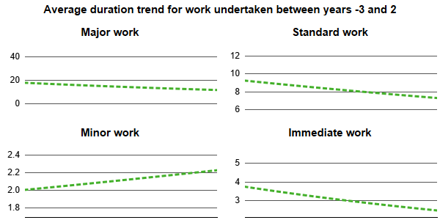
      - Except for Minor work, the average duration of planned work (not Immediate) has seen a decrease over the period of analysis. Minor work has seen a slight increase from 2 to 2.2 days in average duration, which remains below the 3 days allowed for these types of work. This should be monitored in future years to ensure minor works do not exceed the 3 day period allowed.
- It is recommended that the Council monitor the durations of Minor work to ensure average durations do not increase significantly and remain below the 3 days allowed.
      - Immediate works have seen the most significant reduction from 4 days on average to just over 2 days across the four years. This demonstrates a focus by the Council, working with Promoters, to ensure unplanned Immediate work are undertaken efficiently and without unnecessary delay.
      - Gas, electricity and highway sector Immediate works have seen a constant or slightly increasing average duration during the initial two years of the permit scheme and when compared to pre-scheme averages. The average duration of Immediate work across all other sectors has reduced, especially for the high-volume water sector.
- It is recommended that the Council continue to review and challenge durations of Immediate work to ensure durations are kept to a minimum.
The chart below shows the average duration of Immediate works (calendar days) by sector between Years -2 (left) and Year 2 (right). Each line point on the chart is the average duration for the quarter and bar shows the total number of works (started).
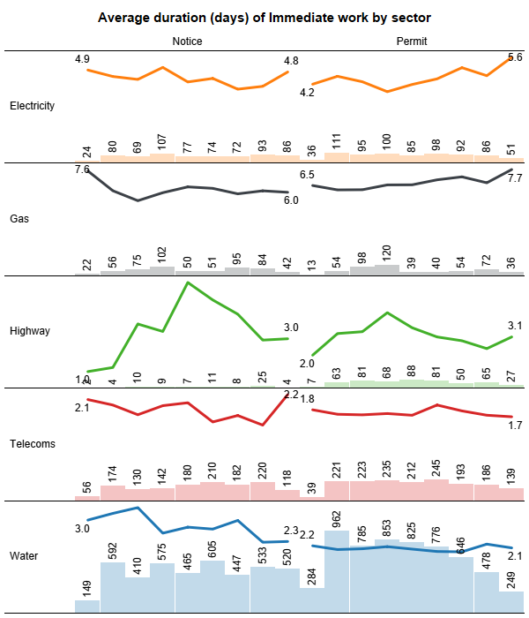
    - Work exceeding planned duration
      - Works being undertaken on a very busy and often congested road network that exceed their agreed reasonable period of duration can create significant coordination issues. In turn, these works can apply a ‘domino effect’ on work programmes and the potential need to reschedule or revoke other active or planned works that may clash with adjacent over running works.
      - For this evaluation a work exceeding the planned duration is identified when a work’s planned duration at the start of work is exceeded by the actual duration at the end of the work. The duration of the unplanned duration is measured in calendar days.
The chart below shows the total number of works undertaken where the actual duration exceeds the planned duration per year (top chart); the additional duration (days) where the work has exceeded the planned duration (middle chart) and the proportion of all works undertaken (% of total) that exceeded the planned duration (bottom chart).
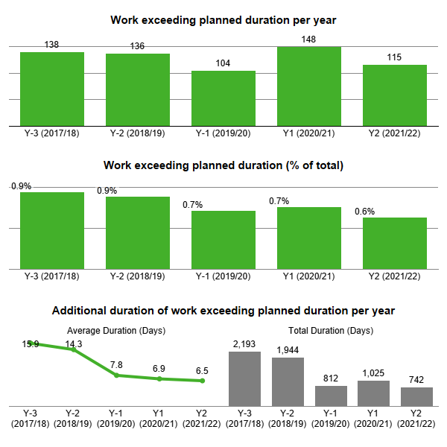
      - Since the introduction of the Scheme the volume of work exceeding planned duration has remained below 1% of total work. However, the average duration of the unplanned duration has seen a steady decrease which is a positive indicator.
    - Work at traffic-sensitive times
      - Designations in the local street gazetteer enable the council to identify whether a street is traffic-sensitive, based on a set of criteria which includes the volume of traffic travelling on the street over a given period, and the times of that traffic-sensitivity, e.g. common peak periods such as 07:00 – 10:00 and 16:00 – 19:00.
      - This traffic-sensitivity designation is used for the coordination of works, to ensure any impacts at peak (traffic-sensitive) times is reduced or controlled, either through work taking place outside of traffic-sensitive times or other measures (permit conditions) when work is at these times, such as removal of traffic control on the carriageway.
      - In addition, the Council can apply such measures on work even if the street is not designated as traffic-sensitive, for example if work is taking place near a school at the drop-off or pick up times, or an event has been scheduled to take place near the worksite.
The chart below shows the proportion of planned work (excludes Immediate work) on a street with a traffic-sensitive designation when the work was undertaken outside of the designation traffic-sensitive times. The works have been delineated into duration bands (hours).
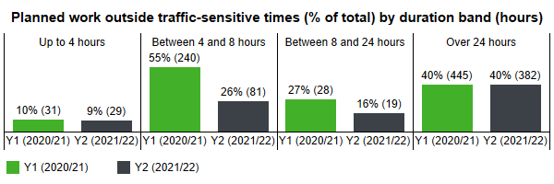
      - The analysis shows an overall decrease in the volume of work at traffic sensitive times between Year 1 and Year 2 which is a positive indicator.
      - The analysis in this evaluation is based on the designated selected by the Promoter to denote whether work is or is not at traffic-sensitive times. Further analysis shows that only 15% of work designated as being outside of traffic-sensitive times (on a traffic sensitive street) has a permit condition applied to ensure the compliance.
- It is recommended that the Council review the use of conditions for traffic-sensitive work to ensure they are applied correctly to ensure compliance with the working arrangements within the permit.
      - Further analysis of work with temporary traffic lights at traffic sensitive times shows an increase in the proportion manually controlled at peak times (for more efficient traffic flow at specified times) between Year 1 and Year 2. The overall proportion of work is lower than expected, however Promoters are increasingly adopting the use of smart lights, as a form of manual control, which is not always reflected in a permit condition.
The chart below planned work (excludes Immediate work) where the traffic control is either 2-way lights or multi-way lights taking place at traffic-sensitive times, and the proportion (% of total) that have a condition (NCT8b) to manually control the lights at specified times.
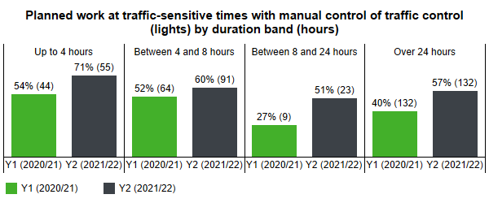

  - Use of traffic management
      - All works must be undertaken using an appropriate form of traffic management (control) and set out within the Code of Practice: Safety at Street Works and Road Works to ensure work is undertaken safely - for those undertaking the works as well as the road user, including pedestrians, cyclists and in particular the needs of disabled people and vulnerable groups. The need to undertake works safely whilst also controlling the impact of works needs to be balanced carefully between the Council and Promoters.
The chart(s) below shows (top) traffic management (legend) for all works undertaken as a proportion of the total works; and (bottom) traffic management and work category for work undertaken in Year 2 by total duration in days (y-axis) and total works (x-axis).
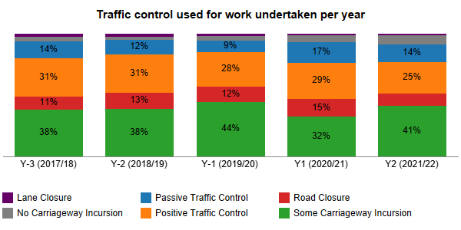
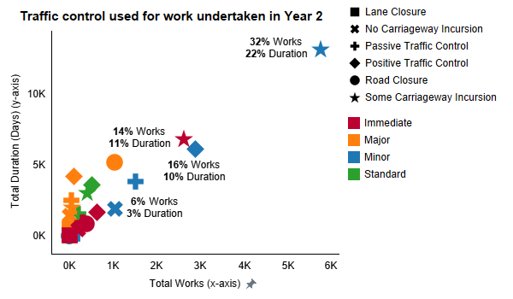
      - Analysis shows an overall reduction in the proportion of work undertaken using positive traffic control, with an increase in the use of passive traffic control. There may be many reasons for this change, such as different types of work being undertaken by Promoters. Further analysis within this evaluation will consider changes applied to traffic management arrangements during the planning stage to identify any changes through Scheme controls.
- Analysis of work coordination
  - Responses to permit applications
      - For a permit scheme to be effective the Council must process and respond to each application. Where the Council accept an application, this is granted. Where the Council do not accept an application, or want to make changes to the proposed work, it is refused, and a response code (based on a set of national codes) must be provided.
The charts below show the PAA applications and permit applications granted by the Council as a proportion of the total received in Years 1 and 2. PAAs and permits that were cancelled or superseded before a response was given have been removed from this analysis.
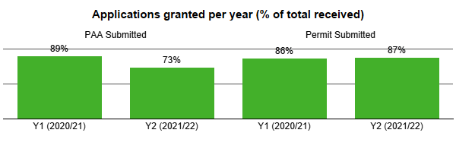
      - The transition from a notice to a permit regime saw a change in the processing of the 3-month advanced notice for Major work (PAA). Many PAAs were being refused as the application process for the Temporary Traffic Regulation Order (TTRO), typically to close a road, had not been completed prior to the end of the response period for the application (one month). Therefore, the Council rejected the initial application to allow this process to complete before the PAA became deemed (granted).
      - The PAA review and approval process has been amended to allow for the processing of the TTRO as a separate process to the PAA. If the process for the TTRO is not complete when the follow-up permit application is received, then the permit is refused.
      - The proportion of permit applications granted has remained similar at c.86% of total across Years 1 and 2. Analysis of response codes for rejected applications (below) shows the predominant reason for rejection as:
- missing or conflicting information, including conditions and traffic management details;
- inappropriate proposed traffic management;
- the timing of work; or
- clashes with other planned or active work.
      - There are low numbers of rejections for collaboration opportunities or to challenge excessive duration, which is an area the Council should review to ensure there are no missed opportunities to deliver benefits in these areas.
- It is recommended that the Council ensure the application process is used effectively to explore collaboration opportunities or reduce excessive planned durations.
      - Section 4.3 considers changes during the planning stage of a work, specifically whether the process of rejecting a permit brings a positive change in the delivery of work and therefore a benefit to the road user as a direct result.
The chart below shows the total response codes used on rejected applications issued via permit modification request, permit refused and PAA refused for Years 1 and 2. A refusal can contains more than one reason and therefore code.
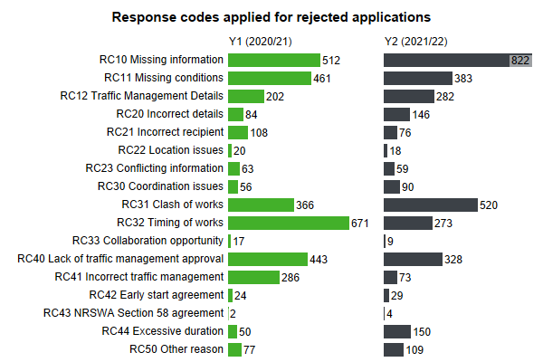
  - Collaborative works
      - One of the most effective methods for the Council to reduce the potential disruption is for Promoters to collaborate their works, thereby undertaking work on the same section of the highway at the same time, under the same form of traffic management, or contiguous working where work methodology does not allow for works in close proximity.
      - Collaboration between Promoters is recognised as an industrywide challenge, with limited opportunities and practical limitations within work delivery, scheduling resources and methodology. As shown in the section above, the refusal for a permit application is rarely for a missed collaboration opportunity.
      - As shown in the chart below, collaborative works undertaken in Years 1 and 2, these are very low levels compared with the total number of works and duration. Most collaborative works were minor works by the water sector, whilst the largest workdays of collaboration were for highway sector major work.
      - As already suggested in the previous section, the Council should continue to actively explore collaboration opportunities wherever possible, even if the likelihood of the collaboration occurring is perceived to be low. The Council should record all work with a collaboration opportunity, using the relevant response code, to at least demonstrate the challenges and limitations that exist across the industry.
      - Analysis shows that the volume of work with a form of collaboration increased from Year 1 to Year 2, as such the total days of collaborative works has also significantly increased. Further analysis of collaborative work by sector and work category shows that these works are predominantly highway authority major work (low volume and high duration) and water minor work (high volume and low duration).
The chart(s) below show (top) the total number of works undertaken and the duration of these works (days)with a form of collaboration in Years 1 and 2; and (bottom) the total work (y-axis) and total duration of work (x-axis) with a form of collaboration by sector and work category in Years 1 and 2.
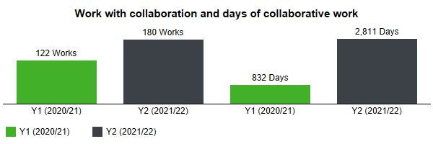
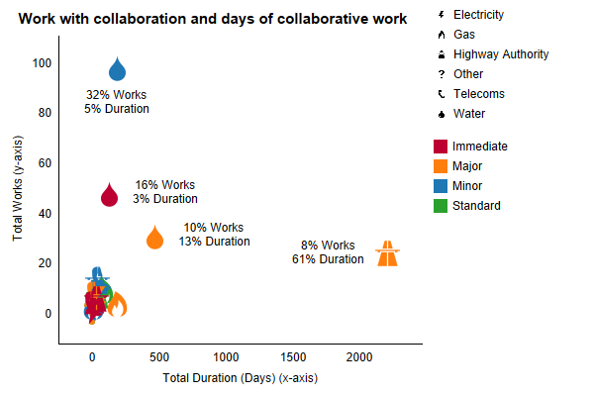
  - Changes during the life of a permit
      - Processing permit applications provides an opportunity for the Council to undertake their network management duty and deliver the benefits of a permit scheme - to reduce the potential disruption of the work. The sections below show analysis of changes to permits during the planning stage - between the initial application and work start - based on the content of the electronic records received and issued.
      - The analysis considers (1) where a change to the permit content, such as a condition, can be identified and (2) where a change has been made whether a permit was refused by the Council with a relevant response (code). This analysis does not include any work comments issued between the Council and Promoters or any other form of communication, such as telephone calls or emails.
      - This analysis should demonstrate the capability of the Scheme for coordination, through changes being made to a permit at the direction (request) of the Council. The analysis considers changes to three key areas of the work: permit conditions, duration, and traffic management.
The charts below show the number of instances where a change was made to a permit condition during the application stage of work undertaken (left); and the number of instances where the condition change can be attributed to the use of a response code (RC11 Missing conditions) (right). The difference in total is a condition change that cannot be attributed to a rejection with the use of RC11. The numbers in brackets are the total records.
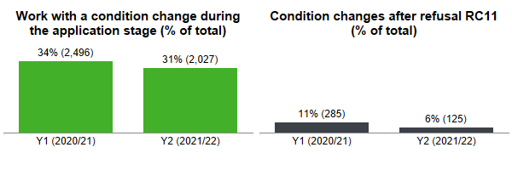
      - Analysis shows that c.33% of work undertaken with an applied condition had a change of condition during the application stage, however only c.8% can be directly attributed to the refusal of a permit for a condition change.
The charts below show the proportion of work undertaken (% of total) with a decrease in the planned duration (left) and the total duration (days) of the planned duration decrease (right).
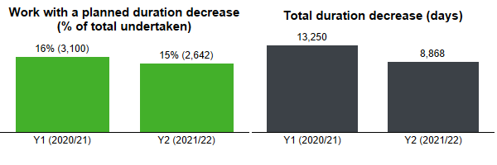
      - Analysis of duration changes shows c.15% of work undertaken had a duration decrease during the planned stage, resulting in a significant reduction in the planned occupation of the highway. Further analysis on the use of a response code (RC44) as a reason for these changes shows where a permit is refused with this reason c.78% result in a duration decrease.
      - The overall reduction in planned duration during the planning stage cannot be directly attributed to the Scheme as the number of works with a planned duration decrease from a rejection is a low proportion of the total work with a planned duration decrease.
- It is recommended that the Council review the use of rejection codes and the outcome, as a quantifiable change, from the use of these.
The charts below show the changes made to the planned duration (of work undertaken) after a refusal was issued during the planning stage with the reason excessive duration (code RC44)
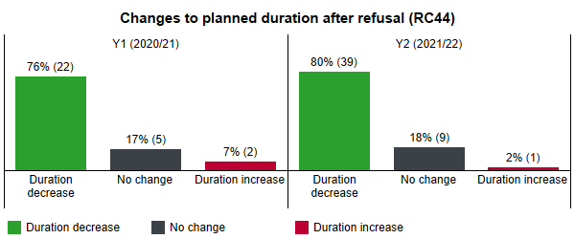
      - Analysis of traffic management changes during the planning stage shows 307 works in Year 2 with a planned traffic management change, however a low proportion of these can be directly attributed to an action (permit refusal) by the Council. The charts below show changes made to the planned traffic management (of work undertaken) (left) and the number of changes where a refusal with a relevant code (RC12, RC40 or RC41) was issued (right).
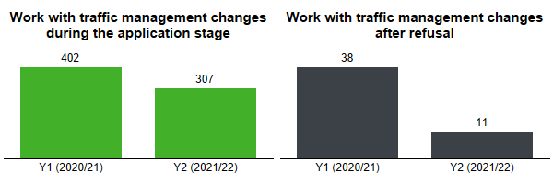
      - Overall, the analysis shows that changes are being made during the planning stage, however these cannot be directly attributed to an action by the Council. In Year 3 the Council need to ascertain how and why changes are being made, and if the any permit scheme controls contribute to these changes.
- It is recommended that the Council investigate changes being made during the planning stage to ascertain how and why these are being applied, and where possible identify the action causing the change.
  - Variations to permits
      - Permit Scheme Regulations includes a provision for the Council to vary or revoke a permit Therefore, a permit variation (change request or alteration as named in Street Manager) can be issued either by the Promoter for the Council to grant or refuse, or by the Council to the Promoter as an imposed change. There are many reasons why variations are issued, which include:
- Changes for planned work dates, because of lack of resources, such as a contractor or work gang availability;
- Changes to work details, such as a change in traffic control or work methodology once a work has been started;
- Requests to extend the planned duration of the work, because of plant breakdown or other factors, such as bad weather, preventing or limiting work.
- Other unplanned activities on the network such as emergency diversion route caused by an accident or other emergency work.
      - The types of permit variation fall within one of four different categories:
- Highway Authority imposed change where the Council want to make a change to the permit, either before or after work has commenced.
- Permit modification where a Promoter is responding to a permit modification request (refusal) from the Council during the application stage.
- Promoter change request where a permit has been granted and the Promoter wants to vary the permit.
- Promoter imposed change where a Promoter wants to vary a permit that is still in the application stage and has not been granted.
- Work extension where a Promoter wants to change the proposed end date of work (typically increasing the duration) once a work has commenced.
  - Requests for work duration extensions
      - Promoter requests for duration extensions have decreased from Year 1 to Year 2, with an associated decrease in the number of additional unplanned duration, which remains a low proportion of overall work duration. The proportion of work extensions being granted has increased from 77% in Year 1 to 93% in Year 2.
      - Overall, the analysis would suggest that duration extensions from Promoters are typically requested when they are essential to complete work, with a genuine reason.
The charts below show requests by Promoters for work duration extensions (top); the proportion granted of the total received (middle) with applications cancelled or superseded removed; and the total duration (whole calendar days) of additional duration of the total work with a duration extension.
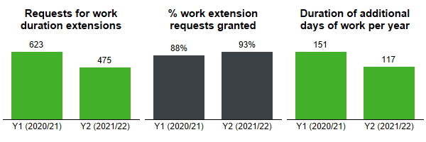

    - Other variations from Promoters
      - The volume of Promoter variations has decreased from Year 1 to Year 2, whilst the proportion of variations granted has remained similar (c.88%). Further analysis shows that the reason for these variations include:
- Response to rejections or comments from the Council;
- Changes to the planned work before start, such as date changes, traffic management or work details.
The chart below shows permit variations (excluding those for duration extension) issued by Promoter in Years 1 and 2 (left) and the proportion of Promoter variations granted as a % of total submitted (right). Applications that were cancelled or superseded before a response was given have been removed from this analysis.
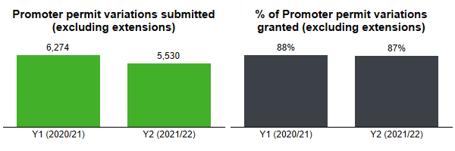
    - Variations issued by the Council
      - Within Street Manager variations issued by the Council (HA imposed change) is limited to adding or removing permit conditions only. As such, the main use of this imposed change is for Immediate work where the Council would not reject an application, as the work is already in progress, but require changes to the permit conditions.
The chart below shows the volume of authority-imposed variations issued by the Council to Promoters in Years 1 and 2.
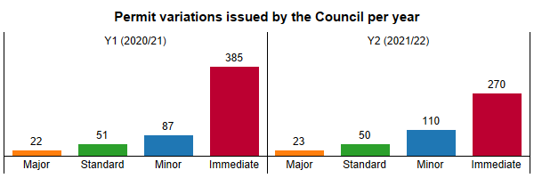
- Analysis of permit conditions
  - Use of permit conditions
      - Applying a condition to a permit is one of the primary methods for achieving the objectives of a permit scheme. The process of a Promoter applying for a permit allows the Council to make changes to the work and where necessary apply conditions, within pre-define categories, to control and minimise the impact of the works, sometimes even before work starts, for example advanced publicity of a road closure.
      - The sub-sections below outline the conditions available to the Council. These are based on the categories defined in the Statutory Guidance for Permit Conditions. This Guidance sets out the conditions that can be applied to permits and the potential parameters that can be associated to these conditions. Analysis only considers years four to nine as these apply the national condition text codes.
      - Analysis and evaluation for the use of conditions can be difficult to undertake as there are many variables for a work that need to be taken into consideration, such as the work methodology, location, use of materials or plant, timing of the work.
      - It can be impracticable to determine the criteria for a work and whether a condition could, or should, have been applied or not. In addition, it is not always possible to determine the effect of the condition or an outcome that can be quantified. This analysis does not include conditions that apply to all permits, such as displaying a permit number on a site board, but only those that can be applied to a permit.
      - In Year 2, 37% of work undertaken has an applied permit condition, with c.31% of these being applied during the planning stage. Further analysis of applied conditions shows these are predominantly to:
- control or specify the timing of work;
- control the use or removal of traffic control;
- ensure advanced publicity of work; and
- manage the road space being occupied for work and impact to traffic.
The charts below show the proportion of work undertaken with any permit condition applied as % of total (right) excluding those conditions that apply to all permits without having to be added to a permit; and the % of those works where the condition was added during the planning stage (right).
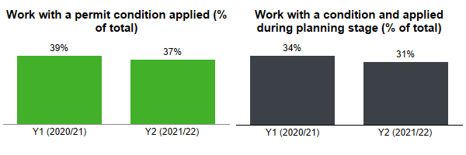

The chart below shows the total conditions, by their type, applied to work undertaken in Years 1 and 2.
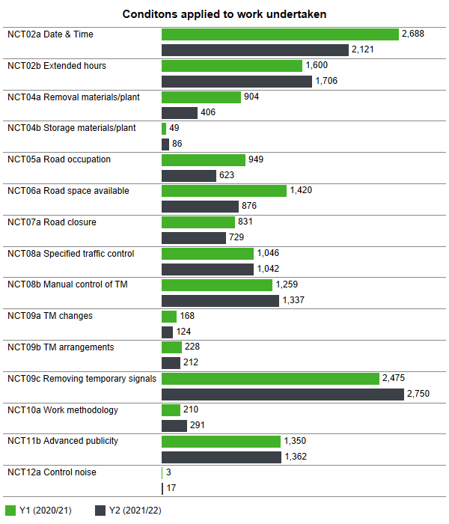
      - The sections below show conditions applied by each type in Years 1 and 2 and whether the condition is added during the initial planning stage, between application and work start, instead of included on the initial application.
  - Conditions for Date & Time Constraints
      - There are two date constraint conditions applied to permits, NCT1a and NCT1b. These conditions limit the flexibility of when works can be started within a timeframe defined by the road category. These conditions are implied and do not need to be applied.
      - There are two further time constraint conditions which can be applied to permits:
- NCT2a –to limit the days and times of day; and
- NCT2b – to specify extended working hours.
The charts below show the number of works undertaken with the specified condition (top) and the % of those conditions that were added during the planning stage for Years 1 and 2 (bottom).
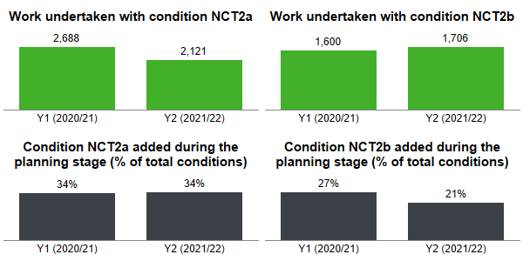
  - Conditions for Material and Plant Storage
      - There are two conditions for the removal and storage of materials and/or plant during works:
- NCT4a -removal of surplus materials and/or plant; and
- NCT4b – the storage of surplus materials and/or plant.
The charts below show the number of works undertaken with the specified condition (top) and the % of those conditions that were added during the planning stage (bottom).
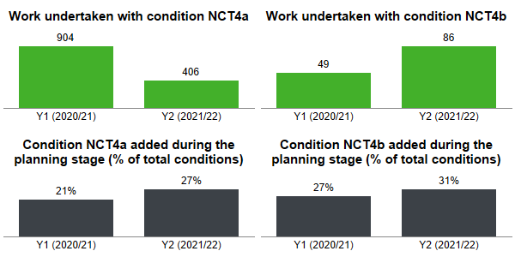

  - Conditions for Road Occupation
      - There are three conditions related to road occupation and traffic space dimensions:
- NCT5a – specifying the width and/or length of road space that can be occupied; and
- NCT6a – specifying the road space to be available to traffic (including pedestrians) at certain times of the day; and
- NCT7a – limiting activities when the specified road is closed to traffic.
The charts below show the number of works undertaken with the specified condition (top) and the % of those conditions that were added during the planning stage (bottom).
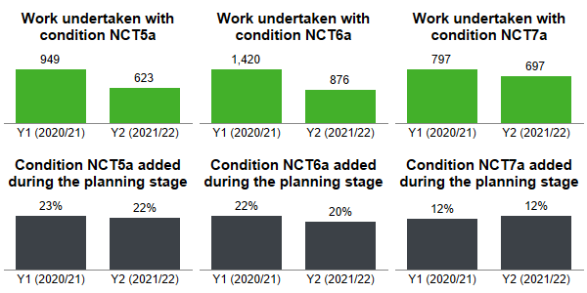
  - Conditions for Portable Traffic Signals
      - There are two conditions related to works using specific forms of traffic control:
- NCT8a – limiting activities to the deployment of specified temporary traffic control; and
- NCT8b – specifying the manual control of traffic management at specified times.
      - These conditions can be used in conjunction with timing conditions (NCT 2a and 2b).
The charts below show the number of works undertaken with the specified condition (top) and the % of those conditions that were added during the planning stage (bottom).
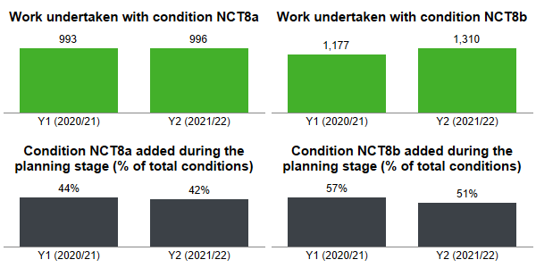
  - Conditions for Traffic Management Changes
      - There are three conditions related to traffic management changes during works:
- NCT9a – notifying the Authority when traffic management changes during works;
- NCT9b – specifying the traffic management arrangements to be in place before activities can commence; and
- NCT9c – removing portable traffic signals from operation when no longer in use.
The charts below show the number of works undertaken with the specified condition (top) and the % of those conditions that were added during the planning stage (bottom).
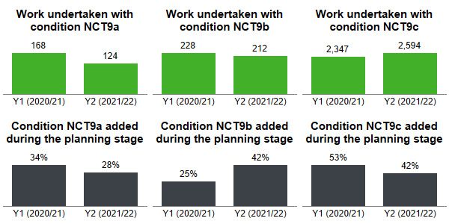
  - Conditions for Work Methodology
      - There is one condition related to work methodology: NCT10a – specifying the work methodology to be used for the proposed activities.
The charts below show the number of works undertaken with the specified condition (left) and the % of those conditions that were added during the planning stage for (right).
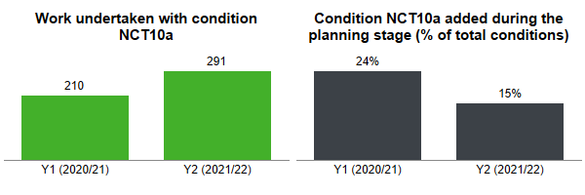

  - Conditions for Consultation and Publicity
      - Displaying a permit number on a site information board during the entire duration of the works is a condition that is implied on all permits (NCT11a). There is an additional condition (NCT11b) specifying the advanced publicity of works that can be applied to work.
The charts below show the number of works undertaken with the specified condition (left) and the % of those conditions that were added during the planning stage (right).
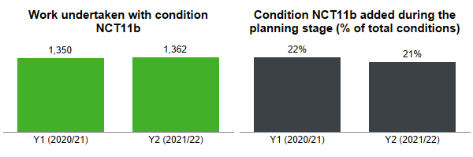
  - Conditions for the Environment (Noise)
      - There is a condition that can be applied to works for an environmental (noise) control: NCT12a – limiting the timing of certain activities for the environment. These conditions can be used in conjunction with timing conditions (NCT2a and NCT2b).
The charts below show the number of works undertaken with the specified condition (left) and the % of those conditions that were added during the planning stage (right).
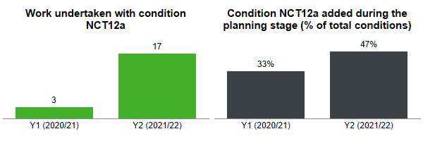
  - Local Conditions
      - Statutory Guidance allows for an agreed non-defined condition between the Council and Promoter, called a local condition. No local conditions have been applied by the Council.
  - Summary
      - There is an overall consistent application of all conditions and various levels of addition during the planning stage. The introduction of the Scheme during the national COVID19 pandemic has limited opportunity to collectively review the application of permit conditions, and it is evident that some conditions are misunderstood and there isn’t a systemic use across the Council and by Promoters.
- It is recommend that the Council undertake further reviews and training for permit conditions, to ensure a clear understanding on the use and benefit, including the use of conditions in conjunction with each other.
- It is recommended that the Council share their understanding of conditions with Promoters to ensure there is a systemic understanding and application.
- Analysis of permit compliance
  - Offences for working without a valid permit or breach of condition
      - The Council undertake a permit compliance inspection with their Category A work in progress inspection and offences are created from any failures. The overall volume of permit offences is less than 1% of total work undertaken.
The charts below show the number of offences issued by the Council for working without a permit (left) and breach of permit condition (right) issued each year.
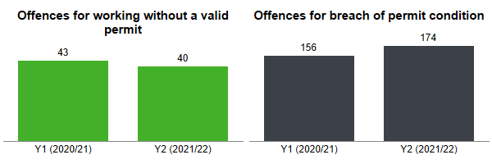
The chart below shows the reason for a permit condition offence, by condition type, for offences issued in Years 1 and 2.
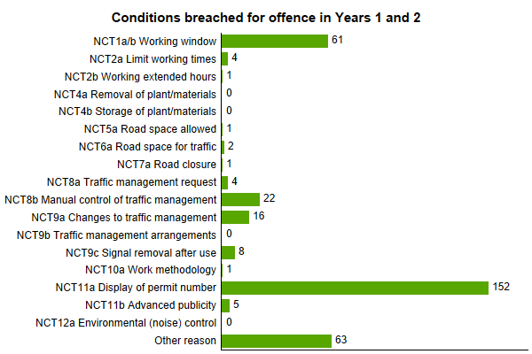
      - The main reason for breaches of permit condition is the lack of a permit number on site, which is typical across the entire industry, however the Council should ensure that compliance inspections cover all condition types, especially those related to timing and duration.
- It is recommended that the Council review their compliance inspection regime to ensure that all condition types are being inspected.
- Analysis of parity treatment
      - Section 40: Non-discrimination of the Permit Scheme Regulations state that the Council must apply the regulations (Parts 5 and 6) without any discrimination between different classes of application for permits or for provisional advanced authorisation. Statutory Guidance defines this further a parity treatment with each permit application received are treated equally regardless of the works’ promoter .... and [Highway] works will be treated in the same way as any undertaker (except that they are not liable for the fees or sanctions).
      - Parity treatment will be analysed using the following specific measures for each sector:
- Response to PAA and permit applications;
- Permit applications deemed (granted);
- Response to Promoter permit variations;
- Variations issued by the Council; and
- Conditions applied to permits.
      - It should be accepted that there will be differences between sectors, when comparing to the average, mainly due to differing working practices, levels of permit quality and volumes of works and applications.
The charts below show the PAA or permit applications granted within Years 1and 2 (as a % of total received) by sector. The charts do not include those applications that were deemed (granted), superseded or cancelled before a response was given.
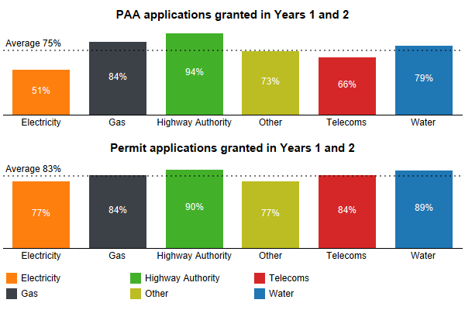

The chart below shows the % of PAA and permit applications (of total) that were deemed (granted) within Years 1 and 2. The charts do not include those applications that were superseded or cancelled before a response could be given.
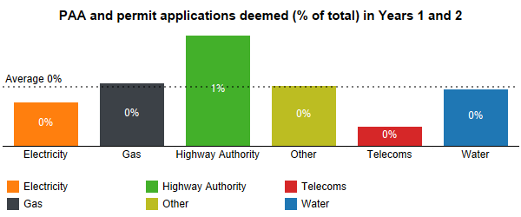

The charts below show the permit variation applications granted within Years 1 and 2 (as a % of total received) by sector. The variations are delineated by requests for extensions and other variations. The charts do not include those applications that were deemed (granted), superseded or cancelled before a response was given.
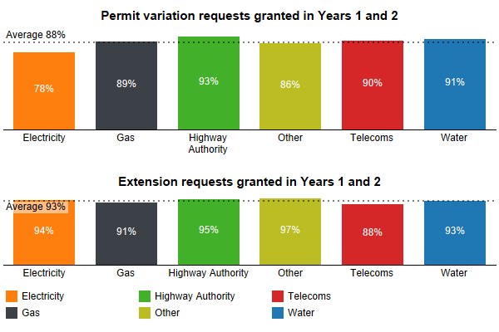

The chart below shows the number of variations issued by the Council in Years 1 and 2.
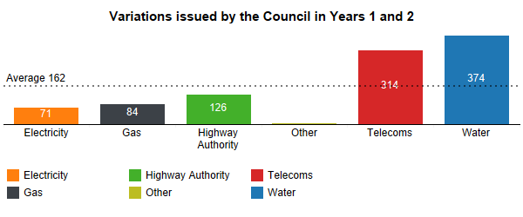
The chart below shows the % of planned works undertaken with a permit condition, as a % of total works, by sector within Years 1 and 2. Unplanned Immediate works are excluded.
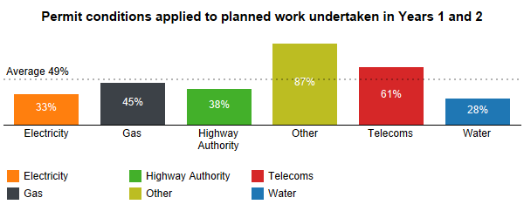
The chart below shows % of work undertaken within Years 1 and 2 with at least one permit compliance inspection (included within a Category A inspection), as a % of total works, by sector.
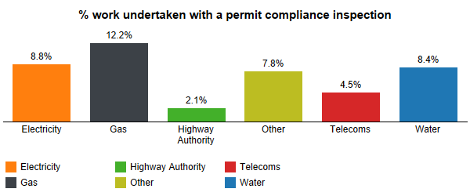
      - The level of Highway Authority work with a permit compliance inspection is lower than the average across Promoters – this needs to be reviewed by the Council to ensure parity treatment and compliance to the scheme is being achieved by the sector.
- It is recommended that the Council consider increasing the proportion of Highway Authority works inspected for permit compliance to meet the Promoter average.
- Review of permit fees
      - The Permit Scheme Regulations allows the Council to charge a fee to recover the prescribed costs for the administration of a permit, a provisional advanced authorisation, and the variation (alteration) of a permit. These fees are applied to statutory undertaker works only, not for work for road purposes (highway authority work).
      - The regulations require that the Council (as a permit authority) consider whether the fee structure needs to be changed in light of any surplus or deficit, to only recover the prescribed costs.
      - The overall operating cost of the permit scheme increased in Year 2 because of increases in Council costs, such as staff costs and overheads. In addition, the Council reviewed and adjusted the resource allocation to permit scheme functions and those related to statutory undertaker work (from those estimated during the scheme implementation), thereby increasing the cost to administer these works.
The table below shows the income from permit fees, recoverable cost and balance (income – cost). The income from permit fees for Year 1 has increased over the figure provided in the Year 1 report after final invoice payments.

      - In Year 2 the Council incurred another deficit, leading to a recoverable cost running balance of -£210,067. Looking ahead, the Council intends to recruit additional staff to support the operation of the permit scheme in Year 3. This will result in an increased operating cost and therefore an increase to the recoverable cost.
      - In consideration to increasing costs and a deficit being accrued the Council intend to undertake a scheme variation to increase the permit fees in Year 3 for the start of Year 4. This variation should enable the Council to recover their deficit income in years 4 through 6, at which point a review of the fee structure will be undertaken as part of the Year 6 anniversary evaluation.
- It is recommended that the Council undertake a scheme variation to adjust the permit fee levels to recover their deficit and ensure further income levels are sufficient for the operating cost.
- Analysis of cost and benefit
  - Cost-benefit-analysis framework
      - A cost-benefit analysis (CBA) provides a framework within which the impacts of a scheme can be compared against the cost of setting up and operating the scheme.
      - Historical works data provides a basis on which to evaluate the impact of works on motorists and the local economy, and to review the value of the scheme against the actual costs and revenues of operations of the scheme since implementation.
      - The approach to the CBA is as follows:
- Identify the scale and characteristics and quantify the scale of societal impact these works will have had to the residents and local economy, using the most detailed information available;
- Estimate the reduction in impact resulting from the permit scheme and quantify the social benefit of this reduction;
- Quantify the costs of operating the permit scheme; and
- Undertake the cost benefit analysis to determine the benefit to cost ratio and net present value delivered by the scheme.
  - Scale and characteristics of works
      - Works data is available for a five-year period covering both pre and post scheme implementation. This data has been analysed to produce estimates of historical impact of works in Wiltshire.
      - The introduction of Street Manager in 2019 has provided a richer and more detailed source of data on the actual delivery of works including detailed timings and traffic management adopted. From this data, a more precise estimate of the actual impact that works have had on motorists has been possible, through the estimation of part-day works impacts, early finishes or overruns and outturn differences in original application and outturn delivery of works. The impact estimate using Street Manager data is therefore not directly comparable to estimates from previous years using EToN data.
      - To ensure the most rigorous analysis for the CBA, the Street Manager data from the most recent complete year (2020/21) has been used as the basis for estimating works impact costs and permit scheme benefits. The table (below) shows the number and durations of works (undertaken) for the most recent complete year.
      - In the period 2020/21 (Year 2), 18,612 individual work events were recorded, representing over 46,000 days of works. Of these, 43,157 days of works involved at least some incursion into the carriageway and hence likely to have resulted in some disruption to road users
Volume, duration and costed impact of works undertaken by traffic management type in Year 2 (200/21).

  - Impact of works
      - For the purposes of the CBA, works are disaggregated by type of traffic management, which has important implications on the scale of impact of those works on highway users. The remainder of works involved no incursion into the carriageway and have been assumed to have no impact on road users. It should be noted that this is a conservative assumption as even non-carriageway works is likely to incur some impact, whether road users or on wider society.
      - The estimated impact of the works with incursion into the carriageway have been modelled using the QUeues And Delays and ROadworks (QUADRO). QUADRO was originally developed for the DfT and designed to assess and monetize the impact of delays due to works. Whilst no longer hosted by the DfT, the QUADRO model continues to be maintained, under the responsibility of Highways England, and is considered the most appropriate tool to quantifying the impact of works for this evaluation.
      - Having developed costs for every work type, each work within the data used for this evaluation has been assigned an impact cost, according to its characteristics and the duration of the work taken from the more robust data contained within Street Manager. This provides highly granular results, especially when compared with the typical aggregated CBA approach adopted in other scheme evaluation documents. The modelled impact of typical works in Wiltshire forms the basis of the benefits calculation.
      - These impact estimates include the following elements:
- Road user travel time (delay caused to consumer and business as a result of works)
- Road user vehicle operating costs (the impact of delay and diversion on vehicle operating costs for consumers and business)
- Accident costs
- Emissions costs (resulting from congested conditions and diversion)
- Indirect tax revenue (increased tax revenue to the exchequer because of higher fuel consumption)
      - Aggregation of the modelled impacts of works occurring in Wiltshire defines the scale of social cost of these works (see table above).
- The annual impact of roadworks undertaken in Wiltshire in 2020/21 are estimated to be £14.543m (2010 prices).
- The average cost impact per day of works is £314.30
      - Whilst QUADRO covers most of the standard monetised elements of work impact, an off-model adjustment was made to account for reliability impacts. DfT guidance recommends that this be captured through application of an uplift to journey time costs/benefits. The recommended uplift factor is 10-20%. A factor of 15% has been adopted for this evaluation to be consistent with this recommendation.
    - Quantification of benefit of permit scheme
      - The benefits of the permit scheme are expected to be achieved through more efficient and better managed work events taking place compared to the patterns observed before scheme implementation. Relating observed changes directly to the scheme is complicated by the range of factors which influence work occurrences. For the CBA, the comparative scenario is one in which the permit scheme had not been implemented and is therefore by its very nature hypothetical and unobservable.
      - A national evaluation of permit scheme impacts was commissioned by the DfT in 2017. This study adopted a rigorous cross region evaluation of the observed pattern of roadworks under authorities with and without permit schemes. It concluded that the impact of work was typically 6.4% lower in Wiltshire and similar authorities which had adopted permit schemes, which aligned closely with the default assumption of 5% works impact reduction previously adopted in assessments (DfT Permit Scheme Evaluation Guidance, 2016).
      - To ensure the most rigorous assessment of the impact of the permit scheme in Wiltshire, the national evaluation estimate of 6.4% reduction in impact under a permit scheme has been paired with the impact cost estimate for 2020/21 based on the Street Manager data.
      - The estimated works costs in Wiltshire in 2020/21 under the permit scheme stand at £14.543m. Therefore, the benefits in terms of the permit scheme can be calculated as follows:

- The annual benefit of the Wiltshire permit scheme is £994,000 (2010 prices)
      - The cost benefit appraisal requires that scheme benefits are appraised against scheme costs over the whole appraisal period, which in this case is recommended as being 25 years in the DFT permit scheme appraisal guidance.
      - Consequently, the benefits are projected forward over following years, with impacts and benefits increasing in real terms to reflect growth in values of time, vehicle operating costs, accident savings and emissions costs.
    - Scheme Operating Costs
      - Having established scheme benefits, these must be set against scheme costs to determine value for money. Permit scheme costs elements include the following:
- Setup costs
- Scheme operating costs (staff, consultants, maintenance/running costs)
- Scheme capital costs – IT equipment, software etc
      - Importantly, the permit scheme costs included within the appraisal are the additional costs of operating the permit scheme above those incurred previously incurred in delivering the council duties regarding work applications. By considering the incremental costs, this fairly compares the ‘with permit scheme’ scenario with the ‘business as usual (i.e. no permit scheme) scenario. The cost assumptions relating to the scheme are detailed below:
      - Whilst the scheme has now been running for 2 years, the appraisal focuses on the projected costs of operation over the coming years, to align with the benefit estimate which is based on 2020/21 works impacts.
      - The annual incremental operating costs are estimated at £879,000 per annum (2020 prices). Rebasing these costs to 2010 prices to align with the price base of the benefits provides an overall operating cost of £715,000 per annum (2010 prices) for the CBA.
      - The operating costs of the permit scheme principally relate to the additional internal staff resources required to process permit applications and additional operating factors to administer the permit scheme, such as finance payment and reconciliation, performance and evaluation. To identify an operational cost a proportion of each (relevant) role within the Councils network management service was assigned to permit scheme administration.
    - Promoter Costs
      - In addition to the costs of operating the permit scheme, it is important to recognise that there are costs borne by works promoters also in operating under the permit scheme. These will include:
- Permit Fee costs which represent a business cost to the promoter. Within the CBA this is treated as a business cost to the promoter, netted from overall scheme benefits. However, the transaction is effectively a transfer payment between promoter and the Council, so the payment is treated as a revenue and is subtracted from scheme operating costs.
- Additional administration costs in complying with the permit scheme.
- Costs related to changes in working practices such as greater use of traffic management or off-peak and weekend working.
      - Detailed promoter cost data has not been available, but in line with evidence gathered from other permit scheme evaluations and adopted as the default assumption in the National Permit Scheme Evaluation, an estimate of 20% of local authority operating costs relating to Statutory Undertaker works has been applied.
  - Appraisal Results
      - The cost benefit analysis takes the benefits and costs established from the most recent year of operation and projects these over the 25-year appraisal period. The future cost and benefit streams are discounted using the standard discount rate of 3.5%, meaning that near term costs and benefits are valued more highly than those occurring later in the appraisal period.
      - The results of the cost benefit analysis are as follows:

      - The benefit to cost ratio (BCR) is a measure of value-for-money exhibited by a scheme.
- With a BCR of 3.3 the permit scheme can be defined as delivering greater benefit than it costs and classified as ‘High Value for Money’.
The Analysis of Monetised Costs and Benefits includes costs and benefits which are regularly or occasionally presented in monetised form in transport appraisals, together with some where monetisation is in prospect. There may also be other significant costs and benefits, some of which cannot be presented in monetised form. Where this is the case, the analysis presented above does NOT provide a good measure of value for money and should not be used as the sole basis for decisions.
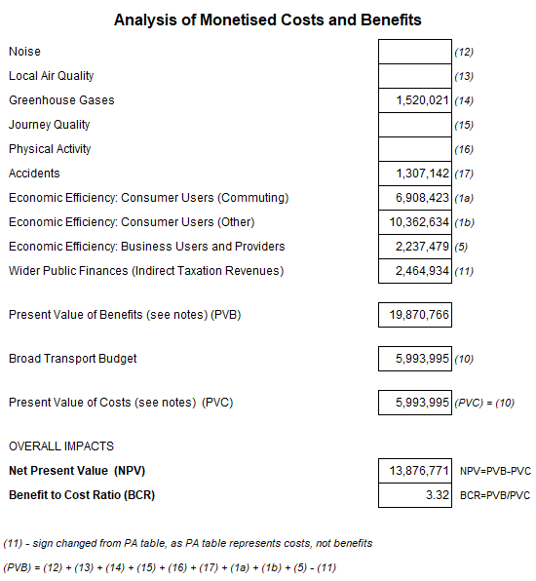
  - Emissions savings
      - A component to the costed benefits presented above is a reduction in carbon emissions. These emissions savings are driven by more efficient vehicle movements, and the avoidance of the ‘stop-start’ movements associated with works. QUADRO places a monetary value on emissions savings by applying a ‘cost of carbon’ to the amount of carbon generated because of works (additional fuel due to idling, or diversion etc).
      - In the most recent year of the scheme (2020/21), the carbon emission generated by works within the Wiltshire area, as calculated within QUADRO, were valued at £873k (2010 prices), which represents around 6% of overall work impact cost.
      - The implied carbon emissions attributable to works amounts to 14,370 tonnes for Year 2, equivalent to 1.8% of overall highway related carbon emissions produced within Wiltshire. The improved efficiency of works under the permit scheme means that the carbon emissions generated because of works may be expected to be lower than they would have been without the scheme. In line with the broader assumptions about permit scheme impacts, on the basis that GHG emissions resulting from works are 94.6% of the level they would have been in the absence of the scheme, would lead to estimated annual carbon emission savings of 920 tonnes CO2 from reduced delays.
      - To set this emission saving in context, using the typical emissions of new cars sold in the UK currently, this reduction amounts to an equivalent saving of over 766,000 annual car kilometres CO2 reduced.
- Annex A: Evaluation methodology
  - Source data for analysis
      - This evaluation uses data collected from both Street Manager and the Council’s system to process and record works. The data collected contains the content of notifications sent between Promoters undertaking work, such as utility companies, and the Council.
      - Analysis of these notifications enables the Council to produce metrics for performance indicators and further measures. For some measures aggregating data for analysis does not provide an accurate picture of the results, for example for the analysis of all work durations can provide a falsely inflated picture of changes over time. This evaluation therefore delineates many of the measures into sub-categories, such as works category, to provide a more accurate result and trend.
      - Many of the measure contained in this evaluation were analysed with sub-categories to ensure accuracy in the results. These have not all been included within this evaluation report; however, it should be accepted than any findings presented have been tested for certainty and any anomalies investigated and defined.
  - Work phases
      - In this evaluation work is analysed in logical phases. A work is typically identified by a work reference number, which often applies to multiple phases of work, for example a work reference number may contain the following individual phases:
- work with a temporary reinstatement;
- follow-up work changing the temporary reinstatement to a permanent reinstatement;
- defect work to rectify a fault with the permanent reinstatement.
      - To logically delineate work phases, a phase is identified from the initial application through to work completion notices within the same work reference. Therefore, the analysis shown for work in this evaluation is for a work phase, i.e. the total works undertaken are the total work phases undertaken.
      - To reduce any anomalies for the analysis of application lead times only applications with a lead time between 1 and 100 days for notices and permits and 1 to 250 days for major works advanced notice or PAA were included.
  - Duration analysis and adjustment
      - Analysis of works duration is calculated using the dates provided within the work start and work stop notifications, inclusive of these dates. As a result of incorrect dates on notices from Promoters spurious durations can be found within the extracted data, such as work with a negative duration, created where the supplied end date is before the start date, or work with a significantly high duration.
      - Since the introduction of the DfT’s digital service, Street Manager, and associated regulatory changes in July 2020 it is possible to determine the timings more accurately and reliably from the works data. This means a work duration can be calculated by minutes instead of whole days. As such, analysis using Street Manager derived data provides a more realistic insight and result.
The charts below show duration calculated by a whole calendar day and the duration calculated by the times provided in the work start and work stop notices in Street Manager. The period shown for both Years 1 and 2 covers June 2021 (partway through year eight) to March 2021 (whole of Year 2).
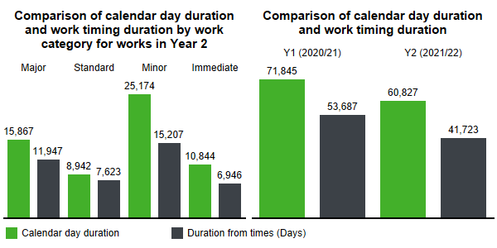
The chart below shows the total duration of work, in whole calendar days, per year. A work is assigned to a year based on the first application date.
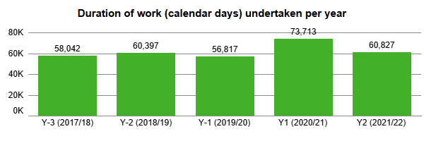
      - Analysis of total duration based on the notice dates (whole calendar day) and notice times shows that there can be noticeable differences between these two types of measure. For this evaluation, analysis of work duration and trend is predominantly based on dates of the work notices, not timings, as the pre-scheme historic data does not contain accurate timings. Future evaluations may contain analysis based on timing once the data range has increased over time. In addition, the use of activity type also introduced by Street Manager can be useful to consider the durations of specific activity and whether these are changing over time or remaining within accepted tolerances.
      - This report contains analysis of duration based on time wherever possible, however for a complete analysis of operational year one and to analyse results compared to previous years it is not possible to effectively use this. It is anticipated that future operating years will use analysis of duration based on work timings time, across far more effectively.

  - Economic cost-benefit analysis
      - A cost-benefit analysis (CBA) provides a framework in which the impact of a scheme can be compared against the cost of setting up and operating the scheme. Annual evaluation of the Permit Scheme CBA provides opportunity to review the value of the scheme with the benefit of the outturn scheme operating costs and revenues, updated estimates of the societal impact of work and to compare this not operating a permit scheme.
      - The approach to the permit scheme CBA is as follows:
- identify the scale and characteristics and quantify the scale of societal impact these works will have had to the residents and local economy;
- estimate the reduction in impact resulting from the permit scheme and quantify the social benefit of this reduction;
- identify the cost of setting up and operating the permit scheme; and
- undertake the cost benefit analysis to determine the benefit to cost ratio and net present value delivered by the scheme.
      - The societal impact of each work is estimated based on impact calculations derived from the QUeues And Delays at ROadworks (QUADRO) model. Originally QUADRO was developed for the DfT and designed to assess and monetize the impact of delays due to works. QUADRO is currently maintained by National Highways.
      - QUADRO captures loss of time to travellers, increased vehicle operating costs because of idling in queues and/or diversion, vehicle emissions and accident impacts. Impact modelling is based on local traffic flow data (within the Council’s boundary), disaggregated by road type, to provide locally relevant impact values.
  - Period of analysis
      - Throughout this evaluation there is a reference to operating years. These years are based on the permit scheme years, where year one is between 1st June 2020 and 31st May 2021. The operating years before the scheme came into legal effect are show as negative years, i.e. Y-1 covers the period 1st June 2019 to 31st May 2020.
  - Defining Promoters
      - Within this evaluation Promoters can be defined by their sector, e.g. water. The Promoter type Highway Authority is included in this definition, as works for road purposes. The sector type ‘Other’ includes other organisations who need to undertake work on the highway, such as Network Rail who typically account for over c.70% of work within this type.
- Annex B: Glossary and common terms
Council | Wiltshire Council including their capacity as a Local Highways Authority.
DfT | Department for Transport
Duration of work | A works duration is calculated in calendar days based on the actual or proposed works start date and the actual or estimated works end date, inclusive of both days. Therefore, a works with an actual start date of 1st April and an actual end date of 5th April would equate to 5 days.
EToN | The Electronic Transfer of Notifications, the nationally agreed format for the transmission of information related to works between the Council and those undertaking works.
HAUC | The Highway Authorities and Utilities Committee.
NRSWA | New Roads and Street Works Act 1991.
PAA | Provisional Advanced Authorisation, which is a notice sent only in relation for Major works 3 months in advanced of the proposed start with a higher-level of detail for the intended works.
Permit | Permission sought by a Promoter to undertake works on the highway, in accordance with the Permit Scheme.
Permit condition | The capability for the Council to apply conditions to a permit, and therefore the work, is one of the primary methods to control and coordinate works through a permit scheme.  The conditions that can be applied are set out within Statutory Guidance, each with a reference code comprising NCT with a unique number, within the following categories: date and time constraints; storage of materials and plant; road occupation and traffic space dimensions; use of traffic management provisions; work methodology; consultation and publicity of works; and environmental considerations for noise.
Permit Scheme | The Wiltshire Council Permit Scheme
Permit Scheme Regulations | The Traffic Management Permit Scheme (England) Regulations 2007, Statutory Instrument 2007 No. 3372 made on 28 November 2007 and the Traffic Management Permit Scheme (England) (Amendment) Regulations, Statutory Instrument 2015 No. 958 made on 26th March 2015.
Permit Variation | The process to change an agreed permit to reflect current or proposed changes in the works.
Promoter | A person or organisation responsible for commissioning activities [works] in streets covered by the Permit Scheme - either an Undertaker or a participating Council as a highway or traffic authority.
Statutory Guidance | The Traffic Management Act (2004) Statutory Guidance for Permits.
TMA | Traffic Management Act 2004
Undertaker | Statutory Undertaker as defined within Section 48(4) of NRSWA.
Work | Also referred to as an activity.  Work that should be registered to the Council carried out by a statutory undertaker, as a street work, or for the Council, as a road work.
Works category | Every work is assigned a category, based on the following:  Major works are works that are 11 days or more in duration or require a temporary traffic regulation order, such as a road closure.  Standard works are non-Major works between 4-10 days.  Minor works are non-Major works with a duration of 3 days or less.  Immediate works are either emergency or urgent works that require an immediate start.
- Annex C: HAUC Performance Indicators
  - TPI 1 Works Phases Started (Base Data)
Permit Scheme Year | Number of works
Y1 (2020/21) | 17,674
Y2 (2021/22) | 18,562
  - TPI2 Works Phases Completed (Base Data)
Permit Scheme Year | Number of works
Y1 (2020/21) | 17,856
Y2 (2021/22) | 18,581
  - TPI3 Days of Occupancy Phases Completed
      - The data shown for this performance indicator includes analysis using either the work start, and work stop notice dates or times (from June 2020).
Permit Scheme Year | Duration from work start and stop times
Y1 (2020/21) | 53,687
Y2 (2021/22) | 41,723
  - TPI4 Average Duration of Works
      - This data is only show for years eight and nine as the accuracy of the information provided by the Promoters since the start of Street Manager was improved significantly. Prior to this the work start and work stop information is insufficient to provide an accurate and comparable average duration.
      - To provide meaningful information the data has been delineated into work category and the duration is show in days, rounded to the nearest one decimal place.
Permit Scheme Year | Major | Standard | Minor | Immediate
Y1 (2020/21) | 44.6 | 8.0 | 1.3 | 2.0
Y2 (2021/22) | 27.0 | 7.3 | 1.4 | 2.0
  - TPI5 Phases Completed involving Overrun
      - The table below shows the results of the data analysis, however as explained within this report these figures should be treated with caution as the accuracy of information provided from the Promoter prior to the introduction of Street Manager in July 2020 seems low.
Permit Scheme Year | Overrunning Works
Y1 (2020/21) | 124
Y2 (2021/22) | 108
  - TPI6 Number of deemed permit applications
      - This data does not include permits that are auto-granted by Street Manager, but only those where a response was not provided to a permit within the specified timescale. The data is delineated by three different events, PAA, permit and permit-variation.
Permit Scheme Year | PAA | Permit | Permit variation | Total
Y1 (2020/21) | 39 | 148 | 220 | 407
Y2 (2021/22) | 19 | 62 | 115 | 196

  - TPI7 Number of Phase One Permanent Registrations
Permit Scheme Year | Permanent Registrations
Y1 (2020/21) | 10,284
Y2 (2021/22) | 10,974

- Annex D: References

The QUADRO model calculates impacts in line with the DfT’s appraisal guidance WEBTAG. Within this guidance the DfT specified base year prices are specified as 2010, enabling comparison between appraisal results for different schemes on a like for like basis.
https://assets.publishing.service.gov.uk/government/uploads/system/uploads/attachment_data/file/700502/permit-schemes-evaluation-report.pdf
Excl. reliability benefits which are added into the appraisal at a later stage

