|  |  |
| --- | --- |
| Environmental | Personal |
| Think of things to do with the environment  that you find distracting?  For example; *Rain* | Think of personal things that you find distracting?  For example; *Your phone* |

**Practical Exercise**

Cut out and stick these photos to show distractions

[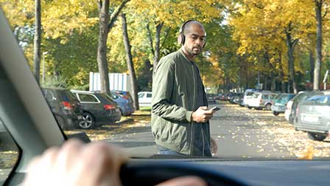](http://erticonetwork.com/checking-whatsapp-while-crossing-the-road/)

[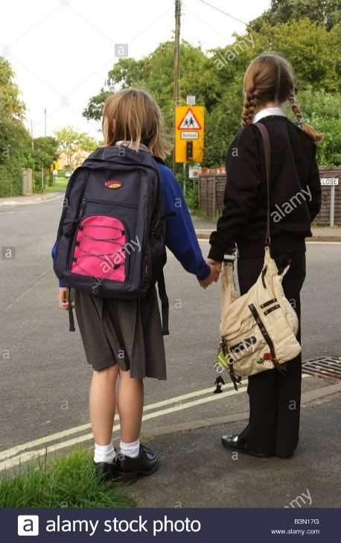](http://www.google.co.uk/url?sa=i&rct=j&q=&esrc=s&source=images&cd=&cad=rja&uact=8&ved=2ahUKEwiyqZGs2L7aAhUCRhQKHdg-DSwQjRx6BAgAEAU&url=http://www.alamy.com/stock-photo-schoolgirls-in-uniform-wait-to-cross-a-road-on-the-school-route-england-19516324.html&psig=AOvVaw2ipywbbeYCleZYPosmfA4J&ust=1523964486181317)[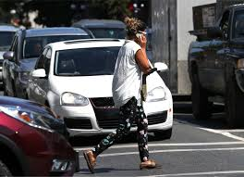](http://www.google.co.uk/url?sa=i&rct=j&q=&esrc=s&source=images&cd=&cad=rja&uact=8&ved=2ahUKEwj-tvHn1b7aAhUBmhQKHVGrAGEQjRx6BAgAEAU&url=http://www.timescolonist.com/news/local/b-c-won-t-regulate-distracted-pedestrians-1.2304906&psig=AOvVaw2F0IQ0THRq9mklIDG-Md4U&ust=1523963815925176)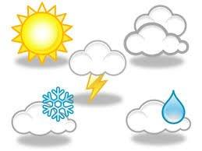[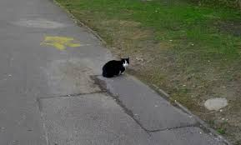](http://www.google.co.uk/url?sa=i&rct=j&q=&esrc=s&source=images&cd=&cad=rja&uact=8&ved=2ahUKEwjku_C71r7aAhWGuBQKHdgNAmgQjRx6BAgAEAU&url=http://jooinn.com/cat-6.html&psig=AOvVaw2BpJ1ty7eDpADBxpZoN_8P&ust=1523963959129871)[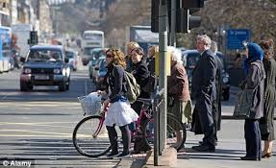](http://www.google.co.uk/url?sa=i&rct=j&q=&esrc=s&source=images&cd=&cad=rja&uact=8&ved=2ahUKEwjA4Nfp1r7aAhVEUhQKHV4_A3sQjRx6BAgAEAU&url=http://www.dailymail.co.uk/news/article-2044222/UK-hands-free-pedestrian-crossing-devout-Jews-cross-road.html&psig=AOvVaw0_wbPUN2RMvvFRVRa9F9VY&ust=1523964095447516)