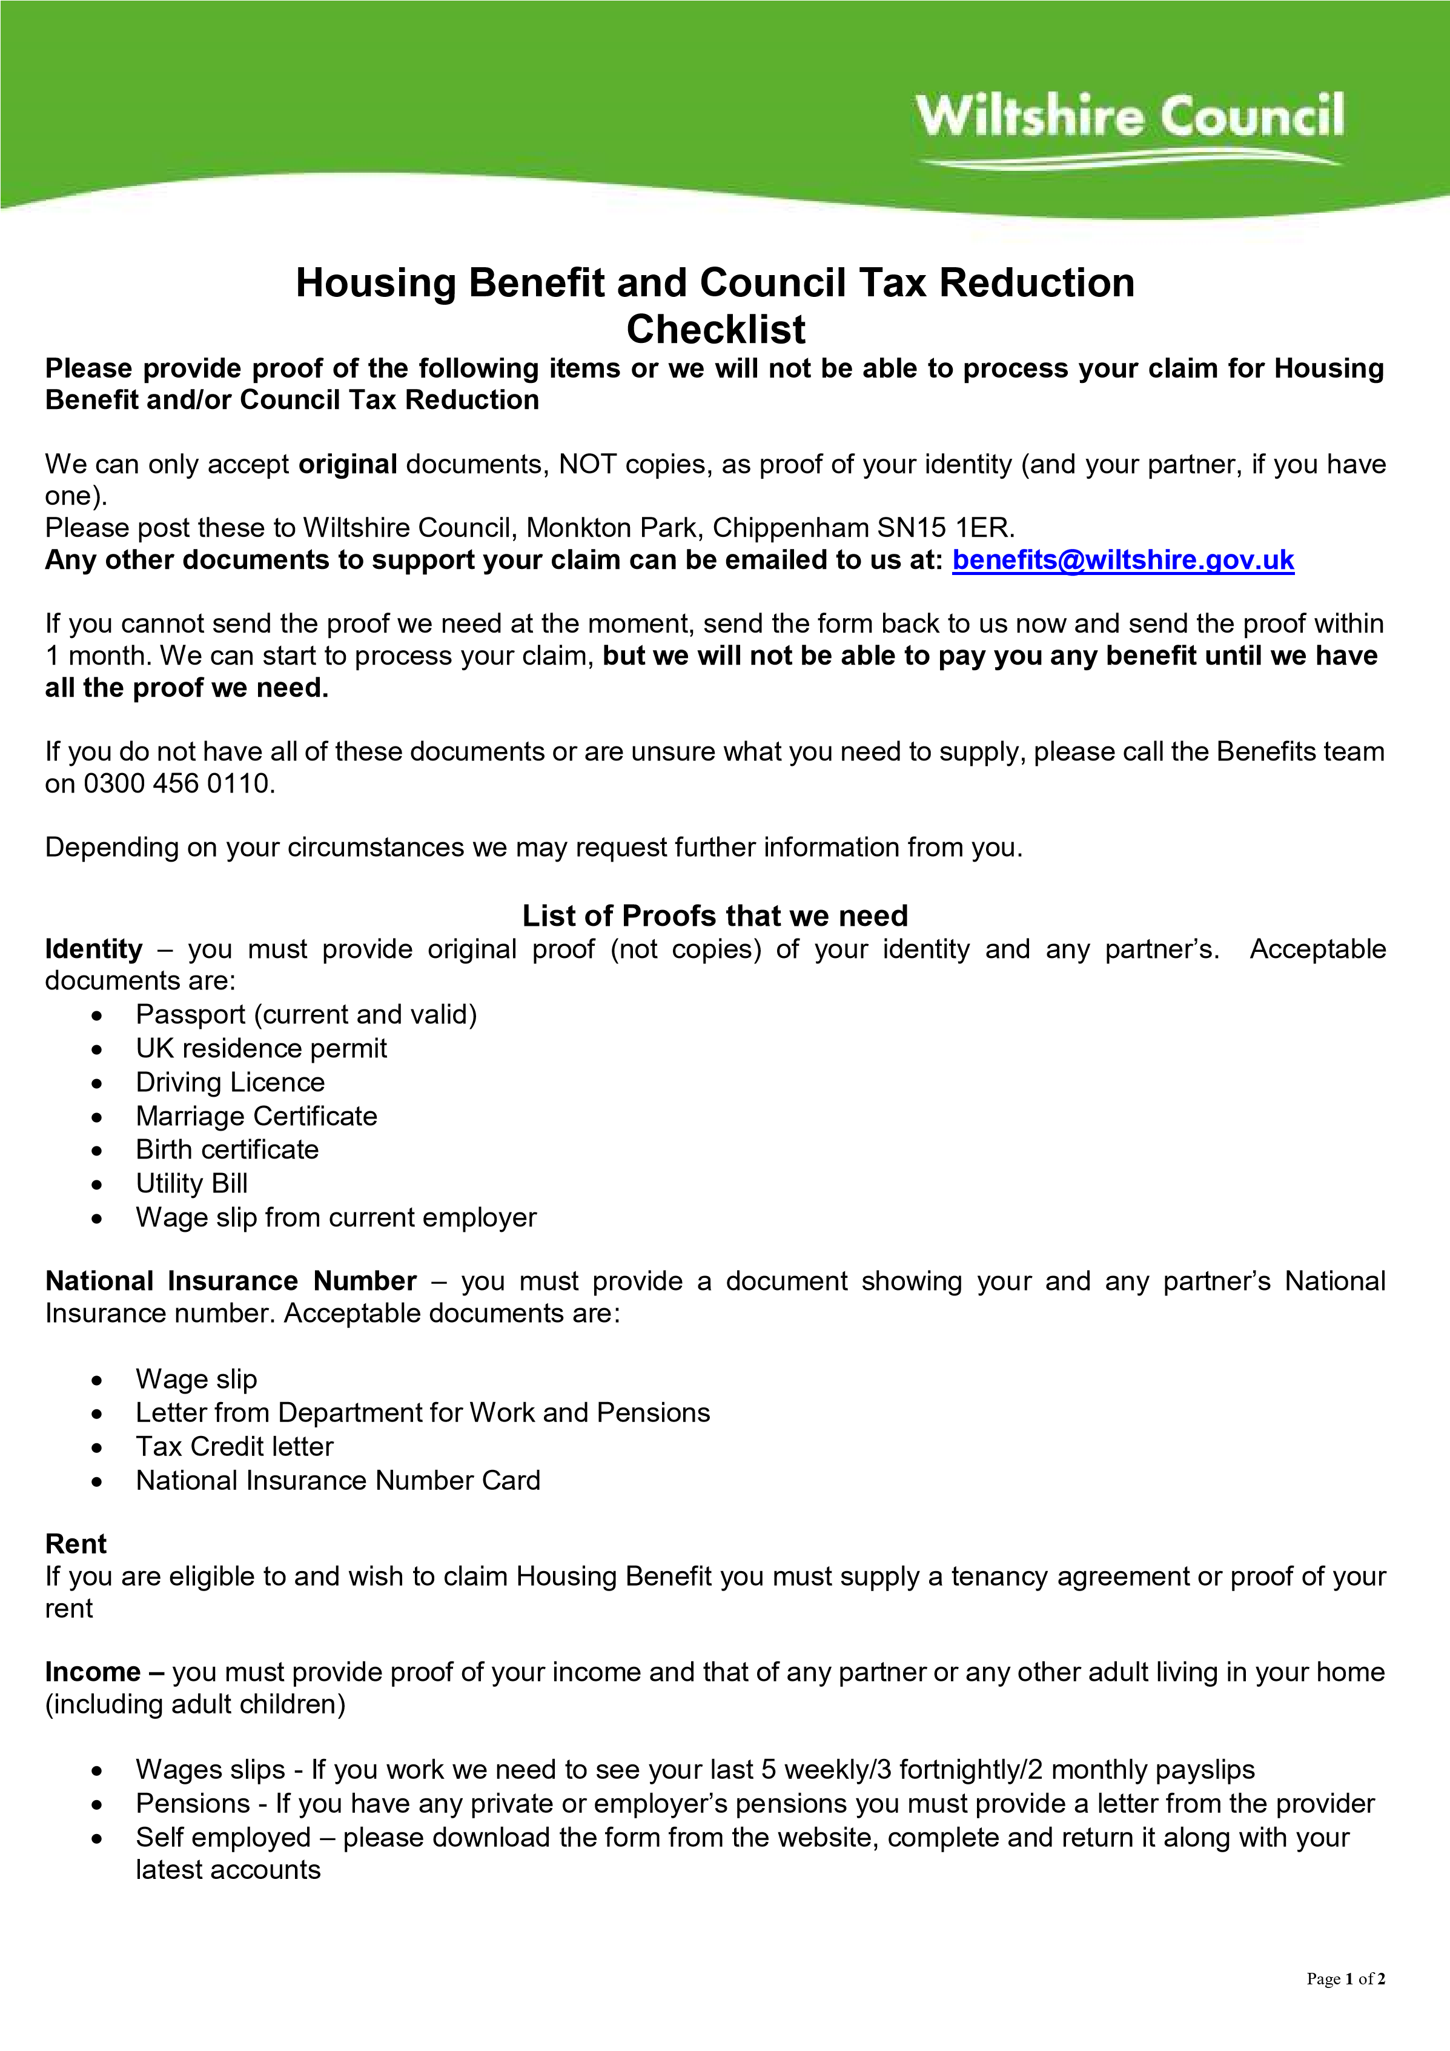


Page
2

of
2

Capital
–

if you
and/or any partner, have
any savings or capital you must supply proof o
f all of it, including:

•

Last 2 months bank or building society statements for all accounts

•

Savings accounts

•

Premium bonds

•

Share certificates

Students
–

if you or your partner is a student you must provide:

•

Student loan/grant letter

•

Letter confirming
course dates

