WILTSHIRE AND SWINDON COUNTRYSIDE ACCESS FORUM
MICROSOFT TEAMS MEETING ON 2 MARCH 2021

WILTSHIRE COUNCIL UPDATE PROVIDED BY RICHARD BROADHEAD, COMMUNITIES AND NEIGHBOURHOODS HEAD OF SERVICE FOR RIGHTS OF WAY, COUNTRYSIDE, TECHNICAL AND STREETSCENE

Introduction to the Rights of Way and Countryside service.
The Rights of Way and Countryside service has, since the spring of 2019 been located with the then newly formed Communities and Neighbourhoods Directorate, within which there are the following service areas divided between seven Heads of Service who all report to Jessica Gibbons, Director, Communities and Neighbourhoods:
Communities
Community Development
Passenger Transport
Libraries and Leisure
Public Protection
Communications
Customer Services
Rights of Way and Countryside, Technical and Streetscene.

The Council’s Cabinet Member within whose remit ROWCTS services are included is Bridget Wayman. Bridget is supported by Portfolio Holders Sven Hocking (Highways and Environment) and Christopher Williams (AONBs and Canals).
The structure of the Rights of Way and Countryside teams within ROWCTS is shown in the chart below. The structures of the Technical team and the Streetscene teams are not included here for the simple reason that that they are not directly relevant to the purposes of the Countryside Access Forum, although a list of the specific services that each provides is included at the end of this section of this update.
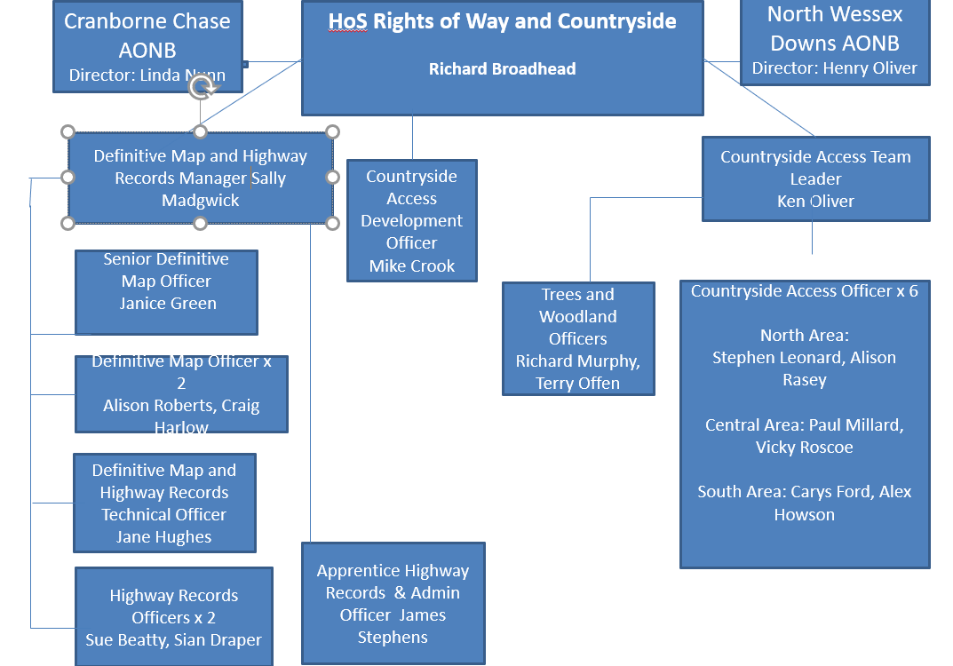

Excluding staff costs, and the two AONBs which are separately funded, the service operates with an annual revenue budget(for 2020-21) of £184,000 for rights of way maintenance and enforcement, £20,000 for definitive map, common and village greens work and £121,500 for the essential maintenance of trees on Wiltshire Council owned land.
Capital budgets are provided by courtesy and at the discretion of our colleagues in Highways and Environment, £100,000 for byway surfacing repairs and improvements and £30,000 for other individual path improvement schemes. The council’s Community Area Boards also provide grant funding towards path improvements on application from community groups.
Physical maintenance and improvement works are carried out by external contractors and a number of very active and enthusiastic volunteer groups to an added value in the region of £200,000 per year (when not constrained as they have been over the last 12 months due to the Covid-19 pandemic).

Services provided by the Technical Team:
- The council’s cemeteries management (7 cemeteries in the former West Wiltshire District Council area) and burials service plus 33 “closed” churchyards across Wiltshire
- Holding, administering and distributing approximately £9 million of Section 106 developer contributions for recreational facilities in designated locations. Approximately £20,000 is contributed annually to Rights of Way and Countryside for essential tree maintenance in public open spaces and approximately £150,000 to Streetscene.
- Administration of applications for new private accesses onto highways (“dropped kerb applications
- Administration of Wiltshire Council owned allotments
Services provided by Streetscene:
- Grounds “soft” maintenance of public open spaces, children’s play areas and playing fields, public toilets
- Street cleansing
Streetscene maintenance contract annual value approx. £5.23million

Report on actions from the last CAF meeting on 4 July 2019
Neither of the meetings scheduled for September 2019 and December 2019 took place, the September one because of the recent resignation of the Chairman for personal reasons and a lack of items having been put forward for the agenda and the December one because of the recent resignation of the Vice-Chairman also because of personal reasons. At the time, we had started to undertake the review of the membership, so the decision was taken to hold the next meeting once that had been completed. That work was not prioritised during 2020 following the outbreak of Covid-19 so this meeting gives a restart to the CAF.
CAF letter concerning the Definitive Map 2026 cut-off date for applications to record historic “lost ways”. – action not undertaken by CAF members
Proposal to review Access Land in Wiltshire ahead of the government’s 2024-25 review – CAF will need to decide whether or not they still wish to do this.
Brexit letter – action not undertaken by CAF members
Impact of hare coursing – item for future agenda?

Principle areas of work undertaken since July 2019
Actions implemented from the CAF paper on rights of way maintenance post-austerity recovery plan:
Initial note:
At the time that the paper was being prepared, announcements were being made that ‘austerity’ was over. In local government that was clearly not the case; year on year Wiltshire Council has had to continue to make substantial savings to cope with the rising costs of social care for adults and children, and during the past twelve months needing to spend upfront a high proportion of its budget on supporting vulnerable people and communities through the Covid-19 pandemic. Strict spending controls on all services had to be imposed even where essential business as usual needed to continue, and large numbers of staff had to be diverted from their usual roles to work on the council’s Covid response. Rights of Way and Countryside were no more exempt from these restrictions and diversions than were other services across the council. All staff for whom it was not essential that their work required their presence within a council building have been working at home since the middle of March 2020. This has had an inevitable adverse effect on some aspects of efficiency and service delivery, with amost all communications now being online and face to face meetings and site visits having to be kept to a Covid-safe minimum.
Reflection on what has been achieved, particularly over the last twelve months, should be undertaken in that context.
Reporting:
Rights of Way, Streetscene and Highways officers worked closely together and with the council’s ICT team to ensure that the MyWiltshire reporting app. would be significantly improved over the previous MyWilts system to allow more accurate recording and management of defect/problems and the provision of feedback to customers. Efforts to get the new system “right” for the services’ purposes resulted in it not being launched until the late summer of 2020; with further improvements to come in a second phase.

It has become evident that the universal nature of a council-wide reporting system makes it difficult to meet all of the bespoke needs of so many different services. and We have had to accept that those limitations will not enable all of the functionality identified as desirable by the CAF to be realised. Our ultimate aim is for reports submitted to MyWiltshire to feed through into the HIAMS (Highways Asset Management System) which is able to provide much of that desired functionality, though estimates suggest that unless an additional staff resource to extend HIAMS for rights of way can be funded, it may be 18 months or so before we can implement that move.

In the meantime, testing of the system has in effect been carried out with the system having gone live and in use by the public. A number of issues have been identified and resources are now being re-allocated within ICT to resolve them. It is generally accepted that MyWiltshire is not yet as good as we expected it to be and we continue to feedback to ICT on things that need to be ‘’fixed’ or provided.
Maintenance:
Adversely and severely affected by Covid-19 restrictions and the need to protect staff. Site inspections to investigate and resolve problems and undertake maintenance (by contractors) were confined to urgent safety issues and almost all volunteer activity was suspended. Recommendations c, d, e, and f at paragraph 62 of the CAF paper remain outstanding, although there were no budget reductions and a considerable amount of time was spent tendering for a rights of way maintenance contract that as it turned out, could not be awarded. Late in 2020, a capital bid was submitted for 2021/22 for major funding of £3.79 million to undertake a full network asset management survey by volunteers with the aim of establish a Wiltshire Council rights of way voluntary path wardens service, recording of the network assets within the HIAMS system, and funding on-the-ground path improvements over the next ten years to achieve better connectivity between communities to help to meet the council’s objectives for the green and blue infrastructure, climate change and carbon reduction, by reducing the need for private car use and encouraging people to walk and cycle. Somewhat ironically, the stay at home and exercise from your doorstep rules of Covid-19 have emphasised the need for good, well maintained local path networks. Although the bid was not one of othe six across the council’s services that did receive early approval, it will be re-submitted in the autumn of 2021.
Enforcement:
Although the presence of our Countryside Access Officers out on the ground to investigate reports of obstructions was much reduced below the level to which we had expected to be possible, we worked with The Ramblers in particular to identify known repeat offenders in respect of ploughing and cropping obstructions.
The intention had been to step up our enforcement action with warning letters and, if necessary, service of notice to reinstate illegally ploughed or cropped paths, we decided to go softly on our approach while farmers, who can be amongst the most vunerable members of our society in terms of isolation, were faced with combatting the pressures on their livelihoods exacerbated by Covid-19.
However, during January and February of 2021 we wrote to over 100 farmers and landowners to remind them of their responsibilities towards public rights of way. The response has been encouraging, with a number who received the letters contacting us to discuss managing public access on their land. That has given us the opening to look at complete landholdings and address concerns about trespass and other misuses of farmland during the last year when the number of people walking in the countryside has seen big increases. Helping land managers in this way will, we hope, have a lasting effect which may forestall the need for enforcement.

A303 Amesbury to Berwick Down (Stonehenge):
The Examination Authority’s series of public hearings into the Development Consent Order (DCO) application submitted by Highways England came to an end in August. Liaison meetings between Highways England to discuss the preliminary works schemes, construction management plans etc. have continued and we are now starting to be formally consulted as a principle stakeholder on individual management plans for the many different aspects of the scheme, notwithstanding the present legal challenge to the government’s decision to approve the DCO. Preliminary works to rights of way may start early in 2022 with the stopping up of BOAT Amesbury 2 and the closing of the junction of BOAT Amesbury 1 with the A303; Amesbury 1 is stopped up with footpath rights retained. Full details of the scheme including the effects upon existing rights of way and creations of new ones can be viewed on Highways England’s website.

Addition of Technical and Streetscene teams and services to Rights of Way and Countryside:
These teams were moved from Highways and Environment into Communities and Neighbourhoods and added to the Rights of Way and Countryside Service, which was deemed to be the ‘best fit’, at the end of March 2020, just as the council was being required to respond to Covid-19. The Head of Service role has expanded accordingly to become one of strategic management with even more reliance than before being placed on the team managers and leaders to manage and make operational decisions. The synergies between the teams have enabled them to complement each other well, but there is more potential to deliver improved services by working more closely together which will be explored further once the distractions of the pandemic lessen and we have the time available to do that.
Definitive Map and Highway Records work
The ability to maintain progress on applications for Definitive Map Modification Orders and other work involving research of historic maps and records was limited by the closure of the Wiltshire and Swindon History Centre, to officers of the council as well as to the public. However, the opportunity was taken to determine applications for public path orders and reduce applicants’ waiting times, and we saw the first on-line non-statutory Public Inquiry held to consider an application for the registration of a new village green in Hilperton (the inspector did not consider the evidence was sufficient to support the registration of the land as a village green and the council has accepted that). This way of progressing cases rather than delaying them worked well for all parties, and we may have found a cost-effective and acceptable way forward for at least some applications in the future.
Staff Development:
Prior to the arrival of Covid-19 we had planned a series of specialist staff training to be provided during 2020 by the Institute of Rights of Way Management. The need was partially as a consequence of the changes made within the structure of the Rights of Way and Countryside teams in the spring and summer of 2019 following Richard Broadhead’s appointment to the then new Head of Service role, by expanding the range of work undertaken by certain team members into areas with which they were less familiar. To save costs and enable the maximum number of particpants we planned for the trainers to come to the council to deliver the courses in person. We were able to switch to on-line delivery and enable more staff to benefit. Training included maintenance, enforcement, definitive map processes and procedures, managing development pressures (and developers!) and Case Law.
Principle areas of work for 2021
Our work over the coming months we shall continue to be affected by the concentration of available staff resources on the council’s Covid-19 recovery plans. These include redeployment of staff to assist with virus testing in schools and the wider community, helping with calls to and from vulnerable people and remaining flexible and agile so that we can respond quickly as new challenges arise.
However, we shall also be trying to be trying to return as far as is possible to whatever form “business as usual” takes as the pandemic eases. Working for more of the time from home and making use of new technology will become the norm for many of us, with associated time savings enabling us to do more at reduced cost, so there will be the opportunity to make some of the financial savings required without having to reduce the amount of work that can be delivered.
Major schemes such as the A303 DCO at Stonehenge will continue to take up significant amounts of our time as we work with Highways England and other partners to finalise and approve construction plans.
We expect to be able to start addressing the outstanding recommendations within the CAF recovery paper as outlined earlier in this update and we are expecting that the rights of way revisions within the Deregulation Act 2015 will be commenced within the year. Our perception is that while the new provisions are largely to be welcomed, new statutory deadlines will increase the pressure on local authorities, not reduce it.

___________________________________________________________________________
Richard Broadhead 26.02.2021

