
NOTIFICATION OF DECISION REGARDING THE APPLICATION FOR DESIGNATION OF CHERHILL WARD NEIGHBOURHOOD AREA FOR THE PURPOSES OF A COMMUNITY RIGHT TO BUILD ORDER UNDER SECTIONS 61E AND 61G AND SCHEDULE 4C (COMMUNITY RIGHT TO BUILD ORDERS) PARAGRAPH 4 (2) OF THE TOWN AND COUNTRY PLANNING ACT 1990 (AS AMENDED)

APPLICANT:

Cherhill Village Hall Charitable Incorporated Organisation

APPLICATION:

Application for the designation of Cherhill Ward Neighbourhood Area

Pursuant to the Wiltshire Council constitution and in particular Part 3B the Associate Director for Economic Development and Planning within whose remit Spatial Planning falls is authorised to consider the area designation applications for Neighbourhood Plans and Community Right to Build Orders, and if appropriate, approve such applications.

DECISION:

The Designation of Cherhill Ward Neighbourhood Area is approved for the purposes of a Community Right to Build Order in accordance with sections 61E and 61G and Schedule 4C (Community Right to Build Orders) paragraph 4(2) of the Town and Country Planning Act 1990 (as amended) for the purposes of Neighbourhood Planning and Community Right to Build Orders. The reasons for this decision are set out in the accompanying ‘Neighbourhood Area Designation Application Report’.

Signed:

Alistair Cunningham Associate Director
Economic Development and Planning Dated: 8th June 2016

WILTSHIRE COUNCIL NEIGHBOURHOOD AREA DESIGNATION APPLICATION REPORT – OFFICERS DECISION ACTING UNDER DELEGATED POWERS

Date of application | 04.01.2016
Date of decision | 08.06.2016
Name of proposed designation | Cherhill Ward Neighbourhood Area
Community Area | Calne Community Area

- INTRODUCTION

  - Pursuant to the Wiltshire Council constitution and in particular Part 3B the Associate Director for Economic Development and Planning within whose remit Spatial Planning falls is authorised to consider the area designation applications for Neighbourhood Plans and Community Right to Build Orders, and if appropriate, approve applications.

BACKGROUND

  - An application must be made to the local planning authority by a relevant community organisation in the case of a Community Right to Build Order for a Neighbourhood Area to be designated (Regulation 5 Neighbourhood Planning (General) Regulations 2012). This can include all or part of a parish council’s administrative area, if that area has not already been designated.

  - The power to designate a Neighbourhood Area is exercisable under sections 61E and 61G and Schedule 4C (Community Right to Build Orders) paragraph 4(2) of the Town and Country Planning Act 1990. Under Regulation 5(1) of The Neighbourhood Planning (General) Regulations 2012 (which came into force on 6 April 2012) an area application has to include a map which identifies the area to which the application relates, a statement explaining why this area is considered appropriate to be designated as a Neighbourhood Area and a statement that the body making the application is a relevant body for the purposes of sections 61E and 61G and Schedule 4C (Community Right to Build Orders) paragraph 4(2) of the 1990 Act.

  - Cherhill Village Hall Charitable Incorporated Organisation forms the ‘relevant body’ (for the purposes of sections 61E and 61G and Schedule 4C (Community Right to Build Orders) paragraph 4(2) of the Town and Country Planning Act 1990 (as amended) and this community organisation submitted an application for the designation of the Neighbourhood Area. A copy of the organisation’s constitution accompanied the application showing that the majority of members live in the Neighbourhood Area.

PROCEDURE

  - Under section 61H of the 1990 Act whenever a local planning authority exercises powers under section 61G to designate an area as a Neighbourhood Area, consideration must be given to whether the authority should designate the area concerned as a business area. The designation of a business area can only occur if the authority considers that the area is wholly or predominately business in nature [Section 61H (3)].
  - If the application for the designation of this Neighbourhood Area is approved, then Regulation 7(1) of the Neighbourhood Planning (General) Regulation 2012 requires the designation to be publicised. If the application is refused, reasons must be given under 61G
(9) of the 1990 Act and Regulation 7(2) of the Regulations which requires the decision to be publicised.

CONSIDERATION AS TO WHETHER OR NOT TO DESIGNATE

  - In determining the application for the designation as a Neighbourhood Area regard must be had to the desirability of designating the whole area. The issue is whether or not the specified area is an ‘appropriate area to be designated as a Neighbourhood Area’.

  - The fact that the designation of the Cherhill Ward Neighbourhood Area would allow a Community Right to Build Order to be prepared does not form part of the determination of this application.

REASONING FOR DESIGNATION

  - The area application is for the Cherhill ward part of the parish of Cherhill. The application explains that Cherhill Village Hall was originally gifted to provide a meeting space for the village. At that time, the constitution actually referred to the Parish of Cherhill because the Parish and the Village shared the same boundary. Later, with boundary changes, the village of Yatesbury (which has its own hall) became part of the Parish of Cherhill creating something of an anomaly. Recently, in applying to the Charity Commission to have the Charity re-registered as a Charitable Incorporated Organisation (granted in early November 2015 – registration number 1164373) the constitution was altered to refer to Cherhill Ward, this being an area with an agreed boundary on Wiltshire Council maps and reflecting the original Cherhill Parish boundary as intended by the charity founders. It is therefore considered appropriate to use the defined Cherhill Ward boundary, within the parish of Cherhill, as the designated Neighbourhood Area. The specified area falls completely within Wiltshire Council’s administrative area.

  - A new village hall to meet the needs of a growing population in Cherhill was first discussed more than ten years ago but made little progress due to the lack of available land. In developing a village plan between 2007 and 2010 it was discussed once more and, through extensive consultation, 75% of the local community said they would like to have a new hall. In 2014 the hall was becoming so heavily booked that prospective users were having to be turned away, the local Scout group announced it was looking for alternative, larger premises and severe lack of parking was causing problems particularly for the disabled.

  - Further enquiries at this point led to the generous donation of a piece of land by a local farmer and made the project viable. Through 2015 further consultation with the local community has clarified the needs of the village and demonstrated great support for the project, as well as some opposition primarily from residents adjacent to the proposed site. In particular an open evening early in the year, following the issue of a questionnaire, helped gather ideas and discuss concerns. Later in the year, following a design competition by three Architects, an open day to present their designs attracted over 200 residents and much excitement about the project. At this open day an opportunity was also given to the
objectors to display and voice their concerns. Further consultation and discussion has taken place through a dedicated website for the project and through Cherhill Facebook pages.

  - The application for designation as a Neighbourhood Area was publicised on the Wiltshire Council website for a period of 6 weeks from 9am Thursday 28th January until 5pm Thursday 10th March 2016. No responses or comments were received within the consultation period.

CONCLUSION

  - The reasoning above shows support for the designation of Cherhill Ward Neighbourhood Area.

  - The specified area is not wholly or predominantly business in nature and so it is inappropriate to designate it as a business area.

  - A copy of this report will be sent to the qualifying body, Cherhill Village Hall Charitable Incorporated Organisation.

DECISION

  - The Designation of the Cherhill Ward Neighbourhood Area is approved in accordance with sections 61E and 61G and Schedule 4C (Community Right to Build Orders) paragraph 4(2) of the Town and Country Planning Act 1990 (as amended) for the purposes of Neighbourhood Planning.
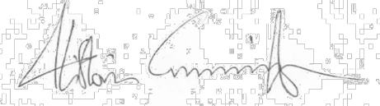
Alistair Cunningham Associate Director
Economic Development and Planning

Dated: 8th June 2016


DECISION REGARDING THE APPLICATION FOR DESIGNATION OF THE CHERHILL WARD NEIGHBOURHOOD AREA FOR THE PURPOSES OF A COMMUNITY RIGHT TO BUILD ORDER UNDER SECTIONS 61E AND 61G AND SCHEDULE 4C (COMMUNITY RIGHT TO BUILD ORDERS) PARAGRAPH 4(2) OF THE TOWN AND COUNTRY PLANNING ACT (AS AMENDED)

- I have no private interests to declare in respect of this matter which would prevent me from determining this application.

- I hereby exercise power under sections 61E and 61G and Schedule 4C (Community Right to Build Orders) paragraph 4(2) of the Town and Country Planning Act 1990 (as amended) (“the Act”) and all other powers delegated to me to designate the area identified on the map below as the Cherhill Ward Neighbourhood Area as I am satisfied that the area is an appropriate area to be designated as a Neighbourhood Area. I do not designate it as a business area for the purposes of section 61H (1) of the Act as it is not wholly or predominately business in nature.

  - Name of Neighbourhood Area: Cherhill Ward Neighbourhood Area

  - Map of Neighbourhood Area:
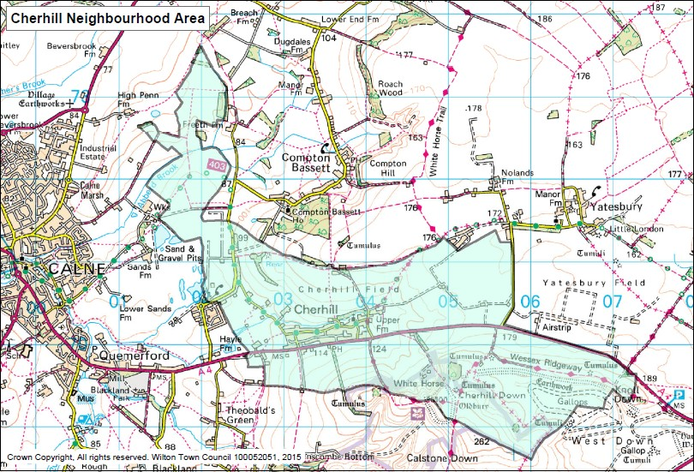

  - Relevant body: Cherhill Village Hall Charitable Incorporated Organisation form the ‘relevant body’ (for the purposes of sections 61E and 61G and Schedule 4C (Community Right to Build Orders) paragraph 4(2) of the Town and Country Planning Act 1990)
  - I have made this decision in line with the information set out in the ‘Neighbourhood Area Designation Application Report’.

Signed:
Alistair Cunningham Associate Director
Economic Development and Planning Decision published: 8th June 2016

