

NOTIFICATION OF THE DESIGNATION OF GREAT BEDWYN NEIGHBOURHOOD AREA UNDER SECTION 61G OF THE TOWN AND COUNTRY PLANNING ACT 1990 AS AMENDED

APPLICANT:

Great Bedwyn Parish Council

APPLICATION:

Application for the Designation of Great Bedwyn Neighbourhood Area

An application has been received that includes a map which identifies the area to which the application relates, a supporting statement explaining why the proposed neighbourhood area is considered appropriate and a statement that the body making the application is a relevant body for the purposes of section 61G(2) of the 1990 Act.

DECISION:

The Designation of Great Bedwyn Neighbourhood Area is approved in accordance with section 61G of the Town and Country Planning Act 1990 as amended for the purposes of Neighbourhood Planning.

As the area specified in the application consists of the whole of the parish council’s area it has been designated without consultation in accordance with Regulation 5A of the Neighbourhood Planning (General) Regulations 2012 as amended in 2016. This regulation 5A states amongst other things that where this regulation applies, regulations 6 and 6A of the Neighbourhood Planning (General) Regulations 2012 as amended in 2016 do not apply.

A map of the designated neighbourhood area is provided on the following page.

Pursuant to the Wiltshire Council constitution (in particular Part 3B) the Associate Director for Economic Development and Planning is authorised to designate neighbourhood areas.

I have no private interests to declare in respect of this matter which would prevent me from designating this neighbourhood area.

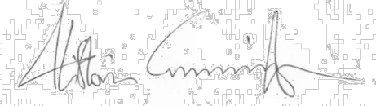
Signed:

Alistair Cunningham Associate Director
Economic Development and Planning Dated: 05.12.16
Map of Great Bedwyn Neighbourhood Area



