

NOTIFICATION OF DECISION REGARDING THE APPLICATION FOR DESIGNATION OF HINDON NEIGHBOURHOOD AREA UNDER SECTION 61G OF THE TOWN AND COUNTRY PLANNING ACT 1990 AS AMENDED

APPLICANT:

Hindon Parish Council

APPLICATION:

Application for the Designation of Hindon Neighbourhood Area

Pursuant to the Wiltshire Council constitution and in particular Part 3B the Associate Director for Economic Development and Planning within whose remit Spatial Planning falls is authorised to consider the area designation applications for Neighbourhood Plans and if appropriate approve applications.

DECISION:

The Designation of Hindon Neighbourhood Area is approved in accordance with section 61G of the Town and Country Planning Act 1990 as amended for the purposes of Neighbourhood Planning. The reasons for this decision are set out in the accompanying ‘Neighbourhood Area Designation Application Report’.
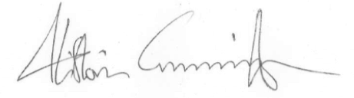
Signed:

Alistair Cunningham Associate Director
Economic Development and Planning Dated: 05.11.2014
WILTSHIRE COUNCIL

NEIGHBOURHOOD AREA DESIGNATION APPLICATION REPORT – OFFICERS DECISION ACTING UNDER DELEGATED POWERS

Date of application | 25.06.2014
Date of decision | 05.11.2014
Name of proposed designation | Hindon Neighbourhood Area
Community Area | Tisbury Community Area

- INTRODUCTION

  - Pursuant to the Wiltshire Council constitution and in particular Part 3B, the Associate Director for Economic Development and Planning within whose remit Spatial Planning falls is authorised to consider the area designation applications for Neighbourhood Plans and if appropriate approve applications.

BACKGROUND

  - The power to designate a Neighbourhood Area is exercisable under section 61G of the Town and Country Planning Act 1990. Under Regulation 5(1) of The Neighbourhood Planning (General) Regulations 2012 (which came into force on 6 April 2012) an area application has to include a map which identifies the area to which the application relates, a statement explaining why this area is considered appropriate to be designated as a neighbourhood area and a statement that the body making the application is a relevant body for the purposes of section 61G(2) of the 1990 Act.

  - Hindon Parish Council forms the ‘relevant body’ (for the purposes of section 61G (2) of the Town and Country Planning Act 1990) and submitted an application for the designation of Hindon Neighbourhood Area. The application is for the whole area of Hindon Parish to be designated as a Neighbourhood Area for the purposes of Neighbourhood Planning and so satisfies section 61G(3) of the Act. The submission of the application complied with the regulations.

  - The Hindon Neighbourhood Plan Steering Group has been set up to prepare the plan and is led by the Parish Council. The Group includes a cross section of community representatives that meet regularly to develop the draft plan.

PROCEDURE

  - Under section 61H of the 1990 Act whenever a local planning authority exercises powers under section 61G to designate an area as a neighbourhood area, consideration must be given to whether the authority should designate the area concerned as a business area. The designation of the specified area can only occur if the authority considers that the area is wholly or predominately business in nature [Section 61H (3)].

  - If the application for the Designation of this Neighbourhood Area is approved, then Regulation 7(1) of the Neighbourhood Planning (General) Regulation 2012 requires the designation to be publicised. If the application is refused, reasons must be given under 61G(9) of the 1990 Act and Regulation 7(2) of the Regulations requires the decision to be publicised.

CONSIDERATION AS TO WHETHER OR NOT TO DESIGNATE

  - In determining the application for the designation as a Neighbourhood Area regard must be had to the desirability of designating the whole area.

  - The issue is whether or not the specified area is an ‘appropriate area to be designated as a Neighbourhood Area’.

  - The fact that the designation of the Hindon Neighbourhood Area would allow a Neighbourhood Plan to be prepared does not form part of the determination of this application.

REASONING FOR DESIGNATION

  - The proposed area for designation is the parish of Hindon. Hindon, identified as a Large Village within the emerging Wiltshire Core Strategy, is centrally located in the parish and bounded by countryside in an Area of Outstanding Natural Beauty. The physical geography therefore makes it a logical planning unit, as there are no immediate cross boundary issues with neighbouring parishes. The Hindon Parish Council is a properly constituted, elected body representing the local community within the defined Parish boundary.
  - They aim to prepare a plan to act as an overall development strategy for the whole village, to ensure that any future development is carried out in a sensitive way, in keeping with its character and well integrated with the existing community. It will build on the Village Design Statement adopted by Wiltshire Council in 2013 and the results of the housing needs study carried out in 2013. Housing development will be considered to prevent the village stagnating, alongside enhanced community facilities and new workspace to provide for local employment opportunities.
  - The specified area falls completely within the Council’s area.

  - The application for designation as a Neighbourhood Area was publicised for a period of 6 weeks and 2 days from 9am Monday 18 August until 5pm Wednesday 1 October 2014.

  - One response was submitted during the consultation, it relates more to the proposed scope of the neighbourhood plan rather than the area designation itself. The representation received is set out in Appendix 1.

  - The proposed Hindon Neighbourhood Area is coherent, consistent and appropriate in planning terms.

CONCLUSION

  - The reasoning for the designation detailed above and the lack of any specific comments against the proposed area lend support to the designation. It is therefore considered that the specified area is an appropriate area upon which to base a subsequent Neighbourhood Plan.

  - All representations received through the consultation have been taken into account.

  - The specified area is not wholly or predominantly business in nature and so it is inappropriate to designate it as a business area.
  - It is also considered that it is not desirable that only part of such parish areas be designated as this could lead to fragmented approach within those areas.

  - The specified area without modification should be designated as a Neighbourhood Area for the reasons set out in the application.

  - A copy of this report will be sent to the constituent qualifying body, Hindon Parish Council.

DECISION

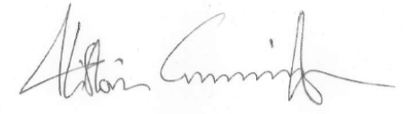
  - The Designation of the Hindon Neighbourhood Area is approved in accordance with section 61G of the Town and Country Planning Act 1990 as amended for the purposes of Neighbourhood Planning.

Alistair Cunningham Associate Director
Economic Development and Planning Dated: 05.11.2014
Appendix 1: Responses submitted to Wiltshire Council during the consultation on the application for designation of Hindon Neighbourhood Area.

Respondent | Comments
Ms Andi Witcombe,  National Farmers Union | The South West NFU welcomes the opportunity to comment on the Hindon Neighbourhood Area Application. The NFU represents approximately 50,000 Farmers and Growers nationally, 10,000 of these farm in the South West. In Wiltshire we represent 800 farmers and growers, including landowners and tenants, from all sectors and commodities. The NFU, and our members, recognise the importance of the Neighbourhood Plan and overall are supportive by the approach given. Our response is set out below along with some key priorities.
 | As you will be aware the farming community continues to face formidable challenges with increasing regulation, volatile markets and fluctuating farming returns. In response to these challenges farmers have had to consider the resources available to them and look at new ways of developing their businesses so that they can grow and remain competitive. This might include the need for modern agricultural buildings to meet regulations or to change the use of existing buildings in order to respond to changing market demand, for example.
 | Our members in Hindon area are no exception and given that the area is largely farmed it is clear that any form of Neighbourhood Plan must adequately address the issues and opportunities of farming. Our vision for the area is:
 | Hindon Parish is a sustainable rural community that is underpinned by an innovative rural economy and thriving farming and food industry, which is profitable and supports viable livelihoods, underpins sustainable and healthier communities and enhances the environmental assets that are vital to the counties prosperity.
 | For the farming community this vision is to be achieved by the following themes
- Strengthening our farming businesses to help them build profitability and respond to new opportunities
- To create thriving localities that meets the needs of their communities, businesses and their environment.
- Realising the value of the region’s environmental assets
 | In addition we would see some of the key priorities for farms to include (not in order of priority):
- The ability for the next generation to take on management of farms and to support this through the provision of affordable housing to allow succession
- Develop farming enterprises that can meet the challenges of food security through modernising and becoming more efficient
- Diversifying farming enterprises to meet new opportunities such as, inter alia , business units or tourism
- Developing renewable energy which meets the needs of the farm and are appropriate to the location and renewable resources available
- Access to high-speed broadband.
 | Food production is a key priority for economic growth both nationally but also, importantly, in a rural area such as Hindon Parish. In the Government white paper ‘Local Growth: realising every place’s potential’ the Coalition Government makes clear that the first priority “is to return the nation’s economy to health ”. This includes creating, “the conditions that will help business and gets the economy growing” and this includes the support for farming enterprises so vital to the rural economy and enabling them to remain viable through crop or livestock production, and also diversified enterprises. We would expect that any proposals for developing farms will take this into account.
Diversification is in line with National Planning Policy Framework (NPPF) that provides that local authorities should support development that enables farmers to become more competitive and sustainable and diversify into new opportunities. A key message within the NPPF is the need for economic growth. “A positive planning system is essential, because without growth, a sustainable future cannot be achieved. Therefore, significant weight should be placed on the need to support economic growth through the planning system…the default answer to development proposals is yes.”

In the NPPF the government makes a number of very important statements related to this the development of renewable energy. Paragraphs 95 to 98 make a number key points including:

‘local planning authorities should recognise the responsibility on all communities to contribute to energy generation from renewable or low carbon sources’ (para 97); ‘have a positive strategy to promote energy from renewable and low carbon sources’ which
‘maximise renewable and low carbon energy sources’ . Renewable energy represents an important opportunity for farms to reduce their energy bills and also to create revenue that can help support farming activity. We understand that this can be a contentious issue within communities and are aware that early consultation with those that are either impacted or likely to gain is crucial.

To help guide any work we have developed some principles which we believe will help Hindon Parish to shape activity in the area. These are:

- Food security is a crucial issue for now and the future and any actions must ensure that we do not compromise our ability to feed ourselves
- We should look to increase farm productivity and decrease impact on the environment
- The achievement of sustainable development in rural areas through the integration of environmental, social and economic objectives
- Meet the needs of a diverse rural population and ensure equality of opportunity.
- Maintain and enhance the areas natural asset base
- Farmers and landowners should always be consulted and listened to with regard to developing the area
- Support sustainable growth in the rural economy
- Sustainable farming will support the wider community
- Not one system of farming is the answer and all should be supported for maximum benefit to society and the environment
- Encourage links between rural areas and urban centres.

Many thanks for the opportunity to respond to this consultation, we hope that these comments are helpful and will be taken into account before the Plan is finalised.



DECISION REGARDING THE APPLICATION FOR DESIGNATION OF HINDON NEIGHBOURHOOD AREA UNDER SECTION 61(G) OF THE TOWN AND COUNTRY PLANNING ACT (AS AMENDED)

    - I have no private interests to declare in respect of this matter which would prevent me from determining this application.

    - I hereby exercise power under section 61G of the Town and Country Planning Act 1990 (as amended) (“the Act”) and all other powers delegated to me to designate the area identified on the map below as the Hindon Neighbourhood Area for the purposes of section 61G (1) of the Act) as I am satisfied that the area is an appropriate area to be designated as a neighbourhood area. I do not designate it as a business area for the purposes of section 61H
      - of the Act as it is not wholly or predominately business in nature.

- Name of neighbourhood area: Hindon Neighbourhood Area

- Map of neighbourhood area:
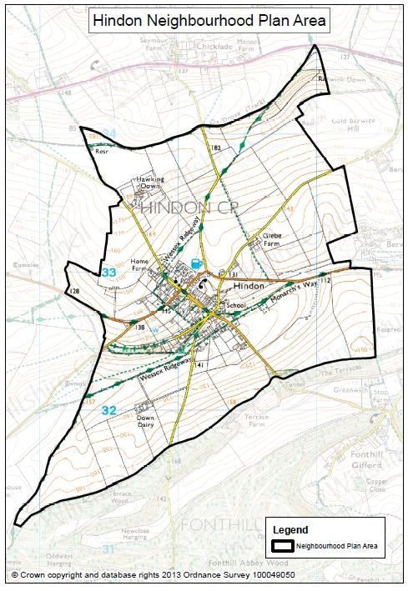
- Relevant body: Hindon Parish Council form the ‘relevant body’ (for the purposes of 61G(2) of the Town and Country Planning Act 1990)

- I have made this decision in line with the information set out in the ‘Neighbourhood Area Designation Application Report’.

Signed:
Alistair Cunningham Associate Director
Economic Development and Planning Decision published: 05.11.2014

