



Wiltshire Council Level 1 SFRA v5.0 i

Wiltshire Council

Level 1 Strategic Flood Risk Assessment

May 2019
www.jbaconsulting.com
JBA Project Manager

8a Castle Street Wallingford Oxfordshire OX10 8DL

Revision history

Revision Ref/Date | Amendments | Issued to
V1.0 09/10/2018 | Draft Report | Wiltshire Council
V2.0 11/01/2019 | Final Draft | Wiltshire Council / EA
V3.0 05/02/2019 | Consultation Draft | Wiltshire Council / EA / Stakeholders
V4.0 14/03/2019 | FINAL | Wiltshire Council
V5.0 21/05/2019 | Corrected Figure 9.1 | Wiltshire Council
Contract
This report describes work commissioned by Wiltshire Council in May 2018. Wiltshire Council’s representatives for the contract were
and of JBA Consulting carried out this work.

Prepared by ..................................

Analyst

....................................................

Assistant Analyst

Reviewed by ..................................

Purpose
This document has been prepared as

Technical Director

a Final Report for Wiltshire Council. JBA Consulting

accepts no responsibility or liability for any use that is made of this document other than by the Client for the purposes for which it was originally commissioned and prepared.
JBA Consulting has no liability regarding the use of this report except to Wiltshire Council.

Wiltshire Council Level 1 SFRA v5.0 i

Acknowledgements
JBA Consulting would like to thank Wiltshire Council, the Environment Agency, Southern Water, Thames Water and Wessex Water for their assistance with the preparation of this report.

Copyright
© Jeremy Benn Associates Limited 2019.

Carbon footprint
A printed copy of the main text in this document will result in a carbon footprint of 635g if 100% post-consumer recycled paper is used and 808g if primary-source paper is used. These figures assume the report is printed in black and white on A4 paper and in duplex.
JBA is aiming to reduce its per capita carbon emissions.

Wiltshire Council Level 1 SFRA v5.0 ii

Executive summary
Introduction
JBA Consulting was commissioned by Wiltshire Council to undertake a Level 1 Strategic Flood Risk Assessment (SFRA). Wiltshire Council are reviewing the Wiltshire Core Strategy (adopted in January 2015), with the reviewed Plan becoming the Wiltshire Local Plan in due course. The SFRA forms part of a comprehensive and robust evidence base for the Local Plan which will set out a vision and framework for development in Wiltshire up to 2036 and used to guide the sequential test and decisions on the location of future development. The SFRA will also be used to assess planning applications, and flood risk mapping information will be made available for developers for carrying out flood risk assessments.
SFRA objectives
The Planning Practice Guidance advocates a tiered approach to flood risk assessment and identifies the following two levels of SFRA:
- Level 1: where flooding is not a major issue and where development pressures are low. The assessment should be sufficiently detailed to allow application of the Sequential Test.
- Level 2: where land outside Flood Zones 2 and 3 cannot appropriately accommodate all the necessary development creating the need to apply the NPPF’s Exception Test. In these circumstances, the assessment should consider the detailed nature of the flood characteristics within a Flood Zone and assessment of other sources of flooding.
At this stage, a Level 1 SFRA has been prepared for Wiltshire Council. The key objectives of this Level 1 SFRA are:
- To take into account the latest flood risk policy and emerging guidance
- Take into account the latest flood risk information and available data
- To provide a comprehensive set of maps including, but not limited to:
  - Fluvial flood risk
  - Surface water flood risk
  - Groundwater flood risk
  - Sewer flood risk
  - Canals and reservoirs flood risk
  - Historic flood records
  - Flood warning coverage
The SFRA also considers the impact of climate change on flood risk in the future and contains an assessment of the cumulative impact of development.
Summary of Level 1 Assessment
The SFRA has considered all sources of flooding including fluvial, surface water, groundwater, sewers, canals and reservoirs within the study area.
Fluvial flood risk is present in a number of settlements in Wiltshire from the major rivers in the study area such as the River Thames in the north, Bristol Avon in the west, River Kennet in the east and Hampshire Avon in the south of Wiltshire. Overall fluvial flood risk is in close proximity to watercourses, with a few areas of more extensive floodplain associated with the River Thames around Cricklade.

Wiltshire Council Level 1 SFRA v5.0 iii

Surface water flooding is shown to correlate with small watercourses and urban areas throughout Wiltshire. Groundwater flood risk is shown to vary across Wiltshire, with areas of increased groundwater risk around Salisbury due to the underlying chalk geology.
The effect of climate change has been assessed. In most catchments, the extent of Flood Zone 3 is not likely to increase significantly with climate change. Climate change is predicted to result in more frequent and extreme rainfall events, increasing the frequency and severity (depth/hazard) of flooding from fluvial and surface water sources.
Detail in section 5 is given on how flood risk is assessed for planning using the Flood Zones and explains the Sequential Approach. It outlines the sources of national and local flood risk mapping data, information and evidence that has been available for use in this SFRA.
Guidance for planners and developers
Section 6 introduces guidance aimed at both planners and developers. The guidance should be read in conjunction with the NPPF and flood risk guidance from the Environment Agency. The guidance addresses: requirements for development in each of the Flood Zones, making development safe, river restoration and enhancement as part of development, dealing with existing watercourses and assets, developer contributions to flood risk improvements, dealing with surface water runoff and drainage, wastewater, water quality and biodiversity.
Use of SFRA data
It is important to recognise that the SFRA has been developed using the best available information at the time of preparation. This relates both to the current risk of flooding from rivers, and the potential impacts of future climate change.
The SFRA is a ‘living’ evidence document and hence will be periodically updated as appropriate when new information on flood risk, flood warning or new planning guidance or legislation becomes available. New information on flood risk may be provided by Wiltshire Council, the Environment Agency, Highways England, or the water companies.
Next steps
It is important to remember that information on flood risk is being updated continuously. As the Council moves forward with its Local Plan, they must use the most up to date information in the Sequential Test, and developers should be aware of the latest information for use in Flood Risk Assessments.
The Flood and Water Management Act (2010), the Localism Act (2011) and the National Planning Policy Framework (2018) all offer opportunities for a more integrated approach to flood risk management and development. As they are in the relatively early stages of developing a Local Plan, the Council have a real chance to make sure development provides improvements to flood risk overall and enhancements to the river environment.
Planning policies should focus on supporting the Lead Local Flood Authority (LLFA) in ensuring that all developments build Sustainable Drainage Systems (SuDS) into their design and ensure that, right from the concept stage, master planning integrates SuDS and makes space for water within the site design.

Wiltshire Council Level 1 SFRA v5.0 iv
v

Contents
1 | Introduction | 1
1.1 | Terms of Reference | 1
1.2 | Purpose of Strategic Flood Risk Assessment | 1
1.3 | Objectives | 1
1.4 | SFRA outputs | 2
1.5 | Approach | 3
1.6 | Consultation | 3
1.7 | SFRA user guide | 4
2 | The Planning Framework and Flood Risk Policy | 5
2.1 | Introduction | 5
2.1 | The Flood Risk Regulations (2009) | 5
2.2 | Flood Risk Management Plans | 6
2.3 | Catchment Flood Management Plans | 7
2.4 | Flood and Water Management Act (2010) | 10
2.5 | Regional Flood and Coastal Committee (RFCC) | 10
2.6 | Lead Local Flood Authorities (LLFAs) | 11
2.7 | Wiltshire Local Flood Risk Management Strategy | 12
2.8 | Planning Policy and Evidence Documents | 12
2.9 | Water Cycle Studies | 14
2.10 | Surface Water Management Plans (SWMPs) | 15
2.11 | Infrastructure Delivery Plan | 15
2.12 | Association of British Insurers Guidance | 16
2.13 | National Infrastructure Assessment | 16
2.14 | Drainage and Wastewater Management Plans | 17
2.15 | Sewers for Adoption version 8 | 17
2.16 | National Flood Resilience Review | 18
2.17 | Roles and Responsibilities in Wiltshire | 18
3 | How flood risk is assessed | 21
3.1 | Introduction | 21
3.2 | Definitions | 21
3.3 | How fluvial flood risk is assessed | 22
3.4 | How flood risk from other sources is assessed | 29
4 | Understanding flood risk in Wiltshire | 33
4.1 | Introduction | 33
4.2 | Topography | 33
4.3 | Geology and soils | 33
4.4 | Fluvial flood risk | 36
4.5 | Surface Water Flood Risk | 37
4.6 | Groundwater Flood Risk | 37
4.7 | Reservoir Flooding | 38
4.8 | Minerals and Waste in Wiltshire | 39
4.9 | Historical Flood Risk | 40
4.10 | Defences, assets and structures | 41
4.11 | Defences in key locations in Wiltshire | 42
5 | The sequential risk-based approach | 53
5.1 | Introduction | 53
5.2 | Applying the Sequential Test and Exception Test in the preparation of a local | plan 53

Wiltshire Council Level 1 SFRA v5.0

  - Applying the Sequential Test and Exception Test in the preparation of a Minerals and Waste Plan 56
  - Applying the Sequential Test and the Exception Test to individual planning applications 57
- Guidance for Planners and Developers: Flood Risk 58
  - When is an FRA required? 58
  - Requirements for Flood Risk Assessments 59
  - Assessing the Impact of Climate Change 60
  - Reducing Flood Risk through site layout and design 61
  - Mitigation Measures 61
  - Water Framework Directive and Natural Flood Risk Management 64
  - Existing watercourses and assets 65
- Guidance for planners and developers: Surface water runoff and drainage 67
  - Introduction 67
  - Local SuDS Design Guidance 67
  - Wastewater 70
  - Groundwater Quality 70
- Flood Warning and Emergency planning 73
  - Warning and Informing the Public 73
  - Response Activation Process 73
  - Emergency Planning 75
- Assessment of flood risk in potential development areas 76
  - Introduction 76
  - Site flood risk summary 76
  - Cumulative impact of development 76
- Development management recommendations 83
  - Overview 83
  - Development management policy 83
- Summary and conclusions 87
  - Summary 87
  - Use of SFRA data 87

Appendices

Appendix A | Community Areas
Appendix B | Flood Zones 2 and 3a
Appendix C | Flood Zone 3b
Appendix D | Impact of climate change on Flood Zone 3a
Appendix E | Risk of flooding from surface Water
Appendix F | Impact of climate change on risk of flooding from surface water
Appendix G | Risk of flooding from groundwater
Appendix H | Risk of flooding from reservoirs
Appendix I | Risk of flooding from sewers
Appendix J | Recorded flood history in Wiltshire
Appendix K | Flood Alert and Warning areas
Appendix L | Wiltshire Council Asset Register
Appendix M | Risk of flooding from canals and recorded incidents
Appendix N | Cumulative impact assessment results
Appendix O | Measures from the Flood Risk Management Plans covering Wiltshire
Appendix P | Level 1 site screening results

Wiltshire Council Level 1 SFRA v5.0 vi

Appendix Q | Recorded flood history
Appendix R | Stakeholder consultation

List of Figures
Figure 2.1 Flood Risk Regulation requirements | 5
Figure 2.2 Flood risk and the preparation of local plans | 13
Figure 2.3 Strategic planning links and key documents for flood risk | 20
Figure 3.1 Definition of Flood Zones | 23
Figure 4.1 Bedrock geology of Wiltshire | 34
Figure 4.2 Superficial geology of Wiltshire | 35
Figure 5.1 Flood risk hierarchy | 53
Figure 5.2 Applying the Sequential Test in preparation of a Local Plan | 54
Figure 5.3 Applying the Exception Test in the preparation of the Local Plan | 56
Figure 8.1 Wiltshire Council Summary Action Card | 74
Figure 9.1 Relative Flood Risk score by WFD catchment | 79
List of Tables
Table 2-1 Indicative number of properties at risk within Wiltshire (Bristol Avon) | 7
Table 2-2 Bristol Avon CFMP Policy areas covering Wiltshire | 7
Table 2-3 Indicative number of properties at risk in Wiltshire (Hampshire Avon) | 8
Table 2-4 Hampshire Avon CFMP policy areas covering Wiltshire | 9
Table 2-5 Indicative number of properties at risk in Wiltshire (Thames CFMP) | 10
Table 2-6 Thames CFMP policy areas covering Wiltshire | 10
Table 2-7 Number of "at risk" properties in 10 highest ranking settlements | 15
Table 2-8 Roles and responsibilities in Wiltshire | 19
Table 3-1 National Flood Zone descriptions, | 23
Table 3-2 Climate change allowances used in SFRA | 26
Table 3-3 Summary of EA models used within the SFRA and indicative timescales for model updates 27
Table 3-4 Peak rainfall intensity allowance for small and urban catchments (from 1961-1990 baseline) 30
Table 4-1 Settlements identified on Risk of Flooding from Reservoirs mapping 38
Table 9-1 Types of sites screened for flood risk 76
Table 9-2 Individual components of relative flood risk score 78
Table 9-3 Translating total score to cumulative impact score 78

Wiltshire Council Level 1 SFRA v5.0 vii
viii

Abbreviations
Term | Definition
AEP | Annual Event Probability
AIMS | Asset Information Management System (Environment Agency GIS database of assets)
CC | Climate change - Long term variations in global temperature and weather patterns caused by natural and human actions.
CDA | Critical Drainage Area - A discrete geographic area (usually a hydrological catchment) where multiple and interlinked sources of flood risk (surface water, groundwater, sewer, main river and/or tidal) cause flooding in one or more Local Flood Risk Zones during severe weather thereby affecting people, property or local infrastructure.
CFMP | Catchment Flood Management Plan- A high-level planning strategy through which the Environment Agency works with their key decision makers within a river catchment to identify and agree policies to secure the long-term sustainable management of flood risk.
CIRIA | Construction Industry Research and Information Association
CRT | Canal and River Trust
CSO | Combined sewer overflow
Defra | Department for Environment, Food and Rural Affairs
DWMP | Drainage and Wastewater Management Plan
EA | Environment Agency
EU | European Union
FFL | Finished floor level
Flood defence | Infrastructure used to protect an area against floods as floodwalls and embankments; they are designed to a specific standard of protection (design standard).
Flood Risk Area | An area determined as having a significant risk of flooding in accordance with guidance published by Defra and WAG (Welsh Assembly Government).
Flood Risk Regulations | Transposition of the EU Floods Directive into UK law. The EU Floods Directive is a piece of European Community (EC) legislation to specifically address flood risk by prescribing a common framework for its measurement and management.
Fluvial Flooding | Flooding resulting from water levels exceeding the bank level of a main river
FRA | Flood Risk Assessment - A site specific assessment of all forms of flood risk to the site and the impact of development of the site to flood risk in the area.
FRMP | Flood Risk Management Plan
FWMA | Floods and Water Management Act - Part of the UK Government's response to Sir Michael Pitt's Report on the Summer 2007 floods, the aim of which is to clarify the legislative framework for managing surface water flood risk in England.
FZ | Flood Zone
GIS | Geographic Information Systems
Ha | Hectare
IDB | Internal Drainage Board
IPR | Intellectual Property Rights
JBA | Jeremy Benn Associates
LFRMS | Local Food Risk Management Strategy
LLFA | Lead Local Flood Authority - Local Authority responsible for taking the lead on local flood risk management
LLPG | Local Land and Property Gazetteer
LPA | Local Planning Authority

Wiltshire Council Level 1 SFRA v5.0
ix

Term | Definition
Main River | A watercourse shown as such on the Main River Map, and for which the Environment Agency has permissive powers, but the riparian owner has the responsibility of maintenance.
MHCLG | Ministry for Housing, Communities, and Local Government
NIC | National Infrastructure Commission
NPPF | National Planning Policy Framework
OAN | Objectively Assessed Need
Ordinary Watercourse | All watercourses that are not designated Main River. Local Authorities or, where they exist, Internal Drainage Boards (IDBs) have similar permissive powers as the Environment Agency in relation to flood defence work. However, the riparian owner has the responsibility of maintenance.
OS | Ordnance Survey
PDL | Previously Developed Land
PFRA | Preliminary Flood Risk Assessment
Pitt Review | Comprehensive independent review of the 2007 summer floods by Sir Michael Pitt, which provided recommendations to improve flood risk management in England.
Pluvial flooding | Flooding as a result of high intensity rainfall when water is ponding or flowing over the ground surface (surface runoff) before it enters the underground drainage network or watercourse or cannot enter it because the network is full to capacity.
PPG | National Planning Policy Guidance
Resilience Measures | Measures designed to reduce the impact of water that enters property and businesses; could include measures such as raising electrical appliances.
Risk | In flood risk management, risk is defined as a product of the probability or likelihood of a flood occurring, and the consequence of the flood.
Return Period | Is an estimate of the interval of time between events of a certain intensity or size, in this instance it refers to flood events. It is a statistical measurement denoting the average recurrence interval over an extended period of time.
RMA | Risk Management Authority
RoFSW | Risk of Flooding from Surface Water map. Environment Agency national map showing risk of flooding from surface water.
SA | Sustainability Appraisal
Sewer flooding | Flooding caused by a blockage or overflow in a sewer or urban drainage system.
SHELAA | Strategic Housing and Economic Land Availability Assessment
SHLAA | Strategic Housing Land Availability Assessment - The Strategic Housing Land Availability Assessment (SHLAA) is a technical piece of evidence to support local plans and Sites & Policies Development Plan Documents (DPDs). Its purpose is to demonstrate that there is a supply of housing land in the authority area which is suitable and deliverable.
SfA | Sewers for Adoption
SFRA | Strategic Flood Risk Assessment
SoP | Standard of Protection - Defences are provided to reduce the risk of flooding from a river and within the flood and defence field standards are usually described in terms of a flood event return period. For example, a flood embankment could be described as providing a 1 in 100-year standard of protection.
SPD | Supplementary Planning Document
SuDS | Sustainable Drainage Systems - Methods of management practices and control structures that are designed to drain surface water in a more sustainable manner than some conventional techniques
Surface water | Flooding from surface water runoff as a result of high intensity rainfall when water is ponding or flowing over the ground surface before it enters the underground drainage

Wiltshire Council Level 1 SFRA v5.0
x

Term | Definition
flooding | network or watercourse or cannot enter it because the network is full to capacity, thus causing what is known as pluvial flooding.
SWMP | Surface Water Management Plan - The SWMP plan should outline the preferred surface water management strategy and identify the actions, timescales and responsibilities of each partner. It is the principal output from the SWMP study.
UKWIR | UK Water Industry Research
WCS | Water Cycle Study
WFD | Water Framework Directive
WRMP | Water Resource Management Plan

Wiltshire Council Level 1 SFRA v5.0

1 Introduction
  - Terms of Reference
JBA Consulting was commissioned by Wiltshire Council to undertake a Level 1 Strategic Flood Risk Assessment (SFRA). Wiltshire Council are reviewing the Wiltshire Core Strategy (adopted in January 2015), with the reviewed Plan becoming the Wiltshire Local Plan. The SFRA forms part of a comprehensive and robust evidence base for the Local Plan which will set out a vision and framework for development in Wiltshire up to 2036 and will be used to inform the sequential test and decisions on the location of future development. The SFRA will also be used to assess planning applications, and flood risk mapping information will be made available for developers for carrying out flood risk assessments.

  - Purpose of Strategic Flood Risk Assessment

    - Levels of SFRA
The Planning Practice Guidance1 advocates a tiered approach to risk assessment and identifies the following two levels of SFRA:
      - Level 1: where flooding is not a major issue and where development pressures are low. The assessment should be sufficiently detailed to allow application of the Sequential Test to the location of development and to identify whether development can be allocated outside high and medium flood risk areas, based on all sources of flooding, without application of the Exception Test.
      - Level 2: where a Level 1 Assessment shows that land outside flood risk areas cannot appropriately accommodate all the necessary development, creating the need to apply the NPPF’s Exception Test. In these circumstances, the assessment should consider the detailed nature of the flood characteristics within a Flood Zone including probability, depth, velocity, rate of onset and duration.

  - Objectives
Wiltshire requires a Level 1 SFRA. The key objectives of the level 1 SFRA are:
To take into account the latest flood risk policy and emerging guidance
To ensure the SFRA is up to date with key changes in policy and guidance that have occurred since the existing SFRA was updated in 2013, which include:
- Changes to legislation and guidance, both relating to flood risk and planning policy, such as the National Planning Policy Framework (NPPF) (2012, revised in 2018)2
- Guidance published in April 20153 regarding the role of lead local flood authorities (LLFAs) local planning authorities (LPAs) and the Environment Agency (EA) with regards to SuDS approval

—————————————————————————————————————————————
1 Planning Practice Guidance: Flood Risk and Coastal Change, Department for Communities and Local Government (2015), Accessed online at:
http://planningguidance.planningportal.gov.uk/blog/guidance/flood-risk-and-coastal-change/ on: 17/09/2018 2 National Planning Policy Framework, UK Government (2018). Accessed online at:
https://www.gov.uk/government/uploads/system/uploads/attachment_data/file/6077/2116950.pdf on: 17/09/2018
- Further changes to statutory consultee arrangements for the planning application process - Government Response to Consultation, UK Government, (2015). Accessed online at: https://www.gov.uk/government/uploads/system/uploads/attachment_data/file/429166/Final_Statutory_Consultee_ Consultation_Response.pdf on: 19/09/2018

Wiltshire Council Level 1 SFRA v5.0 1

  - Changes to technical guidance, for example Defra's Non-statutory technical standards for sustainable drainage systems4 (March 2015), NPPF Planning Practice Guidance replacing PPS25 and PPG25, and CIRIA SuDS Manual C753 (2015)5
  - Latest guidance on climate change allowances for flood risk assessments released by the Environment Agency in February 20166
  - Wiltshire Council Groundwater Strategy7
  - The 2018 National Infrastructure Assessment8.
  - The new commitment of the water industry to prepare transparent and consistent Drainage and Wastewater Management Plans by 2022.9
It is important to note that policy is subject to change and as a result, this is considered a living document.
Take into account the latest flood risk information and available data including:
  - Updated fluvial modelling
  - Risk of Flooding from Surface Water (RoFSW)
  - JBA Risk of Flooding from Groundwater map
To provide a comprehensive set of maps including, but not limited to:
  - Fluvial flood risk
  - Surface water risk
  - Groundwater risk
  - Sewer flooding risk
  - Canals and reservoirs
  - Historic flooding records
  - Flood warning coverage
The mapping has been organised by the 20 Community Areas used to sub-divide Wiltshire into local, settlement-based areas. Appendix A provides an overview of these areas.

  - SFRA outputs
To meet the objectives, the following outputs have been prepared:
- Appraisal of all potential sources of flooding, including Main River, Ordinary Watercourse, surface water and groundwater.
- Updated review of historical flooding incidents recorded by all Risk Management Authorities (RMAs).
- Mapping of location and extent of functional floodplain (flood zone 3b).

—————————————————————————————————————————————
- Non-statutory technical standards for sustainable drainage systems, DEFRA (2015). Accessed online at: https://www.gov.uk/government/uploads/system/uploads/attachment_data/file/415773/sustainable-drainage- technical-standards.pdf on: 17/09/2018
- SuDS Manual C753, CIRIA (2015). Accessed online at: http://www.ciria.org/Resources/Free_publications/SuDS_manual_C753.aspx on: 17/09/2018
- Flood risk assessments: climate change allowances, Environment Agency (2016). Accessed online at: https://www.gov.uk/guidance/flood-risk-assessments-climate-change-allowances on: 17/09/2018
- Wiltshire Council Groundwater Management Strategy, Wiltshire Council (2016). Accessed online at: https://cms.wiltshire.gov.uk/documents/s149234/FR02WiltshireCouncilGroundwaterManagementStrategy2016.pdf on: 02/01/2019
- National Infrastructure Assessment, National Infrastructure Commission (2018). Accessed online at: https://www.nic.org.uk/wp-content/uploads/CCS001_CCS0618917350-001_NIC-NIA_Accessible.pdf on: 07/01/2019.
- A framework for the production of Drainage and Wastewater Management Plans, UK Water Industry Research (2018). Accessed online at:
http://www.water.org.uk/wp-content/uploads/2018/12/Water-UK-DWMP-Framework-Report-Main-Document.pdf on: 07/01/2019.
Wiltshire Council Level 1 SFRA v5.0 2

  - Reporting on the standard of protection provided by existing flood risk management infrastructure.
  - An assessment of the potential increase in flood risk due to climate change.
  - An assessment of areas at risk from other sources of flooding, for example surface water or reservoirs.
  - An assessment of existing flood warning and emergency planning procedures, including an assessment of safe access and egress during an extreme event.
  - Recommendations of the criteria that should be used to assess future development proposals and the development of a Sequential Test and sequential approach to flood risk.

  - Approach

    - General assessment of flood risk
The flood risk management hierarchy underpins the risk-based approach and is the basis for making all decisions involving development and flood risk. When using the hierarchy, account should be taken of:
      - the nature of the flood risk (the source of the flooding);
      - the spatial distribution of the flood risk (the pathways and areas affected by flooding);
      - climate change impacts; and
      - the degree of vulnerability of different types of development (the receptors).
Development proposals should be guided by the application of the Sequential Test using the maps produced for this SFRA. The information in this SFRA should be used as evidence and, where necessary, reference should also be made to relevant evidence in other documents detailed in this report. The Flood Zone maps and flood risk information on other sources of flooding contained in this SFRA should be used where appropriate to apply the Sequential Test.
Where other sustainability criteria outweigh flood risk issues, the decision-making process should be transparent. Information from this SFRA should be used to justify decisions to allocate land in areas at high risk of flooding.

    - Technical assessment of flood hazards
Flood risk has been assessed using results from detailed computer models supplied by the Environment Agency and existing broad scale Environment Agency Flood Zone mapping. The following detailed models inform the flood risk information within the study area:
      - Environment Agency Fluvial (river) models (see section 3.3.5 for full list)
      - Environment Agency surface water (rainfall) models
      - Risk of Flooding from Surface Water map (2016)
      - Risk of Flooding from Reservoirs
      - JBA Consulting Groundwater Flood Risk
      - Risk of flooding from groundwater using records and models
      - Indicative areas of risk from canal breach

  - Consultation
As part of the "duty to cooperate" set out in the Localism Act 2011 (see section 2.8.3), an informal consultation was carried out involving all neighbouring Local Planning Authorities, Risk Management Authorities with a role in flood risk management within Wiltshire, and other key stakeholders with a role in planning. The draft Level 1 SFRA was provided with

Wiltshire Council Level 1 SFRA v5.0 3

a request for comments. All comments received, and follow-up actions, are recorded in Appendix R.

  - SFRA user guide
Section | Contents
1. Introduction | Provides a background to the study, defines objectives, outlines the approach adopted and the consultation performed.
2. The Planning Framework and Flood Risk Policy | Includes information on the implications of recent changes to planning and flood risk policies and legislation, as well as documents relevant to the study.
Level 1 Strategic Flood Risk Assessment
3. How flood risk is assessed | Introduces the assessment of flood risk and provides an overview of the characteristics of flooding affecting the area. Provides a summary of responses that can be made to flood risk, together with policy and institutional issues that should be considered.  Provides an overview of flooding and risk, Flood Zones, and what they mean.
4. Understanding flood risk in the Authority's area | Introduces the assessment of flood risk and provides an overview of the characteristics of flooding affecting the area. Provides a summary of responses that can be made to flood risk, together with policy and institutional issues that should  be considered.
5. The Sequential, risk- based approach | Describes the Sequential approach and application of Sequential and Exception Tests.  Describes the modelling and data used for the assessment. Outlines mapping that should be used for the Sequential and Exception Tests
6. FRA requirements and guidance for developers | Identifies the scope of the assessments that must be submitted in FRAs supporting applications for new development.  Provides guidance for developers and outlines conditions set by the LLFA that should be followed.
7. Surface water management and SuDS | Advice on managing surface water runoff and flooding
8. Flood warning and emergency planning | Outlines the flood warning service in the Councils' areas and provides advice for emergency planning, evacuation plans and  safe access and egress.
9. Assessment of flood risk in potential development areas | Summary of flood risk to sites identified in the Local Plan Process
10. Development Management recommendations | Sets out recommendations for considering and assessing flood risk in the Council’s areas.
Summary and recommendations
11. Summary | Reviews Level 1 SFRA and provides recommendations

Wiltshire Council Level 1 SFRA v5.0 4
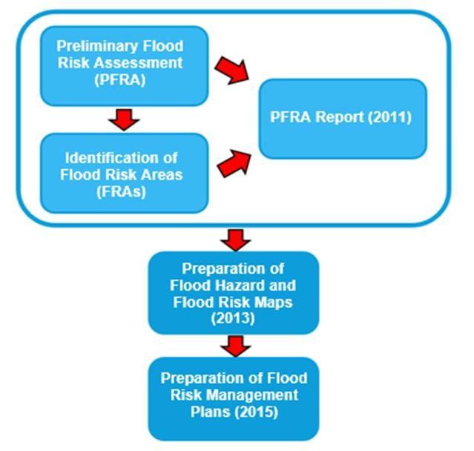

2 The Planning Framework and Flood Risk Policy
2.1 Introduction
The overarching aim of development and flood risk planning policy in the UK is to ensure that the potential risk of flooding is considered at every stage of the planning process. This section of the SFRA provides an overview of the planning framework, flood risk policy and flood risk responsibilities. In preparing the subsequent sections of this SFRA, appropriate planning and policy amendments have been acknowledged and considered.

  - The Flood Risk Regulations (2009)
The Flood Risk Regulations (2009) were intended to translate the current EU Floods Directive into UK law and place responsibility upon Lead Local Flood Authorities (LLFAs) to manage local flood risk. Under the Regulations, the responsibility for flooding from rivers, the sea and reservoirs lie with the Environment Agency; and responsibility for local sources of flooding, from surface water, groundwater and ordinary watercourses, rests with LLFAs.
Figure 2.1 below illustrates the steps that have / are being taken to implement the requirements of the EU Directive in the UK via the Flood Risk Regulations.

Figure 2.1 Flood Risk Regulation requirements
Under this action plan in accordance with the Regulations, LLFAs are required to prepare a Preliminary Flood Risk Assessment (PFRA) report. This is a high-level report assessing historic flood incidents and the probability of future flooding within the administrative area. The first PRFA for Wiltshire was produced in 201110, and updated in 201711, as part of a six-year reporting cycle.

—————————————————————————————————————————————
- Preliminary Flood Risk Assessment, Wiltshire Council (2011). Accessed online at: http://webarchive.nationalarchives.gov.uk/20140328094443/http://www.environment- agency.gov.uk/research/planning/135540.aspx on: 25/06/2018
- Preliminary Flood Risk Assessment (Addendum), Wiltshire Council (2017). Accessed online at: https://assets.publishing.service.gov.uk/government/uploads/system/uploads/attachment_data/file/698754/PFRA_Wi ltshire County_Council_2017.pdf on: 25/06/2018
Wiltshire Council Level 1 SFRA v5.0 5

    - Wiltshire Preliminary Flood Risk Assessment (PFRA)
A Preliminary Flood Risk Assessment (PFRA) is an assessment of historic and future flooding from sources of local flood risk, i.e. surface water, groundwater and ordinary watercourses. It identifies flood risk areas of national significance, to inform the Environment Agency and lead local flood authority planning cycles.
No Flood Risk Areas of national significance were identified by the Environment Agency within Wiltshire, and no significant flood risk areas as defined in accordance with the regulations and published guidance were identified.
Following commencement of the second Planning Cycle of the Flood Risk Regulations (2009), the Wiltshire PFRA was updated with an addendum produced in 201712. There was no change in the statements made in the 2011 PFRA13.

  - Flood Risk Management Plans
Flood Risk Management Plans (FRMPs) are required under the Flood Risk Regulations and highlight the hazards and risks of flooding from rivers, the sea, surface water, groundwater and reservoirs. FRMPs provide catchment scale flood risk planning and set out how RMAs work together with communities to manage flood risk.
The draft FRMPs were prepared by the Environment Agency in 2015, in partnership with LLFAs and other RMAs, and co-ordinated flood risk management planning with river basin management planning required under the Water Framework Directive. Wiltshire is covered by the South West River Basin District FRMP, the Thames River Basin District and the Severn River Basin District.
The current plans run for six years, to 2021. Progress is monitored by the Environment Agency, and delivery is carried out in partnership with other RMAs, including LLFAs, through forums including the Regional Flood and Coastal Committees (RFCCs) and Catchment Partnerships.

    - South West River Basin District14
The South West River Basin district is divided into nine management catchments, with the Avon Hampshire catchment covering part of Wiltshire. The source of the rivers in this catchment is predominantly from chalk aquifers. They therefore react slowly to rainfall as rainwater soaks into the ground and travels underground through the aquifer before it reaches the river. Following prolonged periods of wet weather, the ground may become saturated and the resulting flooding may last for several weeks. This may be particularly true for Salisbury and surrounding villages. Appendix O.1 contains a summary of the measures within the South West River Basin district that cover Wiltshire.

    - Thames River Basin District15
The Thames River Basin District is subdivided into smaller catchments with the Gloucester and the Vale catchment covering the upper Thames near Cricklade, and the Kennet and Tributaries catchment covering the area around Marlborough. A summary of measures planned within this river basin district is contained in Appendix O.2.

—————————————————————————————————————————————
- Preliminary Flood Risk Assessment: Wiltshire - 2017 addendum, Wiltshire Council (2017). Available at: https://assets.publishing.service.gov.uk/government/uploads/system/uploads/attachment_data/file/698754/PFRA_Wi ltshire County_Council_2017.pdf on: 06/07/2018
- Preliminary Flood Risk Assessment for Wiltshire Council, Wiltshire Council (2011). Accessed online at: http://webarchive.nationalarchives.gov.uk/20140328094443/http://www.environment- agency.gov.uk/research/planning/135540.aspx on: 06/07/2018
- South West river basin district flood risk management plan, Environment Agency (2015). Accessed online at: https://www.gov.uk/government/publications/south-west-river-basin-district-flood-risk-management-plan on: 17/09/2018
- Thames River Basin District FRMP, Environment Agency (2016). Accessed online at: https://www.gov.uk/government/publications/thames-river-basin-district-flood-risk-management-plan on: 17/09/2018

Wiltshire Council Level 1 SFRA v5.0 6

    - Severn River Basin District16
The Severn River Basin District is subdivided into ten catchments, with the Bristol Avon & North Somerset Streams catchment covering the north west of Wiltshire including Bradford on Avon, Chippenham and Trowbridge. A summary of measures in this river basin district is included in Appendix O.3

    - River Basin Management Plans and the Water Framework Directive
The Water Framework Directive (WFD) is a European Union directive for the protection of inland surface waters, groundwaters, estuaries and coastal waters. Its objectives include the aim to achieve good status for all water bodies, or good ecological potential and good surface water chemical status for heavily modified water bodies and artificial water bodies. Such considerations need to be accounted for when considering development proposals.

  - Catchment Flood Management Plans
Catchment Flood Management Plans (CFMP) are high level policy documents covering large river basin catchments. They aim to set policies for sustainable flood risk management for the whole catchment covering the next 50 to 100 years.
Wiltshire is covered by three CFMPs; Hampshire Avon CFMP, the Bristol Avon CFMP, and the Thames CFMP.

    - Bristol Avon17
In the Bristol Avon CFMP area, around a third of the people at risk of a 1% annual probability (AEP) flood are in Bristol. Although a substantial area is at risk from fluvial flooding, surface water and groundwater flooding are also recognised. Utilising a 20% increase in peak flow in all watercourses, it is estimated that by 2011, around 20,000 properties will be at risk from a 1% AEP flood. The number of properties at risk in significant settlements in the Bristol Avon CFMP area within Wiltshire is summarised in Table 2-1.
Table 2-1 Indicative number of properties at risk within Wiltshire (Bristol Avon)

CFMP Area | Locations | Indicative number of properties at risk
Bristol Avon | Melksham | 100 to 500
Bristol Avon | Bradford-on-Avon, Calne, Malmesbury, Trowbridge | 50 to 100
Bristol Avon | Chippenham | 25 to 50

The Bristol Avon catchment is split into sub-areas with similar flood risk types. The policies relating to Wiltshire are summarised in Table 2-2 below.
Table 2-2 Bristol Avon CFMP Policy areas covering Wiltshire

Sub Area | Settlements | Policy
3 - Upper Avon | Malmesbury | Policy 6 - "We will take action with others to store water or manage run-off in locations that provide overall flood risk reduction or environmental  benefits."
4 - Lower Avon | Properties are generally dispersed | Policy 3 - "We are generally managing existing flood risk effectively."
—————————————————————————————————————————————
- Severn River Basin District FRMP, Environment Agency (2016). Accessed online at: https://www.gov.uk/government/publications/severn-river-basin-district-flood-risk-management-plan on: 17/09/2018
- Bristol Avon: Catchment Flood Management Plan, Environment Agency (2012). Accessed online at: https://www.gov.uk/government/publications/bristol-avon-catchment-flood-management-plan on: 17/09/2018 Wiltshire Council Level 1 SFRA v5.0 7

Sub Area | Settlements | Policy
 | across region (no main settlements)
7- Wootton Basset and Dauntsey | Royal Wootton Basset and Dauntsey | Policy 3 - "We are generally managing existing flood risk effectively."
8 - Wiltshire Towns | Chippenham, Melksham, Corsham, Calne, Westbury and  Trowbridge | Policy 4 - "We are already managing the flood risk effectively, but we may need to take further actions to keep pace with  climate change."
9 - Bradford-on- Avon | Bradford-on-Avon | Policy 3 - "We are generally managing existing flood risk effectively."
(Note - Other sub-areas do not overlap study area).
Policy 3 - "This policy will tend to be applied where the risks are currently appropriately managed and where the risk of flooding is not expected to increase significantly in the future. However, we keep our approach under review, looking for improvements and responding to new challenges or information as they emerge. We may review our approach to managing flood defences and other flood risk management actions, to ensure that we are managing efficiently and taking the best approach to managing flood risk in the longer term."
Policy 4 - "This policy will tend to be applied where the risks are currently deemed to be appropriately-managed, but where the risk of flooding is expected to significantly rise in the future. In this case we would need to do more in the future to contain what would otherwise be increasing risk. Taking further action to reduce risk will require further appraisal to assess whether there are socially and environmentally sustainable, technically viable and economically justified options."
Policy 6 - "This policy will tend to be applied where there may be opportunities in some locations to reduce flood risk locally or more widely in a catchment by storing water or managing run-off. The policy has been applied to an area (where the potential to apply the policy exists) but would only be implemented in specific locations within the area, after more detailed appraisal and consultation."

    - Hampshire Avon18
The Hampshire Avon CFMP states the number of properties currently at risk as approximately 5,400. This may increase to 6,800 by the year 2100 once the impact of climate change is taken in account. However, the modelling used to predict this was based on a 20% increase in peak river flow by 2100. This is significantly less than the latest guidance from the EA. The number of properties at risk within significant settlements in the Hampshire Avon catchment is summarised in Table 2-3.
Table 2-3 Indicative number of properties at risk in Wiltshire (Hampshire Avon)

CFMP Area | Locations | Indicative number of properties at risk
Hampshire Avon | Salisbury | > 1,000
Hampshire Avon | Warminster | 100 to 500
Hampshire Avon | Downton, Shrewton | 25 to 50
Note: The indicative number of properties takes into account existing flood defences
The Hampshire Avon catchment is split into sub-areas with similar flood risk types. The policies relating to Wiltshire are summarised in Table 2-4.

—————————————————————————————————————————————
18 Hampshire Avon: Catchment Flood Management Plan, Environment Agency (2012). Accessed online at: https://www.gov.uk/government/publications/hampshire-avon-catchment-flood-management-plan on: 17/09/2018 Wiltshire Council Level 1 SFRA v5.0 8

Table 2-4 Hampshire Avon CFMP policy areas covering Wiltshire

Sub Area | Settlements | Policy
1 - River Bourne | Tidworth | Policy 4 - "Areas of low, moderate or high flood risk where we are already managing the flood risk effectively but where we  may need to take further actions to keep pace with climate change."
2 - Upper Avon and Wylye | Devizes, Pewsey, Warminster | Policy 6 - "Areas of low to moderate flood risk where we will take action with others to store water or manage run-off in locations that  provide overall flood risk reduction or environmental benefits."
3 - Warminster | Warminster | Policy 4 - "Areas of low, moderate or high flood risk where we are already managing the flood risk effectively but where we  may need to take further actions to keep pace with climate change."
4 - River Nadder | Tisbury | Policy 6 - "Areas of low to moderate flood risk where we will take action with others to store water or manage run-off in locations that  provide overall flood risk reduction or environmental benefits."
5 - Salisbury | Salisbury, Wilton | Policy 5 - "Areas of moderate to high flood risk where we can generally take further action to reduce flood risk."
6 - Lower Avon | Alderbury, Downton | Policy 4 - "Areas of low, moderate or high flood risk where we are already managing the flood risk effectively but where we  may need to take further actions to keep pace with climate change."
(Note - Sub-areas 7 and 8 (New Forest Streams and Christchurch) are not within the Wiltshire boundary)
Policy 4 – “This policy will tend to be applied where the risks are currently deemed to be appropriately-managed, but where the risk of flooding is expected to significantly rise in the future. In this case we would need to do more in the future to contain what would otherwise be increasing risk. Taking further action to reduce risk will require further appraisal to assess whether there are socially and environmentally sustainable, technically viable and economically justified options.”
Policy 5 – “This policy will tend to be applied to those areas where the case for further action to reduce flood risk is most compelling, for example where there are many people at high risk, or where changes in the environment have already increased risk. Taking further action to reduce risk will require additional appraisal to assess whether there are socially and environmentally sustainable, technically viable and economically justified options.”
Policy 6 – “This policy will tend to be applied where there may be opportunities in some locations to reduce flood risk locally or more widely in a catchment by storing water or managing run-off. The policy has been applied to an area (where the potential to apply the policy exists) but would only be implemented in specific locations within the area, after more detailed appraisal and consultation.”

Wiltshire Council Level 1 SFRA v5.0 9

    - Thames19
In total in the Thames CFMP, there are 135,000 properties with more than 1% chance of flooding however the risk is mainly centralised in London and the Lower Thames. Using broad scale modelling, it is estimated that the number of properties at a 1% risk of flooding will increase by approximately 20% due to climatic change. The estimated number of properties at risk in significant settlements within Wiltshire is shown in Table 2-5.

Table 2-5 Indicative number of properties at risk in Wiltshire (Thames CFMP)

CFMP Area | Locations | Indicative number of properties at risk
Thames | Wiltshire | 250 to 500

The Thames catchment is split into sub-areas with similar flood risk types. The policies relating to Wiltshire are summarised in Table 2-6.
Table 2-6 Thames CFMP policy areas covering Wiltshire

Sub Area | Settlements | Policy
1 - Towns and villages in open flood plain (north and west) | Marlborough | Policy 6 - Areas of low to moderate flood risk where the EA will act with others to store water or manage runoff in locations that provide overall flood risk  reduction or environmental benefits.

Policy 6 – “This policy will tend to be applied where there may be opportunities in some locations to reduce flood risk locally or more widely in a catchment by storing water or managing run-off. The policy has been applied to an area (where the potential to apply the policy exists) but would only be implemented in specific locations within the area, after more detailed appraisal and consultation.”

  - Flood and Water Management Act (2010)
The Flood and Water Management Act (FWMA) (2010) aimed to create a simpler and more effective means of managing both flood risk and coastal erosion and implement Sir Michael Pitt's recommendations following his review of the 2007 floods20. The FWMA received Royal Assent in April 2010.

  - Regional Flood and Coastal Committee (RFCC)
There are twelve Regional Flood and Coastal Committee’s established under the FWMA, with the Wessex RFCC covering most of Wiltshire, and the Thames RFCC covering the north of Wiltshire (Cricklade and Marlborough). The purpose of these committees is:
- To ensure there are coherent plans for identifying, communicating and managing flood and coastal risks across catchments and shorelines
- To encourage efficient, targeted and risk-based investment in flood and coastal risk management that represents value for money and benefits local communities

—————————————————————————————————————————————
19 Thames: Catchment Flood Management Plan, Environment Agency (2012). Accessed online at: https://www.gov.uk/government/publications/thames-catchment-flood-management-plan on: 17/09/2018 20 Cabinet Office (2007) The Pitt Review: Learning Lessons from the 2007 floods. Available at:
http://webarchive.nationalarchives.gov.uk/20100702215619/http://archive.cabinetoffice.gov.uk/pittreview/thepittrev iew/final_report.html on: 17/09/2018

Wiltshire Council Level 1 SFRA v5.0 10

- to provide a link between the Environment Agency, LLFAs, other risk management authorities, and other relevant bodies to build understanding of flood and coastal erosion risks in its area.
Details of the committee members, and contact details can be found here:
- Wessex RFCC21.
- Thames RFCC22

  - Lead Local Flood Authorities (LLFAs)
The duties of Wiltshire Council as LLFA include:
Lead responsibility for managing the risk of flooding from surface water, groundwater and ordinary watercourses (often described collectively as 'local flood risk').
- Local Flood Risk Management Strategy (LFRMS) (Section 9 of the FWMA): LLFAs must develop, maintain, apply and monitor an LFRMS to outline how to manage flood risk, identify areas vulnerable to flooding and target resources where they are needed most.
- Flood investigations (Section 19 of the FWMA): when appropriate and necessary LLFAs must investigate and report on flooding incidents. In Wiltshire, this is defined as “where five or more residential properties are flooded, or one or more non- residential, or where critical services or infrastructure are flooded. Other incidents may be investigated subject to resources.”
- Asset register (Section 21 of the FWMA): LLFAs must establish and maintain a register of structures or features which, in their opinion, are likely to have a significant effect on flood risk in the LLFA area, and a record of information about each structure or feature, including information about ownership and state of repair.
- Designation of features (Section 30, Schedule 1 of the FWMA): LLFAs may exercise powers to designate structures and features that affect flood risk, requiring the owner to seek consent from the authority to alter, remove or replace it.
- Consenting (Section 23 of the Land Drainage Act 199123): Where appropriate, LLFAs, acting as the Land Drainage Authority, will perform consenting of works on ordinary watercourses.
On 18 December 2014, a Written Ministerial Statement laid by the Secretary of State for Communities and Local Government set out changes to the planning process that would apply to major development from 6 April 2015. In considering planning applications, planning authorities should consult the LLFA on the management of surface water, and ensure, through use of planning conditions or obligations, that there are clear arrangements in place for ongoing maintenance over the lifetime of the development.
In March 2015, the LLFA was made a statutory consultee to the planning system, which came into effect on 15 April 2015. As a result, Wiltshire Council are required to provide technical advice on surface water drainage strategies and designs put forward for new major developments.
Major development is defined within the Town and Country Planning Order 201524 as:
- The winning and working of minerals or the use of land for mineral-working deposits;
- Waste development;
—————————————————————————————————————————————
21 Wessex Regional Flood and Coastal Committee, UK Government (2018). Accessed online at: https://www.gov.uk/government/groups/wessex-regional-flood-and-coastal-committee on: 08/10/2018 22 Thames Regional Flood and Coastal Committee, UK Government (2018). Accessed online at: https://www.gov.uk/government/groups/thames-regional-flood-and-coastal-committee on: 02/01/2019 23 HMSO (1991) Land Drainage Act 1991. Accessed online at https://www.legislation.gov.uk/ukpga/1991/59/contents on 04/02/2019
- The Town and Country Planning (Development Management Procedure) (England) Order 2015, UK Government (2015). Accessed online at:
http://www.legislation.gov.uk/uksi/2015/595/article/2/made on: 26/09/2018
Wiltshire Council Level 1 SFRA v5.0 11

- The provision of dwelling houses where –
  - the number of dwelling houses to be provided is 10 or more; or
  - the development is to be carried out on a site having an area of 0.5 hectares or more and it is not known where the development falls within sub-paragraph (c)(i);
- the provision of a building or buildings where the floor space to be created by the development is 1,000 square metres or more; or
- development carried out on a site having an area of 1 hectare or more.

  - Wiltshire Local Flood Risk Management Strategy
Under the Flood and Water Management Act (2010), Lead Local Flood Authorities are required to produce a Local Flood Risk Management Strategy (LFRMS). This document provides a framework for flood risk management within the boundary of the authority, setting policies and outlining a plan of deliverable actions.
The Wiltshire LFRMS was published in 201525 and has the following objectives:
- Improve knowledge regarding flood risk
- Improve protection from flooding
- Improve resilience to flooding
- Improve the environment
- Improve communications about flooding issues
The Wiltshire LFRMS is, at the time of writing, due for renewal, however Wiltshire Council has been advised, by the Environment Agency, to wait until the National FCERM Strategy is revised, so that the Local strategy can be aligned with it. The National FCERM Strategy consultation has been delayed as a result of the government priorities as the UK leaves the EU26.

  - Planning Policy and Evidence Documents

    - National Planning Policy Framework
The National Planning Policy Framework (NPPF)27 was issued on 27 March 2012 and updated on 24 July 2018 as part of reforms to, firstly, make the planning system less complex and more accessible, and secondly, to protect the environment, promote sustainable growth and replace most of the previously issued Planning Policy Guidance Notes (PPGs) and Planning Policy Statements (PPSs). The NPPF is a source of guidance for LPAs to assist in preparation of Local Plans, as well as for applicants preparing planning submissions.
Paragraphs 156 and 157 of the NPPF states that: "Strategic policies should be informed by a strategic flood risk assessment and should manage flood risk from all sources. They should consider cumulative impacts in, or affecting, local areas susceptible to flooding, and take account of advice from the Environment Agency and other relevant flood risk management authorities, such as lead local flood authorities and internal drainage boards. All plans should apply a sequential, risk-based approach to the location of development – taking into account the current and future impacts of climate change– so as to avoid, where possible, flood risk to people and property".

—————————————————————————————————————————————
- Local Flood Risk Management Strategy, Wiltshire Council (2015). Accessed online at: http://www.wiltshire.gov.uk/downloads/4287 on: 06/07/2018
- https://consult.environment-agency.gov.uk/fcrm/fcerm-national-strategy-info/
- National Planning Policy Framework, Ministry for Housing, Communities and Local Government (2018) Accessed online at: https://assets.publishing.service.gov.uk/government/uploads/system/uploads/attachment_data/file/728643/Revised_ NPPF_2018.pdf on: 26/09/2018

Wiltshire Council Level 1 SFRA v5.0 12
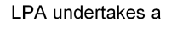
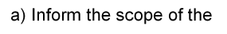

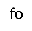
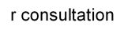


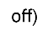
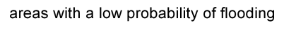
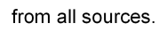


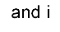
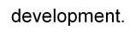





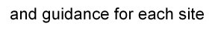
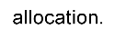




The web-based Planning Practice Guidance on Flood Risk and Coastal Change28 (henceforth referred to as 'the Planning Practice Guidance') was published alongside the NPPF and was most recently updated in November 2016. This is currently being updated to reflect the 2018 update to the NPPF. The guidance sets out how the policy should be implemented. A flow chart of how flood risk should be taken into account in the preparation of Local Plans is shown in Figure 2.2 below.

Figure 2.2 Flood risk and the preparation of local plans
Based on Diagram 1 of the Planning Practice Guidance: Flood Risk and Coastal Change (paragraph 004, Reference ID: 7-021-20140306).

—————————————————————————————————————————————
- Planning Practice Guidance: Flood Risk and Coastal Change, Department for Communities and Local Government (2015). Accessed online at:
http://planningguidance.planningportal.gov.uk/blog/guidance/flood-risk-and-coastal-change/ on: 26/09/2018

Wiltshire Council Level 1 SFRA v5.0 13

    - Updates to the NPPF
The NPPF was revised in 2018 to implement the 2017 planning and housing market reforms introduced within the Housing White Paper29. Following public consultation on the draft revised NPPF between March and May 2018, the Framework was published on 24 July 2018. Central to the reforms is the concept of ‘planning for the right homes in the right places.’ The key amendments with regards to development and flood risk, are as follows:
Clarification of the Exception Test (Paragraphs 157, 159-164)
Local Plans should not allocate land for development where it is not possible to meet the requirements of the Exception Test.
At the planning application stage, it may be necessary to reapply the Exception Test to individual allocated sites, which have undergone the Sequential Test. This may be due to the significant extent or nature of the flood risk identified to a site, or the age of the evidence base used to previously assess the site.
Minor Development and Changes of Use (Paragraph 164)
Minor development and change of use should not be subject to the Sequential and Exception Tests, but should still follow the requirements set out in Footnote 50 of the NPPF relating to the provision of a site-specific flood risk assessment, and ensuring that flood risk is not increased elsewhere.
Cumulative impact on flood risk (Paragraph 156)
Local Plans must be supported by a SFRA and provide policies for managing all sources of flood risk.
Planning policy on flood risk should address the cumulative flood risks associated with separate new developments which are located within, or affect, areas susceptible to flooding.
The Impacts of Climate Change (Paragraph 148-150, 157)
Where climate change is expected to increase flood risk, and lead to development becoming unsustainable in the future, opportunities should be taken to relocate development to more sustainable locations.

    - Localism Act
The Localism Act (2011) provides local communities with greater control in local decision- making, such as deciding the location of new homes and businesses, through the preparation of neighbourhood development plans. It requires local authorities to "engage constructively, actively and on an ongoing basis in any process by means of which development plan documents are prepared so far as relating to a strategic matter".
Neighbourhood Plans are the vehicle through which local communities are able to contribute to making decisions about the location and type of development, and the supporting infrastructure required to enable sustainable development within their areas. A Neighbourhood Plan is written by local people and communities with a mandate provided by Parish/Town Councils (the Qualifying Body), and "made" or adopted by the LPA, becoming part of the development plan for that LPA. To meet the Basic Conditions Tests that govern the examination of Neighbourhood Plans, the Qualifying Body should take national guidance into account and should demonstrate that their plan is in general conformity with the LPA's strategic planning policy.

  - Water Cycle Studies
Predicted future changes in climate and projected increases in new development can be expected to exert greater pressure on the existing waste water supply and infrastructure within settlements. Many new homes, for instance, may cause the existing water supply
—————————————————————————————————————————————
- Fixing our broken housing market, Ministry of Housing, Communities and Local Government (2017). Accessed online at:
https://www.gov.uk/government/publications/fixing-our-broken-housing-market on: 10/01/2019
Wiltshire Council Level 1 SFRA v5.0 14

infrastructure to become overwhelmed, which would result in adverse effects on the environment both locally and in wider catchments. Planning for water management therefore needs to take these potential challenges into account.
Water Cycle Studies (WCS) assist local authorities in selecting and developing sustainable development allocations, so that there is minimal impact on the environment, water quality, water resources, infrastructure and flood risk. In areas where there may be conflict between any proposed development and environmental requirements, this can be achieved through the recommendation of potential sustainable solutions.
A water cycle study has not been undertaken within Wiltshire, however WCSs have been completed in the neighbouring authorities of Swindon, Cotswold District and Vale of the White Horse District. None of the conclusions of these studies impact on the SFRA for Wiltshire.

  - Surface Water Management Plans (SWMPs)
SWMPs outline surface water issues in a given location, and the preferred options for managing the flood risk. SWMPs are undertaken, when required, by LLFAs in consultation with key local partners who are responsible for surface water management and drainage in their area. SWMPs establish a long-term action plan to manage surface water, and are intended to influence future capital investment, drainage maintenance, public engagement and understanding, land-use planning, emergency planning and future developments.
At a strategic level, there are approximately 18,000 properties at risk from surface water flooding within the administrative area of Wiltshire Council, based on the analysis undertaken as part of the PFRA process. The ten highest ranking settlements within Wiltshire are listed in Table 2-7 with their rank and number of properties at risk from surface water flooding. Wiltshire Council identified a requirement to undertake a SWMP focusing on strategically significant towns (Chippenham, Trowbridge and Salisbury) where significant future development is planned. This was published in 201130. However, it was recognised that other towns may require future investigations.
Table 2-7 Number of "at risk" properties in 10 highest ranking settlements

Settlement | Rank | Number of Properties at Risk | Settlement | Rank | Number of Properties at Risk
Salisbury | 1 | 1,476 | Warminster | 6 | 751
Chippenham | 2 | 1,192 | Calne | 7 | 652
Westbury | 3 | 1,174 | Corsham | 8 | 642
Trowbridge | 4 | 935 | Bradford on Avon | 9 | 445
Devizes | 5 | 866 | Melksham | 10 | 387

The intermediate assessment further analysed these areas and identified hotspots that are more likely to experience surface water flooding. It also identified whereby further assessment should be undertaken. Detailed assessments follow this stage and identify the causes and consequences of surface water flooding whilst testing the benefits and costs of mitigation measures. However, this level of study was not conducted in this SWMP and is therefore a required future action alongside any future review of evidence and investment priorities.

  - Infrastructure Delivery Plan
An Infrastructure Delivery Plan (IDP) identifies the infrastructure required for future growth, and schedule of delivery needed to meet anticipated service demands. In the county, the

—————————————————————————————————————————————
- Surface Water Management Plan: Focussing on Chippenham, Trowbridge and Salisbury, Wiltshire Council (2011). Accessed online at:
http://www.wiltshire.gov.uk/planningpolicy-wiltshire-swmp-phase-1-and-2-report.pdf on: 17/09/2017
Wiltshire Council Level 1 SFRA v5.0 15

IDP supports the Wiltshire Core Strategy (January 2015) and the Wiltshire Community Infrastructure Levy (CIL) Charging Schedule (May 2015). The IDP comprises of several chapters including education, sustainable transport, open space and green infrastructure, emergency services, health and social facilities, and utilities. The NPPF requires the council to address flood risk within the IDP through the assessment of quality and capacity of transport. Flood risk is specifically addressed in the 'Utilities' section of the IDP. The review of the Wiltshire Core Strategy will be undertaken in parallel with a review of the IDP to ensure that development proposals are appropriately supported in a timely manner through the provision of infrastructure.

  - Association of British Insurers Guidance
The Association of British Insurers (ABI) and the National Flood Forum have published guidance to assist local authorities in England in producing local plans and reviewing planning applications in flood risk areas. The guidance complements the National Planning Policy Framework, and provides the following key recommendations:
- Ensure strong relationships with technical experts on flood risk
- Consider flooding from all sources, taking account of climate change
- Take potential impacts on drainage infrastructure seriously
- Ensure that flood risk is mitigated to acceptable levels for proposed developments
- Make sure Local Plans take account of all relevant costs are regularly reviewed
The government and insurance companies have been working together to develop a new flood re-insurance scheme known as FloodRe. It was launched in April 2016, and is designed to:
- Enable flood cover to be affordable for those households at highest risk of flooding;
- Increase availability and choice of insurers for customers;
- Allow time for government, local authorities, insurers and communities to become better prepared for flooding;
- Create a 'level playing field' for new entrants and existing insurers in the UK home insurance market.
Further details are available on the FloodRe website at www.floodre.co.uk.

  - National Infrastructure Assessment
The National Infrastructure Commission (NIC) was set up by HM Treasury to provide impartial and expert advice on the major long-term infrastructure challenges faced by the UK. In 2018 the NIC published its first National Infrastructure Assessment31, which sets out its recommendations for a plan covering the next 10-30 years. Its seven principal recommendations include a national standard of flood resilience for all communities by 2050. Within this, specific recommendations include:
- A national standard for all properties to be resilient to flooding up to and including the 0.5% (1 in 200 years) Annual Event Probability (AEP) by 2050.
- A higher standard for cities of over half a million population, to be resilient to the 0.1% (1 in 1,000 year) event.
- Flood resilient design should allow for climate change up to 2°c in global temperatures, with the ability to be adapted to provide resilience up to a 4°c rise.
In addition, NIC recommend development of a long-term strategy for flood resilience, to include:

—————————————————————————————————————————————
- National Infrastructure Assessment, National Infrastructure Commission (2018). Accessed online at: https://www.nic.org.uk/wp-content/uploads/CCS001_CCS0618917350-001_NIC-NIA_Accessible.pdf on: 07/01/2019. Wiltshire Council Level 1 SFRA v5.0 16

  - A rolling 6-year investment programme, in line with the NIC’s assessment of capital
costs to meet the national standards.
  - Updated catchment flood management plans and shoreline management plans by 2023.
  - Local authorities and water companies should co-operate to publish joint Surface Water Management Plans by 2022.
  - The Ministry of Housing, Communities and Local Government and LPAs should ensure that, from 2019, all new development is resilient to flooding with a 0.5% AEP for its lifetime.
These are recommendation and have not yet been adopted as government policy. They are, however, indicative of the potential direction of travel within flood risk management.

  - Drainage and Wastewater Management Plans
The UK Water Industry Research (UKWIR) “21st Century Drainage” programme has brought together water companies, governments, regulators, local authorities, academics and environmental groups to consider how planning can help to address the challenges of managing drainage in the future. These challenges include climate change, population growth, urban creep and meeting the Water Framework Directive.
The group recognised that great progress has been made by the water industry in its drainage and wastewater planning over the last few decades, but that, in the future, there needs to be greater transparency and consistency of long-term planning. The Drainage and Wastewater Management Plan (DWMP) framework32 sets out how the industry intends to approach this, with the objective of the water companies publishing plans by the end of 2022, in order to inform their business plans for the 2024 Price Review.
DWMPs will be prepared for wastewater catchments or groups of catchments and will encompass surface water sewers within those areas which do not drain to a treatment works. The framework defines drainage to include all organisations and all assets which have a role to play in drainage, although, as the plans will be water company led, it does not seek to address broader surface water management within catchments.
LPAs and LLFAs are recognised as key stakeholders and will be invited to join, alongside other stakeholders, in Strategic Planning Groups (SPGs) organised broadly along river basin district catchments.
As the DWMP process is only just commencing, it is too early to inform this study. In the future, however, DWMPs will provide more transparent and consistent information on sewer flooding risks and the capacity of sewerage networks and treatment works, and this should be taken into account in SFRAs, Water Cycle Studies, as well as in site-specific FRAs and Drainage Strategies. Wessex Water has launched a DWMP web portal33 which includes outline plans for selected catchments (including Corsham), and a map viewer which currently shows locations of existing strategies, storm overflows and recently completed schemes.

  - Sewers for Adoption version 8
Sewers for Adoption (SfA) provides detailed guidance for developers, designers and constructors on how to design and build foul and surface water sewerage systems to a standard such that they will subsequently be adopted by water companies, under Section 104 of the Water Industry Act. This is the method by which most new sewerage is designed, constructed and becomes a public sewer.

—————————————————————————————————————————————
- A framework for the production of Drainage and Wastewater Management Plans, UK Water Industry Research (2018). Accessed online at:
http://www.water.org.uk/wp-content/uploads/2018/12/Water-UK-DWMP-Framework-Report-Main-Document.pdf on: 07/01/2019.
- https://www.wessexwater.co.uk/environment/drainage-and-wastewater-management-plan
Wiltshire Council Level 1 SFRA v5.0 17

The standard, up to and including version 7, has included a narrow definition of sewers to mean below-ground systems comprising of gravity sewers and manholes, pumping stations and rising mains. This has essentially excluded the adoption of SuDS by water companies, with the exception of below-ground storage comprising of oversized pipes or chambers.
Water UK, the industry body representing water and sewerage companies in the UK, has led the development of version 8 (SfA8), which was released as a pre-implementation version in August 201834. This recognises the roles of the various Risk Management Authorities with responsibilities for surface water management, and the expectation within NPPF that SuDS be implemented, as a first preference, for all developments. It therefore widens the definition of what can be defined as adoptable sewers, to include components which:
  - drain buildings and yards appurtenant to buildings,
  - have a channel,
  - convey water to a sewer, surface water body or groundwater, and
  - have an effective point of discharge with a lawful authority to discharge.
This definition will allow for the adoption of components including swales, rills, bioretention systems, ponds, wetlands, basins, tanks, infiltration trenches and soakaways as adoptable sewers. The CIRIA SuDS Manual is widely referenced as the key source of design guidance. Watercourses and components which drain only highway surfaces are excluded for adoption under SfA 8.
The responsibility for the final approval of SfA 8 lies with the industry regulator OfWAT, and it is anticipated that it will come into effect in mid-2019. This will, therefore, during the life of the Local Plan, provide developers with a nationally consistent route for having many SuDS components adopted by the relevant water company.

  - National Flood Resilience Review
Following two winters of severe flood events in 2013-14 (Thames Valley, Somerset Levels) and 2014-15 (storms Desmond, Eva and Frank across the North of England), HM Government undertook a review of England’s level of resilience and preparedness for major flood events35. The focus was largely on incident response and management, with actions for the power, water and telecommunications utility sectors to improve the level of flood resilience of their systems. This included establishment of a national infrastructure resilience council or forum to co-ordinate and enable better co-operation, information sharing and understanding of interdependencies between utilities.
For spatial planning, the most significant recommendation is likely to be the support for a rolling programme of long-term flood modelling improvements. This will include work to improve the inclusion of flood history and recent events in order to improve assessments of extreme flood events, and support for the EA’s work to improve modelling of flooding from all sources.
This underlines the need for SFRAs and site-specific FRAs to keep up-to-date with revisions to and new sources of flood risk information.

  - Roles and Responsibilities in Wiltshire
Flood risk management responsibilities under the Flood and Water Management Act 2010 and the Flood Risk Regulations 2009 are summarised in Table 2-8.

—————————————————————————————————————————————
- Water UK (2018) Sewers for Adoption Eighth Edition. August 2018. Accessed online at: https://www.water.org.uk/publication/sewers-for-adoption/ on: 05/02/2019
- HM Government (2016) National Flood Resilience Review. Accessed online at: https://assets.publishing.service.gov.uk/government/uploads/system/uploads/attachment_data/file/551137/national- flood-resilience-review.pdf on: 05/02/2019
Wiltshire Council Level 1 SFRA v5.0 18

Table 2-8 Roles and responsibilities in Wiltshire

Risk Management Authority (RMA) | Strategic Level | Operational Level
Environment Agency | National Statutory Strategy  Reporting and supervision (overview role) | Main Rivers, reservoirs  Identify Significant Flood Risk Area Flood Risk and Hazard Maps  Flood Risk Management Plan  Warn and inform during flood events Enforcement authority for Reservoirs Act 1975  Water Framework Directive (WFD)
Lead Local Flood Authority & Land Drainage Authority & Highway Authority (Wiltshire Council) | Input to national strategy Formulate and implement local flood risk management strategy | Ordinary watercourses Enforce and consent works  Surface water, groundwater, other sources of flooding  Prepare and publish a PFRA (and produce flood hazard mapping and flood risk plans in areas of nationally significant flood risk) Identify Flood Risk Areas  Maintain a register of 'significant' flood risk assets  Designating authority for essential flood infrastructure  Statutory consultee for surface water  drainage proposals on large scale developments
Sewerage Undertaker (Southern Water, Thames Water and Wessex Water) | Preparation of Drainage and Wastewater Management Plans.  5-yearly Asset Management Plans. | Operate and maintain public foul, combined and surface water sewers. Permit the connection of new developments, where necessary increasing capacity to accommodate additional flows.  Monitor, manage and reduce sewer flooding.  Co-operate with other RMAs to manage flood risk.

Figure 2.3 outlines the key strategic planning links for flood risk management and associated documents. It shows how the Flood Risk Regulations and the Flood and Water Management Act, in conjunction with the Localism Act "duty to cooperate", introduce a wider requirement for the mutual exchange of information and the preparation of strategies and management plans.
SFRAs contain information that should be referred to in responding to the Flood Risk Regulations and the formulation of local flood risk management strategies and plans. SFRAs are also linked to the preparation of Catchment Flood Management Plans (CFMPs), Shoreline Management Plans (SMPs), Surface Water Management Plans (SWMPs) and Water Cycle Studies (WCSs).

Wiltshire Council Level 1 SFRA v5.0 19
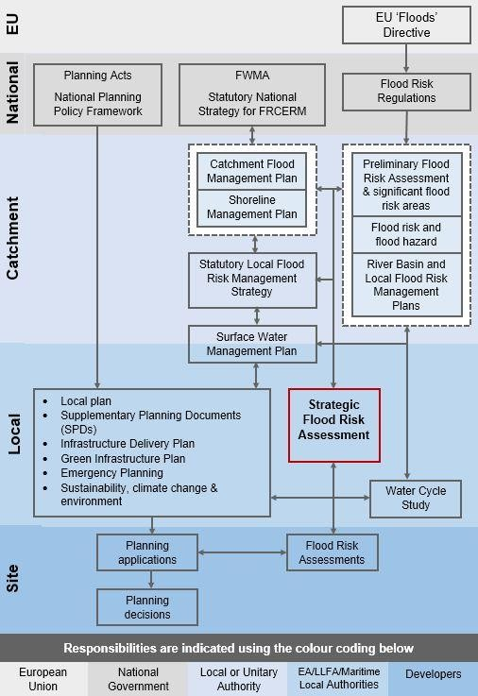

Figure 2.3 Strategic planning links and key documents for flood risk

Wiltshire Council Level 1 SFRA v5.0 20

3 How flood risk is assessed
  - Introduction
This section describes how flood risk is defined and assessed within the SFRA, including the main sources of information, data and mapping.
Planners and developers should use the evidence and maps presented in this SFRA, along with any other available evidence, to identify any risk of flooding from all sources for a particular site.

  - Definitions

    - Flood
Section 1 (subsection 1) of the Flood and Water Management Act (FWMA) (2010)36 defines a flood as:
‘any case where land not normally covered by water becomes covered by water’
Section 1 (subsection 2) states that “it does not matter for the purposes of subsection (1)”
whether a flood is caused by:
      - heavy rainfall;
      - a river overflowing, or its banks being breached;
      - a dam overflowing or being breached;
      - tidal waters;
      - groundwater; or
      - anything else (including any combination of factors).” Section 1 (subsection 2) states that flood “does not include:
      - a flood from any part of the sewerage system, unless wholly or partly caused by an
increase in the volume of rainwater (including snow and other precipitation) entering or otherwise affecting the system, or
      - a flood caused by a burst water main (within the meaning given by section 219 of the Water Industry Act 1991).

    - Flood risk
Section 3 (subsection 1) of the FWMA defines the risk of a potentially harmful event (such as flooding) as:
‘a risk in respect of an occurrence is assessed and expressed (as for insurance and scientific purposes) as a combination of the probability of the occurrence with its potential consequences.’
Thus, it is possible to summarise flood risk as:
Flood Risk = (Probability of a flood) x (Scale of the consequences)

—————————————————————————————————————————————
- Flood and Water Management Act (2010), UK Government (2010). Accessed online at: http://www.legislation.gov.uk/ukpga/2010/29/pdfs/ukpga_20100029_en.pdf on: 17/09/2018
Wiltshire Council Level 1 SFRA v5.0 21
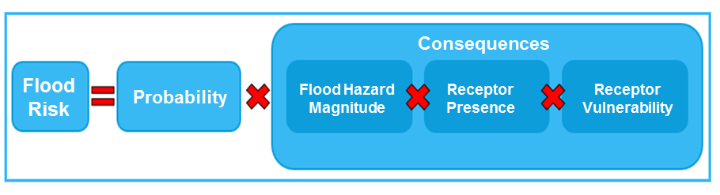

Using this definition, it can be seen that:
Increasing the probability or chance of a flood being experienced increases the flood risk:
  - In situations where the probability of a flood being experienced increases gradually over time, for example due to the effects of climate change, then the flood risk will increase.
The potential scale of the consequences in a given location can increase the flood risk:
  - Flood Hazard Magnitude: If the direct hazard posed by the depth of flooding, velocity of flow, the speed of onset, rate of risk in flood water or duration of inundation is increased, then the consequences of flooding, and therefore risk, is increased.
  - Receptor Presence: The consequences of a flood will be increased if there are more receptors affected, for example with an increase in extent or frequency of flooding. Additionally, if there is new development that increases the probability of flooding (for example, increase in volume of runoff due to increased impermeable surfaces) or increased density of infrastructure then consequences will also be increased.
  - Receptor Vulnerability: If the vulnerability of the people, property or infrastructure is increased then the consequences are increased. For example, old or young people are more vulnerable in the event of a flood.

  - How fluvial flood risk is assessed
Fluvial flooding is caused by high flows in rivers or streams exceeding the capacity of the river channel and spilling onto the floodplain, usually after periods of heavy rainfall. Fluvial flood risk is present on both Main Rivers (from which the Environment Agency and riparian owners are responsible for managing flood risk) and ordinary watercourses (from which the Council and riparian owners are responsible for managing flood risk).
The assessment of fluvial flood risk in the SFRA is primarily based on the following three types of information:
- Flood Map for Planning (Rivers and Sea), known as Flood Zones
- Actual flood risk
- Residual risk
The Environment Agency Flood Zone mapping is provided in Appendix B, and the fluvial risk from Main Rivers within the study area has been summarised in Section 4.4.

    - Flood Map for Planning (Rivers and Sea) (Flood Zone 2 and 3)
The NPPF sets out a Sequential Test to steer new development to areas with the lowest probability of flooding. This is initially based on the Flood Map for Planning (Rivers and Sea), as provided by the Environment Agency, but should be refined by the SFRA to take into account the probability of flooding, other sources of flooding and the impact of climate change.
The Flood Map for Planning (Rivers and Sea) is made up of a suite of map layers, including Flood Zone 2 and 3, Defences, Areas Benefiting from Defences, and Flood Storage Areas.
Wiltshire Council Level 1 SFRA v5.0 22
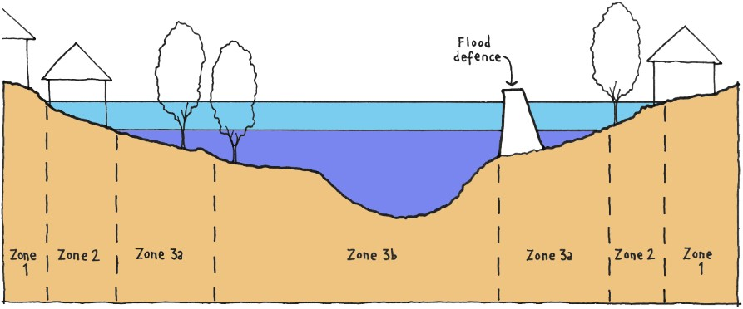
There is no distinction in the Flood Map for Planning between Flood Zone 3b, known as the Functional Floodplain and represented by a 1 in 20-year flood extent, and Flood Zone 3a, the 1 in 100-year flood extent. Further details of how Flood Zone 3b is defined are provided in Section 3.3.3.
A concept diagram showing the classification of NPPF Flood Zones graphically, is included in Figure 3.1. Table 3-1 includes a description and discussion of appropriate development. A fuller discussion of Flood Zones and their relation to planning policy can be found in the NPPF and the Planning Policy Guidance.

Figure 3.1 Definition of Flood Zones
Table 3-1 National Flood Zone descriptions37, 38

Zone | Probability | Description
Zone 1 | Low | This zone comprises land assessed as having a less than 1 in 1,000 annual probability of river or sea flooding in any year (<0.1%).
Zone 1 | Low | All land uses are appropriate in this zone.
Zone 1 | Low | Flood Zone 1, an assessment should accompany all proposals involving: sites of 1 hectare or more; land which has been identified by the Environment Agency as having critical drainage problems; land identified in a strategic flood risk assessment as being at increased flood risk in future; or land that may be subject to other sources of flooding, where its development would introduce a more vulnerable use.
Zone 1 | Low | Developers and local authorities should seek opportunities to reduce the overall level of flood risk in the area and beyond through the layout and form of the development, and the appropriate application of sustainable drainage systems.
Zone 2 | Medium | This zone comprises land assessed as having between a 1 in 100 and 1 in 1,000 annual probability of river flooding (0.1% - 1%) or, in coastal areas, between 1 in 200 and 1 in 1,000 annual probability of sea flooding (0.1% – 0.5%) in any year.
Zone 2 | Medium | Essential infrastructure, water compatible infrastructure, less vulnerable and more vulnerable land uses (as set out by NPPF) are permitted in this zone. Highly vulnerable land uses are allowed as long as they pass the Exception Test (see Section 5.2.2).
Zone 2 | Medium | A site-specific flood risk assessment should be provided for all development in Flood Zones 2 and 3.

—————————————————————————————————————————————
- National Planning Policy Framework: paragraph 163. Ministry of Housing, Communities and Local Government (2018). Accessed online at: https://www.gov.uk/government/uploads/system/uploads/attachment_data/file/6077/2116950.pdf on: 25/10/2016. 38 National Planning Practice Guidance, Ministry of Housing, Communities and Local Government (2014). Accessed online at:
https://www.gov.uk/guidance/flood-risk-and-coastal-change on: 07/10/2019.
Wiltshire Council Level 1 SFRA v5.0 23

 |  | Developers and local authorities should seek opportunities to reduce the overall level of flood risk in the area and beyond through the layout and form of the development, and the appropriate application of sustainable drainage systems.
Zone 3a | High | This zone comprises land assessed as having a greater than 1 in 100 annual probability of river flooding (>1.0%) or a greater than 1 in 200 annual probability of flooding from the sea (>0.5%) in any year Developers and the local authorities should seek to reduce the overall level flood risk, relocating development sequentially to areas of lower flood risk and attempting to restore the floodplain and make open space available for flood storage.
Zone 3a | High | Water compatible and less vulnerable land uses are permitted in this zone. Highly vulnerable land uses are not permitted. More vulnerable and essential infrastructure are only permitted if they pass the Exception Test (see Section 5.2.2).
Zone 3a | High | A site-specific flood risk assessment should be provided for all development in Flood Zones 2 and 3.
Zone 3a | High | Developers and local authorities should seek opportunities to:  Reduce the overall level of flood risk in the area and beyond through the layout and form of the development, and the appropriate application of sustainable drainage systems.  Relocate existing development to land in lower risk zones.  Create space for flooding by restoring functional floodplain and flood flow pathways and by identifying, allocating and safeguarding open spaces for flood storage.
Zone 3b | Functional Floodplain | This zone comprises land where water has to flow or be stored in times of flood. SFRAs should identify this Flood Zone in discussion with the LPA and the Environment Agency. The identification of functional floodplain should take account of local circumstances.
Zone 3b | Functional Floodplain | Only water compatible infrastructure is permitted in this zone. Essential infrastructure is only permitted in this zone if it passes the exception test. All infrastructure should be designed to remain operational in times of flood, resulting in no loss of floodplain or blocking of water flow routes. Infrastructure must also not increase flood risk elsewhere.
Zone 3b | Functional Floodplain | A site-specific flood risk assessment should be provided for all development in Flood Zones 2 and 3.
Zone 3b | Functional Floodplain | Developers and local authorities should seek opportunities to:  Reduce the overall level of flood risk in the area and beyond through the layout and form of the development, and the appropriate application of sustainable drainage systems.  Relocate existing development to land in lower risk zones.

The Flood Zones describe the land that would flood from rivers if there were no defences present. They are based on broad scale modelling that has been refined with detailed hydraulic models in areas of higher risk. Areas Benefiting from Defences can be identified using the accompanying layers.
Where outlines are not informed by detailed hydraulic modelling, the Flood Map for Planning is based on generalised modelling to provide an indication of flood risk. Whilst the generalised modelling is mostly accurate on a large scale, it is not provided for specific sites or for land where the catchment area of the watercourse falls below 3km². For this reason, the Flood Map for Planning is not of a resolution for use as application evidence to provide details for flooding of individual properties or sites, and for any sites with watercourses on, or adjacent to the site. Accordingly, for site specific assessments it will be necessary to perform more detailed studies in circumstances where flood risk is an issue. Where the Flood Map for Planning is based on generalised modelling, developers may be required to undertake their own detailed modelling.

Wiltshire Council Level 1 SFRA v5.0 24

The most up to date version of the Flood Map for Planning (Rivers and Sea) should always be used and can be viewed on the Environment Agency's website39.
For planning purposes under the NPPF, a more detailed breakdown of risk within Flood Zone 3 is required as the flood map for planning does not define Flood Zone 3b. The SFRA is required to define Flood Zone 3b (also known as a Functional Floodplain), and also assess the impact of climate change on the 1 in 100-year flood event, using more detailed data from hydraulic models where available. This information is included in the detailed mapping which accompanies this report and encompasses all the local authority's currently identified sites.

    - Updating the Flood Zone Mapping
The Environment Agency's Flood Zones 2 and 3 are updated quarterly with any new detailed hydraulic modelling information, and planners and developers should always refer to the most up to date issue. These data sets are now freely available on the Government open data website.
The Flood Zone 3b and the 1 in 100-year flood extent plus climate change provided by the SFRA will not be automatically updated. However, users should be aware that if Flood Zones 3 and 2 have changed, this is an indication that new modelled information is also available which could be used to refine Flood Zone 3b and 3a plus climate change.

    - Functional Floodplain (Flood Zone 3b)
The 'functional floodplain' is defined as an area of land where water flows or is stored in times of flood. This forms Flood Zone 3b within the NPPF. Following discussion between the Council and Environment Agency, the following definition of the functional floodplain was agreed:
      - Use the 1 in 20-year modelled flood extent wherever suitable hydraulic models are available.
      - Elsewhere, take a precautionary approach and assume that Flood Zone 3 (1 in 100- year flood extent) represents the functional floodplain.
Mapping showing the extent of Flood Zone 3b is shown in Appendix C.

    - Climate Change (Flood Zone 3a (1 in 100-year event) plus climate change))
The Flood Map supplied by the Environment Agency does not provide any allowance or indication of the impact of climate change on the Flood Zones.
Updated government guidance on assessing the impact of climate change on flooding in line with the UKCP09 Climate Change Projections40 was released in February 201641. The guidance provides a range of climate change allowances which are dependent on location (by river basin) and timescale of development (epoch). It also provides several bands (termed ‘central’, ‘higher central’ and ‘upper end’) to test depending on the vulnerability of the development and the Flood Zone within which it is located. For example, for 'more vulnerable' development in Flood Zone 3a, FRAs should use the higher central and upper end estimates to assess a range of allowances. Further information on assessing the impact of climate change on flood risk is provided in section 6.3.
For the purposes of strategic planning, the key epoch considered is 2070-2115 as this reflects the lifetime of residential development; and the key vulnerability is ‘more vulnerable’ as this represents a conservative classification incorporating all vulnerabilities. The key allowances to consider for Flood Zone 3a are therefore the higher central and upper

—————————————————————————————————————————————
- Flood Map for Planning (Rivers and Sea), Environment Agency (2018). Accessed online at: https://flood-map-for-planning.service.gov.uk/ on: 26/09/2017
- UK Climate Projections (UKCP09), Met Office (2015), Accessed online at: http://ukclimateprojections.metoffice.gov.uk/21678 on: 02/06/2018
- Climate change allowances, Environment Agency (2016) Accessed online at: https://www.gov.uk/guidance/flood- risk-assessments-climate-change-allowances on: 02/06/2018
Wiltshire Council Level 1 SFRA v5.0 25

end (for example, 35% and 70% in the Thames river basin respectively) as shown in Table 3-2.
Due to the lower vulnerability of minerals and waste sites, the central allowance is suggested for the 'water compatible' development of sand and gravel extraction, whereas the central to higher central range of allowances should be assessed for 'less vulnerable' development, such as ancillary buildings or waste treatment facilities. Extraction of other minerals, including chalk and clay, are also classified as 'less vulnerable' developments.
However, hazardous waste and landfill are 'more vulnerable' development types, which require assessment of the upper end allowance. To ensure provision of flood risk information for any future, more sensitive development types, the higher central and upper climate change allowances have been assessed.
Mapping showing the impact of climate change on Flood Zone 3a is included in Appendix D.
Table 3-2 Climate change allowances used in SFRA

River basin district | Allowance category | Total potential change anticipated for the ‘2020s’ (2015  to 2039) | Total potential change anticipated for the ‘2050s’ (2040  to 2069) | Total potential change anticipated for the ‘2080s’ (2070  to 2115)
Thames | Upper end | 25% | 35% | 70%
Thames | Higher central | 15% | 25% | 35%
Thames | Central | 10% | 15% | 25%
South West | Upper end | 25% | 40% | 85%
South West | Higher central | 20% | 30% | 40%
South West | Central | 10% | 20% | 30%
Severn | Upper end | 25% | 40% | 70%
Severn | Higher central | 15% | 25% | 35%
Severn | Central | 10% | 20% | 25%
UKCP18 Climate Change projections have now been released, however they have not yet been translated into river flows so cannot be incorporated into the climate change assessment at this stage.

    - Hydraulic modelling
Flood risk within the district has been assessed using results from computer models supplied by the Environment Agency and existing Environment Agency Flood Zone mapping.
Table 3-3 lists the models provided by the Environment Agency for analysis within the Wiltshire Level 1 SFRA. Several of the models are currently being updated, although the timescales for delivery of the updated model were beyond the programme of the SFRA. It was agreed that the Level 1 SFRA should progress with the available model data, rather than delay the assessment to receive updated model results.
Should a Level 2 SFRA be required, the most recent model data available should be reviewed and incorporated, where relevant.

Wiltshire Council Level 1 SFRA v5.0 26

Table 3-3 Summary of EA models used within the SFRA and indicative timescales for model updates

Model | Year created | Model Type | Data source used in Flood  Zone 3b | Data source used in Flood  Zone 3a + CC
Bradford on Avon Model Update 2015 | 2015 | 1D-2D | 1 in 30  modelled outline | Flood Zone 2
Bristol Avon SoP Study  2013 - Lambrok, Trowbridge. | 2013 | 1D-2D | 1 in 20  modelled outline | Flood Zone 2
Bristol Avon SoP Study 2013 – Paxcroft Brook | 2013 | 1D-2D | 1 in 20  modelled outline | Flood Zone 2
Bristol Avon SoP Study 2013 – South Brook | 2013 | 1D-2D | 1 in 20  modelled outline | Flood Zone 2
Bristol Avon SoP Study 2013 - Trowbridge | 2013 | 1D-2D | 1 in 20  modelled outline | 1 in 100-year +  70% modelled outline
Bristol Avon SoP Study 2013 - Melksham | 2013 | 1D-2D | 1 in 20  modelled outline | Flood Zone 2
By Brook Flood Risk Mapping | 2016 | 1D-2D | 1 in 20  modelled outline | Flood Zone 2
Chippenham & Calne  Mapping and Modelling Study | 2016 | 1D-2D | 1 in 25  modelled outline | 1 in 100-year +  70% modelled outline
Malmesbury Flood Modelling Study | 2016 | 1D-2D | 1 in 20  modelled outline | 1 in 100-year +  70% modelled outline
SW042 River Avon  (Pewsey) – Flood risk Mapping | 2003 | 1D only | Flood Zone 3a | Flood Zone 2
SW107 River Bourne (at  Newton Tony) – Flood Risk Mapping Study | 2013 | 1D-2D | 1 in 25  modelled outline | Flood Zone 2
SW647 River Bourne (Tidworth & Shipton) –  Flood Risk Mapping | 2005 | 1D-2D | 1 in 25  modelled outline | 1 in 100-year +  85% modelled outline

    - Actual Flood Risk
If it has not been possible for all future development to be allocated within areas of low flood risk from all sources, Level 2 SFRA assessments are recommended at any sites identified as being located within Flood Zone 3b, 3a or 2, and therefore requiring application of the Exception Test.
The Sequential Test must also consider risk of flooding from other sources, for example sites in Flood Zone 1 where there is a significant flood risk from other sources such as surface water and groundwater. The risk to a site is dependent on the vulnerability of proposed land use, and therefore the requirements for a Level 2 SFRA are specific to housing and employment, or mineral extraction sites where equipment or stockpiles are likely to be located within areas at risk of flooding.

Wiltshire Council Level 1 SFRA v5.0 27

Understanding the implications of development is accomplished by considering information on the “actual risk” of flooding. The assessment of actual risk takes account of the presence of flood defences and provides a picture of the safety of existing and proposed development. It should be understood that the standard of protection afforded by flood defences is not constant and it is presumed that the required minimum standards for new development are:
      - Residential development should be protected against flooding with an annual probability of river flooding of 1% (1 in 100-year chance of flooding) taking into account climate change in any year.
The assessment of the actual risk should take the following issues into account:
      - The level of protection afforded by existing defences might be less than the appropriate standards and hence may need to be improved if further growth is contemplated;
      - The flood risk management policy for the defences will provide information on the level of future commitment to maintain existing standards of protection. If there is a conflict between the proposed level of commitment and the future needs to support growth, then it will be a priority for the Flood Risk Management Strategy to be reviewed;
      - The standard of safety must be maintained for the intended lifetime of the development (assumed to be 100 years for residential development). Over time the effects of climate change will erode the present-day standard of protection afforded by defences. Commitment is needed to invest in the maintenance and upgrade of defences, if the present-day levels of protection are to be maintained, and where necessary land secured for affordable future flood risk management measures; and
      - The assessment of actual risk can include consideration of the magnitude of the hazard posed by flooding. By understanding the depth, velocity, speed of onset and rate of rise of floodwater, it is possible to assess the level of hazard posed by flood events from the respective sources. This assessment will be needed in circumstances where consideration is given to the mitigation of the consequences of flooding or where it is proposed to place lower vulnerability development in areas that are at risk from inundation.
      - The proposed development must not negatively impact on the integrity of any flood defence structure, and appropriate maintenance access must be retained.
For information on defences reference should be made to the Environment Agency's Asset Information Management System (AIMS) which contains details on the standard of protection of defences.

    - Residual Risk
The residual risk refers to the risks that remain in circumstances after measures have been taken to alleviate flooding. It is important that these risks are quantified to confirm that the consequences can be safely managed. The residual risk can be:
      - The effects of a flood with a magnitude greater than that for which the defences or management measures have been designed to alleviate (the ‘design flood’). This can result in overtopping of flood banks, failure of flood gates to cope with the level of flow or failure of pumping systems to cope with the incoming discharges; or
      - Failure of the defences or flood risk management measures to perform their intended duty. This could be breach failure of flood embankments, failure of flood gates to operate in the intended manner or failure of pumping stations.
The assessment of residual risk demands that attention be given to the vulnerability of the receptors and the response to managing the resultant flood emergency. In this instance, attention should be paid to the characteristics of flood emergencies and the roles and responsibilities during such events. Additionally, in the cases of breach or overtopping

Wiltshire Council Level 1 SFRA v5.0 28

events, consideration should be given to the structural safety of the dwellings or structures that could be adversely affected by significant high flows or flood depths.

  - How flood risk from other sources is assessed
Under paragraphs 158-160 of the NPPF, the sequential, risk-based approach to allocating development should 'steer new development to areas with the lowest risk of flooding' and 'the strategic flood risk assessment will provide the basis for applying this test'. In addition, 'the sequential approach should be used in areas known to be at risk now or in the future from any form of flooding'.
Evidence and maps presented in this SFRA on other sources of flooding (including surface water, ordinary watercourses, groundwater, sewers, canals and reservoirs) are derived from a range of sources of information, mostly publicly available. They are intended for use by planners and developers, along with any other available evidence, to identify any risk of flooding from all sources for a particular site.

    - Surface Water
Flooding of land from surface water runoff is usually caused by intense rainfall and tends to occur in lower lying areas. It is exacerbated where the drainage system is unable to cope with the volume of water, due to exceedance, blockage or failure of the surface water drainage system.
Mapping of surface water flood risk in Wiltshire has been taken from the Risk of Flooding from Surface Water (RoFSW) map published by the Environment Agency. This information is based on a national scale map identifying those areas where surface water flooding poses a risk. Surface water flood risk is subdivided into the following four categories:
      - High: An area has a change of flooding greater than the 1 in 30 (3.3%) each year;
      - Medium: An area has a chance of flooding between 1 in 100 (1%) and 1 in 30 (3.3%) each year;
      - Low: An area has a chance of flooding between 1 in 1000 (0.1%) and 1 in 100 (1%) each year;
      - Very Low: An area has a chance of flooding of less than 1 in 1000 (0.1%) each year.
The RoFSW shows the flooding that takes place from the 'surface runoff' generated by rainwater which:
- is on the surface of the ground, and
- has not yet entered a watercourse, drainage system or public sewer.

The RoFSW predominantly follows topographical flow paths of existing watercourses or dry valleys with some isolated ponding located in low lying areas.
It should be noted that because of the broad-scale nature of surface water flooding, wherever possible, these mapped outlines should be used in conjunction with other sources of local flooding information to confirm the presence of a surface water risk.
The Environment Agency Risk of Flooding from Surface Water (RoFSW) mapping is provided in Appendix E. Surface water flood risk within the study area is summarised in section 4.5.
Climate change is predicted to increase the intensity of rainfall increasing the risk of flooding from surface water. Table 3-4 shows the anticipated change in rainfall intensity in small and urban catchments. The Upper end for the ‘2080s’ was used to produce an impact the climate change on the risk of flooding from surface water map in Appendix F.

Wiltshire Council Level 1 SFRA v5.0 29

Table 3-4 Peak rainfall intensity allowance for small and urban catchments (from 1961-1990 baseline)

Applies across all of England | Total potential change anticipated for the ‘2020s’ (2015 to 2039) | Total potential change anticipated for the ‘2050s’ (2040 to 2069) | Total potential change anticipated for the ‘2080s’ (2070 to 2115)
Upper end | 10% | 20% | 40%
Central | 5% | 10% | 20%
Reproduced from “Flood risk assessments: climate change allowances”, Environment
Agency (2017)

    - Ordinary watercourses (not included in Flood Zone maps)
The location of small ordinary watercourses, which may not be included in the Flood Zones if they have a catchment area of less than 3km², can be found using the OS MasterMap Water Network Layer or OS Open Rivers layer. The OS Open Rivers layer has been used in this assessment. A good indication of potential flood risk from such watercourses can be gained from the RoFSW map. In addition, Section 19 Flood Investigation Reports undertaken by Wiltshire Council42, in its role the Lead Local Flood Authority, can provide further details of historic flood risk from ordinary watercourses at a particular location.

    - Groundwater
The risk of groundwater flooding is dependent on local geological/soil conditions at any given time. Groundwater levels rise during wet winter months and fall again in the summer when effective rainfall is low, and extractions are higher. In very wet winters, rising groundwater levels may lead to the flooding of normally dry land, as well as reactivating flow in streams that only flow for part of the year.
The JBA Groundwater Flood Map provides a detailed assessment of the risk of groundwater emergence in a 1 in 100-year event at a 5m resolution. The risk is scaled between 0 and 4, with 0 indicating no risk and 4 identifying groundwater levels either at or very near (within 0.025m of) the ground surface. The groundwater levels are compared against ground surface levels to determine the head difference in metres; with 0m suggesting artesian discharge of groundwater at the ground surface.
The JBA Groundwater Flood Map should be used in combination with other information, such as local data or historic data. It should not be used as sole evidence for any specific flood risk management, land use planning or other decisions at any scale. The data can however help to identify areas for further assessment at a local scale, where finer resolution datasets may exist or more data could be gathered. The JBA Groundwater Map is provided in Appendix G.

    - Reservoir
In England, reservoirs which retain 25,000m3 or more of water are regulated under the Reservoirs Act 1975. The owners and operators of these reservoirs are required to register the features with the Environment Agency, and features identified as 'high-risk' are subsequently subject to high levels of inspection and supervision.
The Environment Agency Risk of Flooding from Reservoirs map (Appendix H) has been used to identify areas that may be at risk from failure or overtopping of reservoirs. The data was published following the Environment Agency's National Reservoir Inundation Mapping project in 2009, which mapped the risk of flooding from all large raised reservoirs (storing over 25,000m3 of water above ground level) in England. Layers showing depth, extent and speed of flooding are available, but no information is given on the likelihood of reservoir failure.
—————————————————————————————————————————————
- http://www.wiltshire.gov.uk/civil-emergencies-flooding
Wiltshire Council Level 1 SFRA v5.0 30

There are also a number of privately-owned reservoirs in Wiltshire. Stringent operational requirements are in place43 to ensure that reservoir owners maintain structures and produce an on-site reservoir flood plan to contain and reduce the impacts of a reservoir breach.
However, there is likely to be a higher risk associated with assets which are owned and managed by private individuals, rather than formal organisations.
The Reservoir Flood Risk Map is provided in Appendix H.

    - Canals
Canals may pose a flood risk if they overtop or breach, but impacts will depend on the topography. There is a higher flood risk where the canal is raised by embankments (or perched) above a settlement.
The Kennet and Avon Canal is a 140km long navigable waterway, which follows the Rivers Avon and Kennet from Bristol to its confluence of the River Thames, east of Reading44. The canal enters the study area to the north west of Bradford on Avon and passes through Bradford on Avon, Trowbridge, Devizes, and Great Bedwyn. It interacts with the River Avon and River Kennet at several locations within Wiltshire. At high flows this allows the transfer of water from the River Kennet into the canal, raising water levels. As a result, canal flooding in the Kennet catchment can occur in combination with fluvial flooding.
The Kennet and Avon Canal is also perched in several locations through Wiltshire including Avoncliff, south of Bradford on Avon where it runs close to the River Avon, the north of Trowbridge, north of Semington, Martinslade, a number of villages in the Vale of Pewsey, and the south of Great Bedwyn.
The interaction of flows between the Rivers Kennet and Avon and the Kennet and Avon Canal are not explicitly represented within the hydraulic models of the Rivers Avon or Kennet within Wiltshire.
The Environment Agency is undertaking remodelling of the River Kennet, which includes a review of the operation of flow control structures on the watercourse by private owners.
The Wiltshire and Berkshire Canal links the Kennet and Avon at Semington with the Thames and Severn Canal close to Kempsford. Its 63km runs predominantly through Wiltshire and is currently unnavigable.
The Thames and Severn Canal links Lechlade on the Thames with the Stroudwater Canal at Stroud, with a short section running through the far north of Wiltshire. It is also currently unnavigable.
No national mapping of risk from overtopping or breach of canals is currently available from the Canals and Rivers Trust. The maps in Appendix M show the route of canals, the locations of embankments (where the canal is raised above the surrounding land on one or both banks) and records of historic breach and overtopping events. All data was provided by the Canal and River Trust (CRT).

    - Sewer
Sewer flooding incidents recorded in the water companies’ sewer flooding registers were provided for the assessment. These are registers of flooding from the 'public' sewer system ('public' in this context meaning assets under the control of Water & Sewerage Companies in England & Wales).
Sewerage and wastewater services are provided by Wessex Water for the majority of Wiltshire. Thames Water serves the north east of Wiltshire, including Marlborough and Royal Wootton Basset, whilst Southern Water serves several small settlements along the

—————————————————————————————————————————————
- Reservoirs: owner and operator requirements, Environment Agency (2014). Accessed online at: https://www.gov.uk/guidance/reservoirs-owner-and-operator-requirements on: 01/10/2018
- The Trust and its Branches, Kennet and Avon Canal Trust (2017). Accessed online at: https://katrust.org.uk/about-us/ on: 26/09/2018
Wiltshire Council Level 1 SFRA v5.0 31

south eastern boundary. Veolia are known to serve the MoD land at Tidworth, and other inset agreements exist within Wiltshire including Land at Old Sarum in Salisbury.
Thames Water consider the register to be confidential and do not release the data in a resolution higher than ‘number of properties per 4 or 5-digit postcode’, known as the Postcode Sector. Sewer flooding records provided by Thames Water are therefore not detailed enough to identify site-specific risks. However, Thames Water will comment on larger planning applications, and on Local Plans. Sewer flooding records obtained from Southern Water and Wessex Water contained records at the full postcode level. Veolia were not approached for data on sewer flooding at Tidworth as work for the MoD is subject to strict data sharing restrictions.
During periods of high groundwater, inundation of the foul sewer systems can take place resulting in sewer flooding on the surface. Following the extensive groundwater flooding during the wet winters of 2012/2013 and 2013/2014, the water companies prepared Infiltration Reduction Plans45,46 and Drainage Strategies47 for catchments at risk of groundwater inundation of the foul sewer systems. The areas mainly affected in the Wessex Water’s region are the towns and villages in South Wiltshire, villages in the Vale of Pewsey, villages to the north-east of Malmesbury and villages to the north and east of Chippenham. Thames Water has drainage strategies addressing groundwater infiltration to sewerage in Marlborough and Ramsbury.
The Sewer Flood Risk Map is provided in Appendix I, and includes incidents caused as a result of groundwater infiltration into sewerage systems.

—————————————————————————————————————————————
- https://www.wessexwater.co.uk/environment/drainage-and-wastewater-management-plan/infiltration-reduction- plans
- https://www.southernwater.co.uk/infiltration-reduction-plans 47https://www.thameswater.co.uk/sitecore/content/corporate/corporate/about-us/investing-in-our- network/drainage-strategies/stage-1
Wiltshire Council Level 1 SFRA v5.0 32

4 Understanding flood risk in Wiltshire
  - Introduction
The diverse nature of Wiltshire in terms of geology and topography produces a complex mix of flooding from multiple sources which varies with location. In the north and west of Wiltshire, the underlying geology and soils largely comprise impermeable clays giving rise to rapid runoff during heavy rain. The central and southern regions are generally underlain by chalk, thus delaying the response to heavy rainfall and providing a significant baseflow contribution to river flows. The following section describes the geology of Wiltshire, and of the main river systems present, and how this impacts on flood risk.

  - Topography
In the north-east of the county, there are steep areas which characterise the western North Wessex Downs. Within this area, the Kennet forms the main river valley with its tributaries homing smaller valleys nearby. The central part of Wilshire is dominated by Salisbury Plain, a large area consisting of rolling chalk hills with large arable fields. To the south and west of the plain the broad hills of the West Wiltshire Downs are separated by shallow dry valleys. Further west the catchment of the River Wylye has more dramatic deep chalk combes. The topography is relatively flat in the North and North-West.

  - Geology and soils
Bedrock: Figure 4.1 shows the bedrock geology across Wiltshire. A large proportion of the county's central and eastern areas are underlain by the White Chalk Group. In the North, there are large areas of the Great Oolite Group (sandstone, limestone and argillaceous rocks) as well as Kellaways Formation and Oxford Clay Formation (mudstone, siltstone and sandstone). In northern areas there are also bands of the Corallian Group (limestone, sandstone, siltstone and mudstone), West Walton Formation (mudstone, siltstone and sandstone) and smaller areas of both the Lower Greensand Group (sandstone and mudstone). A band of Gault Formation and Upper Greensand Formation stretches through the centre of the county to the east. The south of the county is also dominated by the White Chalk Group however there are smaller areas which are made up by various formations creating geological mix. These include Portland Group (limestone and calcareous sandstone), Wealden Group (sandstone and siltstone - interbedded), Bracklesham Group and Barton Group (sand, silt and clay), Thames Group (sand, silt, clay and gravel) and the Lambeth Group (sand, silt and gravel).
Superficial Deposits: Figure 4.2 displays superficial geology across Wiltshire. Within close proximity of all the rivers within the county clay, silt, and sand and sand and gravel deposits are a common feature. Large areas of Diamicton (poorly sorted, unconsolidated sediment) is also found near rivers in the south and east with smaller deposits found further away from river channels. Areas of unknown geology (due to landslip) are also located throughout the county.

Wiltshire Council Level 1 SFRA v5.0 33
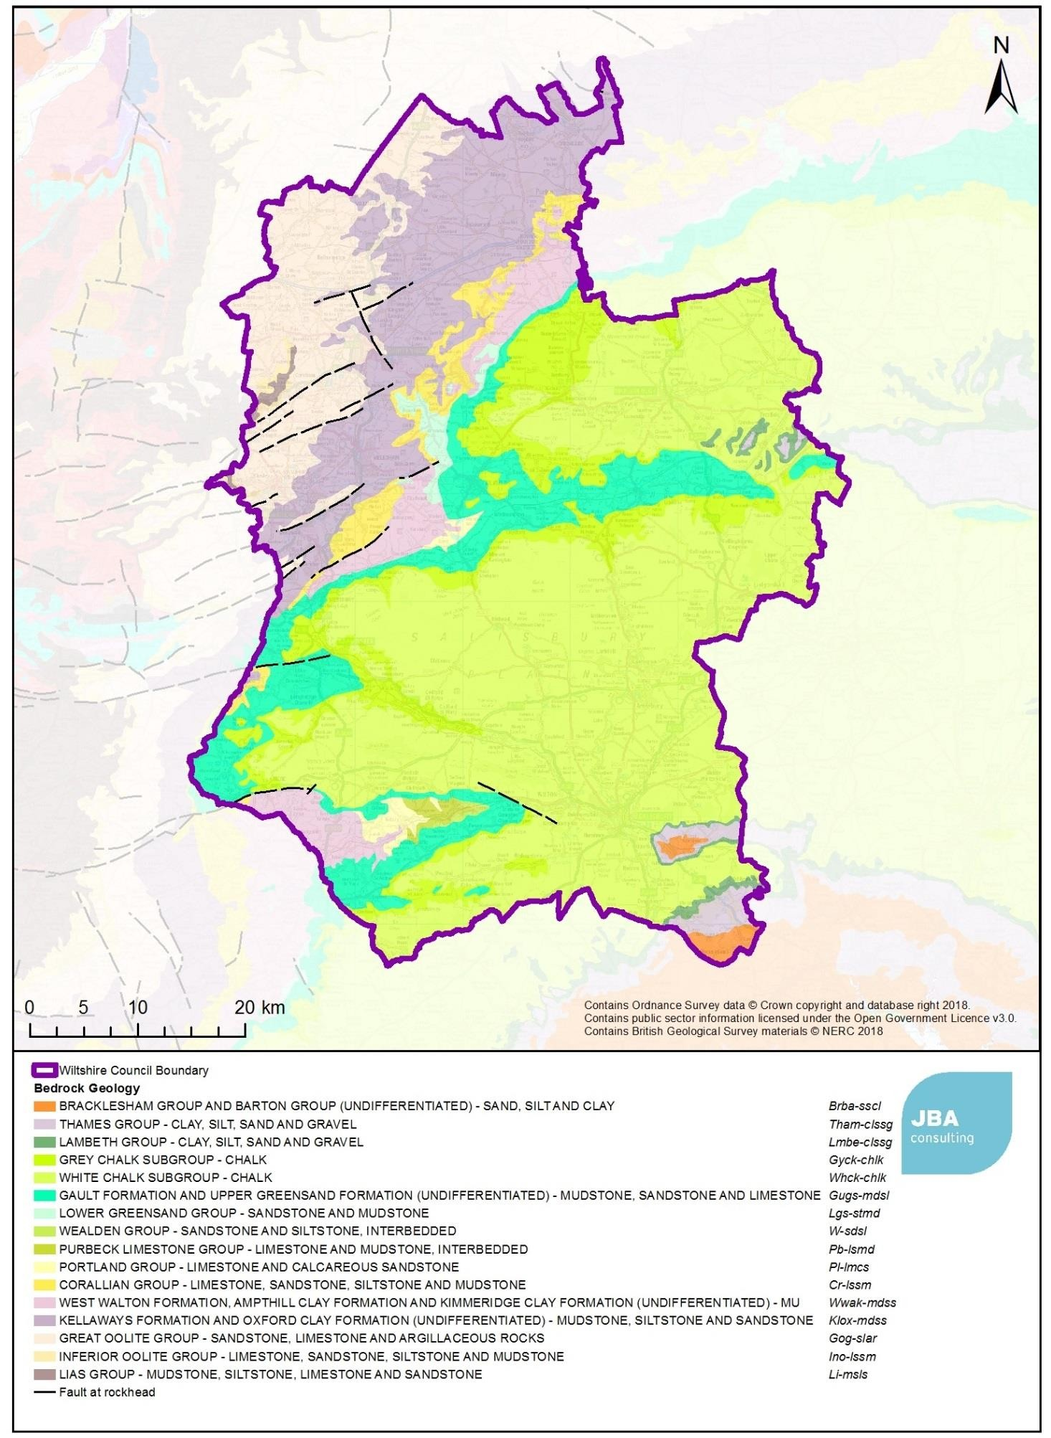

Figure 4.1 Bedrock geology of Wiltshire

Wiltshire Council Level 1 SFRA v5.0 34
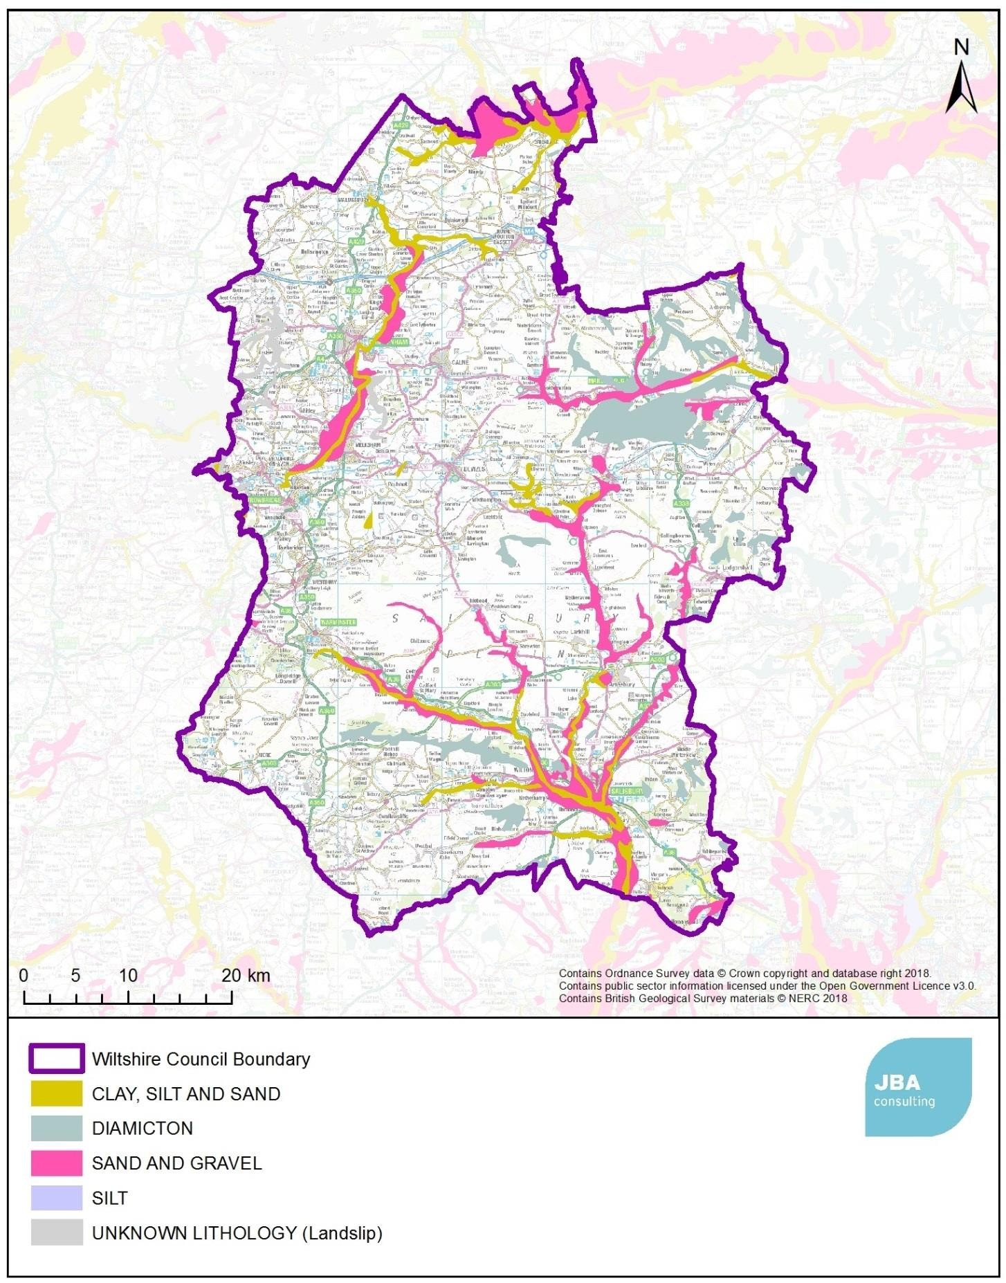

Figure 4.2 Superficial geology of Wiltshire

Wiltshire Council Level 1 SFRA v5.0 35

  - Fluvial flood risk

    - Bristol Avon
The River Avon rises near the town of Chipping Sodbury (south Gloucestershire). As the river passes the Wiltshire county border, it flows through Luckington (the first main settlement) and then progresses to Sherston. As the Avon's course passes through Malmesbury, its first major tributary, Tetbury Avon, connects originating near Tetbury in Gloucestershire. Away from Malmesbury, the river flows south-east into Dauntsey Vale whereby the River Marden forms a tributary. Here, the river flows to pass through the towns of Chippenham, Melksham and Bradford-on-Avon, respectively. Along the Somerset/Wiltshire border, the River Frome forms another major tributary. Outside of the county, the Avon flows through the city of Bath whereby it flows over the weir and is soon joined by the Kennet and Avon Canal (which connects through Bath Locks). In Bristol, the river becomes tidal and the River Trym forms a further tributary prior to reaching the river mouth.
Within the county of Wiltshire, the river is predominantly underlain by the Kellaways Formation and Oxford Clay Formation and, in the west, the Great Oolite Group. The low permeability of this area results in a rapid response to rainfall. Communities that have experienced flooding from this river system include Malmesbury, Chippenham, Melksham and Bradford on Avon.

    - River Thames
The source of the River Thames is traditionally identified as north of the village of Kemble in Gloucestershire, but the headwaters extend down into the north of Wiltshire and include Swill Brook that has its source close to the villages of Crudwell, and Hankerton and Derry Brook which has its source close to Minety. The Thames then flows through Ashton Keynes before being joined by The River Key and River Ray (which have their sources close to Purton and Lydiard Millicent respectively) in Cricklade and leaves the study area north of Swindon. The upper headwaters consist of an area underlain by Great Oolite Group (sandstone, limestone and argillaceous rocks), the area around Minety, Ashton Keynes and Cricklade is underlain by Kellaways formation and Oxford Clay formation. Cricklade is the main settlement that has experienced flooding from this river system in recent years.

    - River Kennet
The River Kennet which is a tributary to the Thames, has its source close to Uffcott and is joined by Yatesbury Bourne at Avebury before flowing through Beckhampton and Marlborough where it is joined from the north by the River Og. At Ramsbury, it is joined by the Aldbourne, before leaving the study area west of Hungerford. It eventually joins the River Thames in Reading to the East.
The geology of the Upper Kennet is Grey and White Chalk subgroups.

    - Hampshire Avon
The catchment of the Hampshire Avon dominates the south of Wiltshire with the confluence of a number of tributaries at Salisbury. The headwaters of the Avon are in the Vale of Pewsey, and it then flows south through Netheravon, Amesbury to Salisbury where it is joined from the west by the Rivers Wylye and Nadder.
The River Wylye has its source in Warminster and flow parallel with the A36 through Codford St Mary and Stapleford where it joined by the Till, and Wilton where it is joined by the River Nadder (the source of which is near Semley and Newtown) before it flows into Salisbury.
The River Bourne has its source near Burbage and flow south through Collingbourne Kingston and Tidworth, joining the Avon east of Salisbury. The River Ebble (rising in Berwick St John) joins the Avon south of Salisbury at Bodenham.
The Hampshire Avon and its tributaries are mostly underlain by the white chalk group, and display characteristics typical of chalk streams. However, some of the upper reaches of the Nadder, and Avon are fed from catchments underlain with clay and so can respond rapidly
Wiltshire Council Level 1 SFRA v5.0 36

to rainfall. Communities that have previously flooded in this river system include Upavon, Durrington, Amesbury and Salisbury.

    - River Dun
The River Dun, a tributary to the River Test to the east, rises near Pitton and flows through West Grimstead. It is formed of chalk streams which further up in the catchment are ephemeral in nature. The town of Marlborough has experience flood from the River Dun in the past.

    - River Frome
The river source is located in Dodington Park, South Gloucestershire, and flows along western areas of the catchment prior to joining the River Avon in Bristol. The river enters the county boundary for relatively short segments near Tellisford and Wingfield. Within the catchment, the river is underlain by sandstone, limestone and argillaceous rocks as part of the Great Oolite Group.

    - Dorset Stour
The River Stour emerges in South-West Wiltshire at the lakes at Stour Head. The river flows south from here into the county of Dorset and into the towns of Gillingham and Sturminster Newton. Within Wiltshire, the river flows over the Gault Formation and Upper Greensand Formation which is comprised of mudstone, limestone and sandstone. The river is joined by the River Allen before being joined by the River Avon at its estuary in Christchurch.

  - Surface Water Flood Risk
The Risk of Flooding from Surface Water flood map covering Wiltshire is shown in Appendix E and shows areas where surface water may flow or accumulate in a rainfall event.
Research undertaken by Defra in 2009 at a national level reported that 16,000 properties within Wiltshire may be susceptible to surface water flooding. This led to three settlements initially being selected for a Surface Water Management Plan - Chippenham, Trowbridge and Salisbury. These included detailed surface water risk modelling, however this information is now outdated and has been superseded by the surface water mapping developed as part of this SFRA. Further settlements are likely to be considered at a later date.

  - Groundwater Flood Risk
In comparison to fluvial and tidal flooding, the understanding of the risks posed by groundwater flooding is limited and mapping of flood risk from groundwater sources is in its infancy. Groundwater flooding is often difficult to identify and can be mistaken for surface water flooding or vice versa. The risks and mechanisms of groundwater flooding have traditionally been poorly reported. However, under the Flood and Water Management Act (2010), the LLFA now has powers to undertake risk management functions in relation to groundwater flood risk.
There are areas of Wiltshire where groundwater levels can be high, and in some locations, there may be a risk of groundwater emergence during extremely wet winters. This occurred in 2013/14 when groundwater levels rose to their highest recorded level causing flooding at multiple locations in the south of Wiltshire. The risk of groundwater flooding is dependent on local conditions at any given time. Groundwater levels rise during wet winter months and fall again in the summer when effective rainfall is low, and extractions are higher. In very wet winters, rising groundwater levels may lead to the flooding of normally dry land, as well as reactivating flow in streams that only flow for part of the year. This is particularly true for some of the upper reaches in the Hampshire Avon catchment where there are ephemeral chalk streams.
The JBA Groundwater Flood Map (Appendix G) shows that in the south of Wiltshire, areas at risk of flooding from groundwater follow the course of the Hampshire Avon and its
Wiltshire Council Level 1 SFRA v5.0 37

tributaries, which are underlain by Chalk. The highest risk areas can be found in the western part of Salisbury, and to the south of Salisbury east of Bodenham. The Upper Nadder is underlain by clay, and this is reflected in a lower groundwater flood risk.
In the northern part of Wiltshire, areas at risk of flooding from groundwater generally correspond to a limestone bedrock geology. Settlements within or close to areas of high groundwater flood risk include Chippenham, Calne, Melksham and Trowbridge. High groundwater flood risk around Cricklade corresponds to the superficial deposits of sand and gravel.
Wiltshire Council published a Groundwater Management Strategy in 2016 aimed at identifying the level of detail required for site specific FRAs, providing guidance on areas susceptible to Groundwater Flooding, and outlining methods for dealing with groundwater.
Historic flood records indicate that groundwater flooding has occurred at:
- Amesbury
- Downton
- Durrington
- Salisbury
- Shrewton
- Pitton
- Tilshead
- Upavon
High groundwater levels can also result in inundation of the foul sewer systems and sewer flooding at the surface (see section 3.4.6).

  - Reservoir Flooding
Mapping of reservoir flood risk is shown in Appendix H, and summarised in Table 4-1 below. It should be noted that although a number of waterbodies are identified as contributing to flood risk from failure or overtopping of reservoirs, the actual risk of reservoir failure is considered to be very low.
Table 4-1 Settlements identified on Risk of Flooding from Reservoirs mapping

Catchment | Waterbody Name and location | Receiving watercourse | Settlements at risk
Bristol Avon | Braydon Pond (East of Malmesbury) | Woodbridge Brook and River Avon | Rural settlements along Avon.
Bristol Avon | Tockenham Reservoir (North of  Lyneham) | Dauntsey Brook and River Avon | Rural settlements in vicinity of Grittenham, and Dauntsey.
Bristol Avon | Bowood Lake (south west of Calne) | River Marden | Chippenham
Bristol Avon | Corsham Lake (east of Corsham) | Westrop Watercourse and River Avon | Melksham, and rural settlements in vicinity of Easton, Thingley and  Reybridge.
Bristol Avon | Lake at Lower  Foxhanger’s Farm  (west of Devises) | Summerham Brook and  Semington Brook | Rural settlements in vicinity of Baldham Farm
Bristol Avon | Lake at east of Heywood | Bitham Brook and River Biss | Rural settlements in vicinity of Dursley, Norleaze
River Kennet | “The Lake” south  west of Ramsbury | River Kennet | Ramsbury and Chilton Foliat

Wiltshire Council Level 1 SFRA v5.0 38

Catchment | Waterbody Name and location | Receiving watercourse | Settlements at risk
Hampshire Avon | Lake at Mullins Farm (east of Bottlesford) | River Avon | Rural settlements in vicinity of North Newnton,  Woodbridge, Upavon, East Chisenbury.
Hampshire Avon | Shearwater Lake (south west of Warminster) | River Wylye | South of Warminster, rural settlements in vicinity of Crockerton, Henfords Marsh, Heytesbury, Upton Lovell, Sherrington, Codford St Mary  and Wylye.
Hampshire Avon | Bitham Lake and  Fonthill Lake (north of Tisbury) | River Nadder | Tisbury, Tilshead, and rural  settlements along course of River Nadder to Salisbury.

  - Minerals and Waste in Wiltshire

    - Mineral extraction
The principal minerals extracted in the area are sand and gravel, clay, chalk and building stone. Mineral workings in Wiltshire have evolved from small sites (serving local needs for building materials and agricultural fertiliser) towards fewer and larger sites serving wider market areas. The primary purpose of extracted materials in Wiltshire is for use as aggregates.
In this area, sand and gravel occur in two distinct forms; 'soft sand' and 'sharp sand and gravel'. Soft sand is mostly extracted from the Lower Greensand deposits east of Calne where two quarries currently operate and a third is at present dormant with extant planning permission. Soft sand is also produced from the Bagshot Sands at Brickworth Quarry, west of the village of Whiteparish. Within the Plan Area sharp sand and gravel occurs almost entirely in the form of terrace deposits laid in Pleistocene times by great rivers of meltwater from retreating glaciers and are now found in river valleys such as the Thames, Bristol Avon, Wylye and Salisbury Avon. An example of this is the sand and gravel quarry at Marston Meysey (Roundhouse Farm/Whetstone Bridge) in the Thames river valley.
Various types of building stones have been mined and quarried in the Plan area with Bath Stone from the “stone belt” in the north-west of the county (around Corsham/Box), and Portland Stone in the Vale of Wardour (Chilmark Mine and Chicksgrove Quarry) currently worked on a relatively small scale. None of stone extraction sites produce particularly large quantities of mineral due to the methods of extraction used and the specialist nature of the market.
In Wiltshire, chalk and clay were worked for a range of end-use applications including the manufacturing of cement. However, with the recent closure of the Westbury Cement Works, chalk and clay extraction is no longer prevalent. Chalk is worked on a very limited basis for agricultural specifications and in cement manufacturing. Clay is also generally extracted for use in manufacturing of cement whereby the most extensive clay working site is located in Westbury.
Mineral extraction and processing can have various negative impacts upon the water environment, and so there are a wide range of controls which are set to ensure protection. The Environment Agency is the main body with responsibility for safeguarding the water environment and its concerns under the Water Resources Act 1991 (amended by the Environment Act 1995). To protect the groundwater supply in Wiltshire the Environment Agency has adopted a policy framework, which considers new development, entitled "Policy and Practice for the Protection of Groundwater" (1998). Mineral workings can also have adverse impacts upon surface water whereby rainwater can carry silts, containing salts and chemicals, into the watercourse. This risk is generally avoided through good site design
Wiltshire Council Level 1 SFRA v5.0 39

and operating practice. Another potential adverse impact of mineral operations on watercourses is that of land drainage and increased flood risk whereby watercourses may become overloaded by increased run-off from disturbed land or by water discharged from de-watered quarries.
Where land is returned after quarrying activities, there may be opportunities to provide flood risk mitigation, recreational space and nature reserves. For example, the Cotswold Water Park to the north of the study area.

    - Waste Management
The following types of waste arise in Wiltshire as they generally do in varying amounts in all local authority areas:
      - Construction, Demolition and Excavation waste;
      - Local Authority Collected Waste;
      - Commercial and Industrial waste;
      - Hazardous waste;
      - Radioactive waste;
      - Agricultural waste (for example from dairy farms);
      - Sewage sludge; and
      - Equine waste.
All waste will require some type of management and it is acknowledged that waste crosses administrative boundaries. Therefore, it is logical that waste from other local authority areas will be managed in Wiltshire, and vice versa. The location of waste sites must consider all sources of flooding, as they are susceptible to the mobilisation and transfer of debris and pollutants into watercourses of lakes, and the leaching of contaminants into groundwater. As a result, flooding of a waste site can have considerable off-site impacts on the performance of flood risk management assets, such as culvert blockages, as well as the water quality of neighbouring water bodies.
The increase in impermeable areas through construction of waste facilities can also influence surface water flow paths, by increasing the rate and volume of runoff from the site.

  - Historical Flood Risk
Wiltshire has experienced a number of severe flooding incidents, with flood history recorded on the EA Recorded Flood Outline dataset as far back as 1894. This is shown in detail in Appendix Q and are mapped in Appendix J. Recent significant events are summarised below.

    - Summer 2007
Prolonged rainfall throughout May-July led to the flooding of the River Thames and its tributaries flooding throughout Wiltshire leading to any areas of flooding including Malmesbury. The 2007 flooding led to the publication of the Pitt Report.

    - November 2012
Wiltshire experienced widespread flooding throughout this winter period as a result of flooding from multiple main rivers including the Upper River Avon at Malmesbury, Chippenham, Upavon and Salisbury, the River Biss at Westbury and Trowbridge, the River Nadder between Donhead St Mary and Salisbury and the Upper River Thames above Cricklade. Bradford-on-Avon was also flooded. Groundwater flooding was also recorded at Cranbourne Chase. Malmesbury was particularly affected with many (including the fire brigade and mayor) reporting that it was the worst flooding in the town in decades. The flooding led to large rail disruption along with sections of the B4069 and A429 closed or almost impassable.
Wiltshire Council Level 1 SFRA v5.0 40

4.9.3 Winter 2013-2014
Severe flooding events occurred between December 2013 and March 2014 whereby large areas of the county were affected. These are mapped in the LFRMS and included in the map in Appendix J. Aldbourne and Great Bedwyn were particularly affected by the succession of storms and several main roads were affected or closed causing widespread transport disruption. The A303 was affected at Deptford whereby the roads drainage system was overwhelmed due to the high groundwater running from adjacent agricultural land. As a result, there was a 12-mile diversion through Salisbury. In total, approximately 500 properties in the county were flooded causing significant economic losses. Wiltshire Council considers that this figure underreports the true number of properties affected. The county experienced fluvial flooding as well as surface water and groundwater. Groundwater levels rose to their highest level ever recorded in 2013, with especially high values occurring in the south of the county.

  - Defences, assets and structures
The Flood Zones do not take into account the effect of flood defences and assets on flood risk. Three broad scale 'national' GIS layers are provided alongside the Flood Map which define flood defences: the EA Spatial Flood Defences, (recognised defences with a standard of protection of 1% or greater annual probability), Areas Benefiting from Defences (ABD) and Flood Storage Areas. These are shown in section 4.11. Defences identified in the EA Spatial Flood Defences layer are not necessarily deliberately built structures and can include natural features such as earth banks or buildings that are providing a level of flood defence.
Appendix L is a map provided by Wiltshire Council that identifies formal flood defences in Wiltshire, and bridges identified on the Environment Agency Asset Information Management System (AIMS) database. These bridges are identified due to their potential to contribute to existing flood risk, through blockage, damage or the restricted capacity of the asset.
The Regional Flood and Coastal Committee advises on and gives consent to the Flood and Coastal Erosion Risk Management (FCERM) investment programme ensuring investment is coordinated and takes account of local priorities and climate change impacts. The 2015- 2021 FCERM programme contains details of 1,500 schemes aimed at better protecting the country from flooding. The Environment Agency maintains a list of ongoing and planned schemes on its website.48Wiltshire Council have published a document summarising recent flood alleviation and drainage improvements49. These cover 35 different locations, and interventions ranging from CCTV surveys and jetting work to the construction of a reservoir to attenuate flows near Tilshead. The document covers a number of highway drainage schemes that aren’t included in the FCERM programme.

—————————————————————————————————————————————
- Flood and coastal erosion risk management programme 2015 to 2021 – republished March 2018, Environment Agency (2018). Accessed online at:
https://www.gov.uk/government/publications/programme-of-flood-and-coastal-erosion-risk-management-schemes on: 01/10/2018
- Recent Flood Alleviation and Drainage Improvement Schemes, Wiltshire Council (2015). Accessed online at: https://cms.wiltshire.gov.uk/documents/s106102/Appendix%201%20-
%20Recent%20Flood%20Als19leviation%20and%20Drainage%20Improvement%20Schemes.pdf on: 09/10/2018
Wiltshire Council Level 1 SFRA v5.0 41

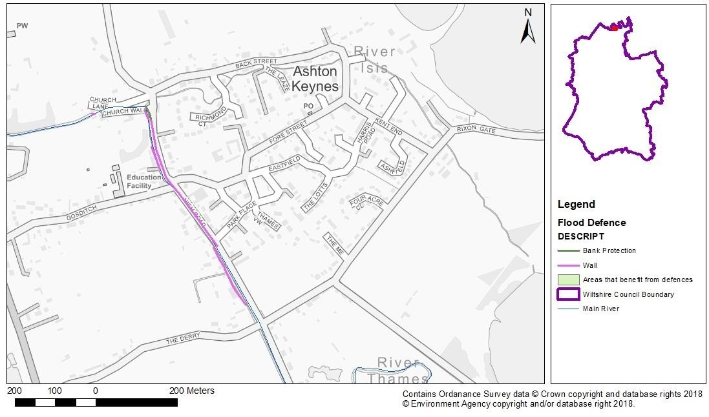
  - Defences in key locations in Wiltshire Ashton Keynes, North Wiltshire

Ashton Keynes is situated near the River Isis / River Thames. Within the town, walls are built along a relatively large section of High Road as well as additional bank protection.

Wiltshire Council Level 1 SFRA v5.0 42
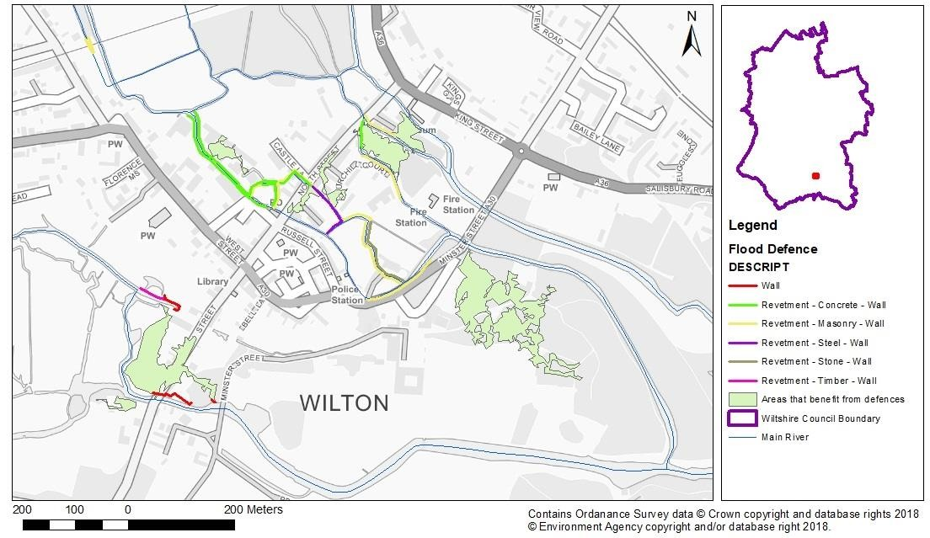
Wilton, South Wiltshire

The River Wylye flows through Wilton. There are several defences throughout the town, most of which are revetments, of various materials. There are also sections of wall in some parts of the town. These defences serve to protect numerous areas of the town.

Wiltshire Council Level 1 SFRA v5.0 43
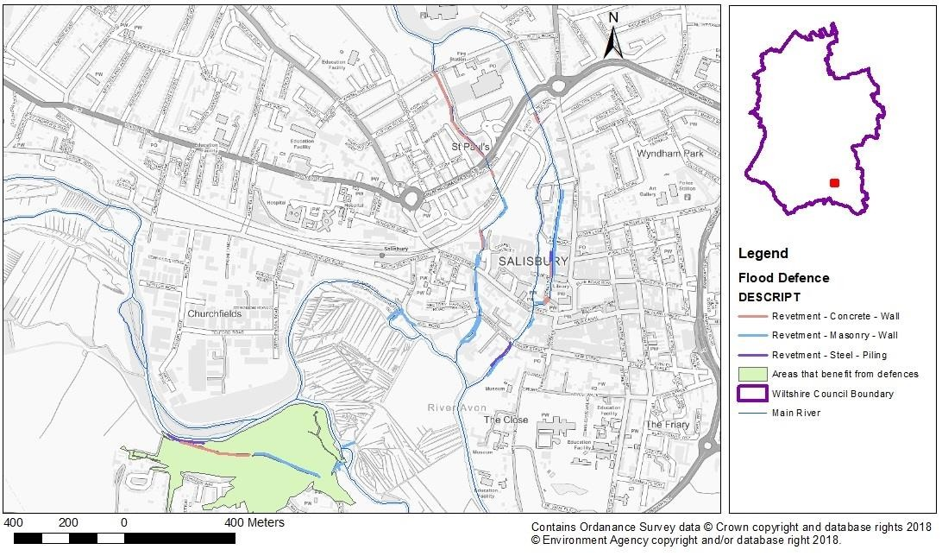
Salisbury, South-East Wiltshire

The River Avon flows through the town and is lined with flood defences in several locations. As shown in the map, all defences in this area of revetments constructed from various materials. These defences are mainly situated in central Salisbury however there are also revetments in the south-west which are shown to protect a large area.

Wiltshire Council Level 1 SFRA v5.0 44
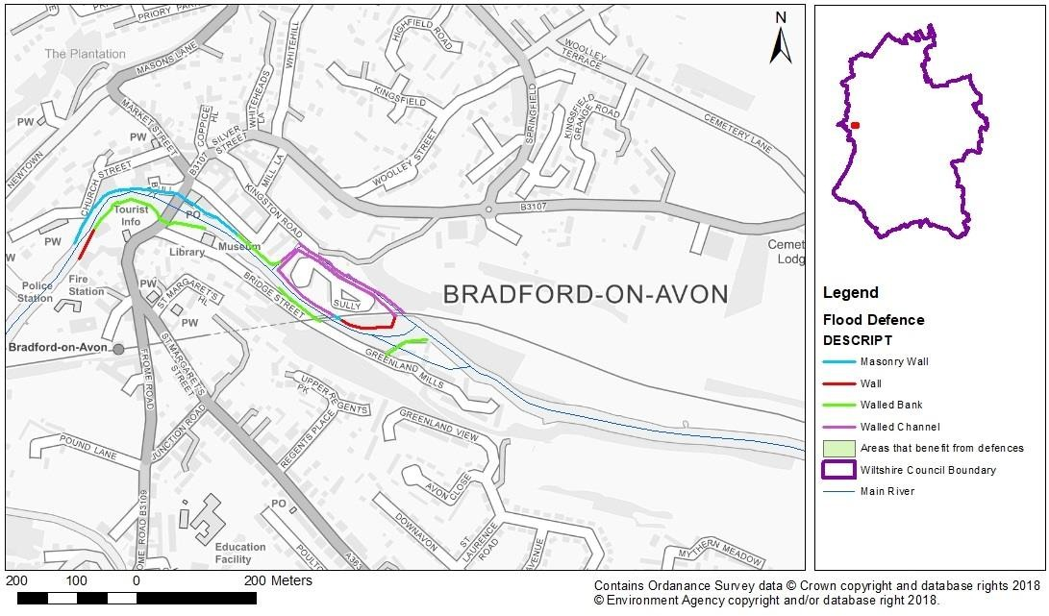
Bradford-on-Avon, West Wiltshire

The River Avon flows through the town which is lined with various flood defence types. Along the river bank there are relatively long walled banks (opposite a masonry wall) as well as other wall defences. In other locations, walled channels are utilised. The defences within the area are focused around a similar location.

Wiltshire Council Level 1 SFRA v5.0 45
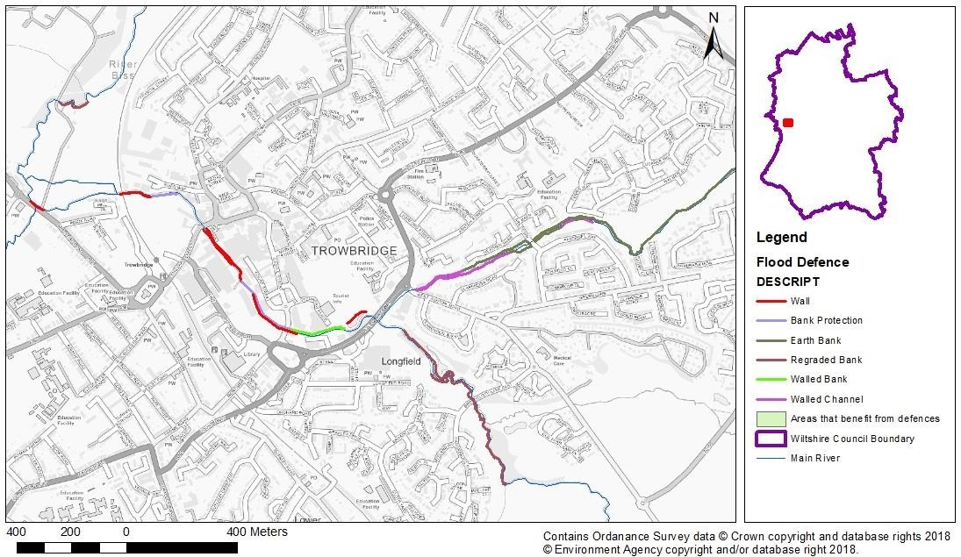
Trowbridge, West Wiltshire

The River Biss flows through the town as well as Paxcroft Brook which forms a tributary from the east. Along the river there are several different defence types. In the south of the town, a large segment has regraded river banks. Further north, walls are used along with walls which line the river banks. The brook also has defences which compromise of walled channels and earth banks.

Wiltshire Council Level 1 SFRA v5.0 46
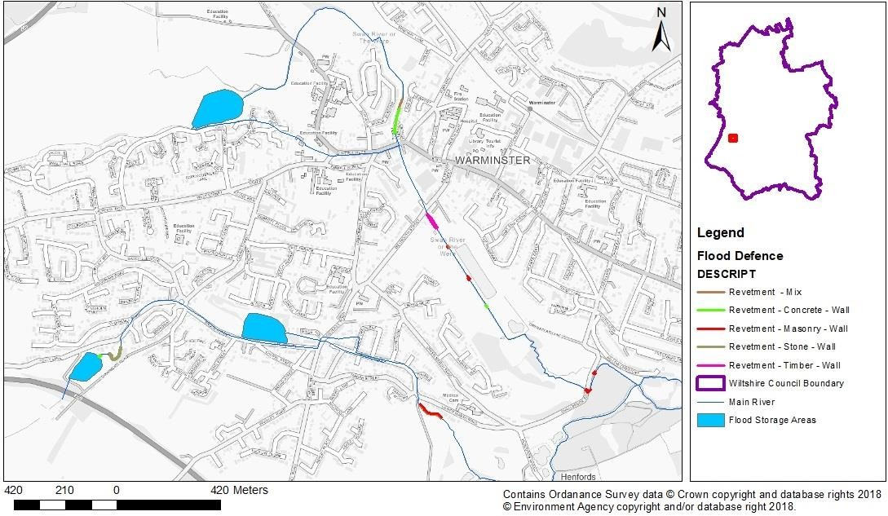
Warminster, West Wiltshire

The River Were is the Main River of Warminster. In the south-west, the Cannimore Stream also flows through the town. Along the River there is a large flood storage area. There are two further storage areas south-west of the town which are located along the Cannimore Stream. In the town there are several stretches of the river that have defences, all of which are revetments constructed of various materials.

Wiltshire Council Level 1 SFRA v5.0 47
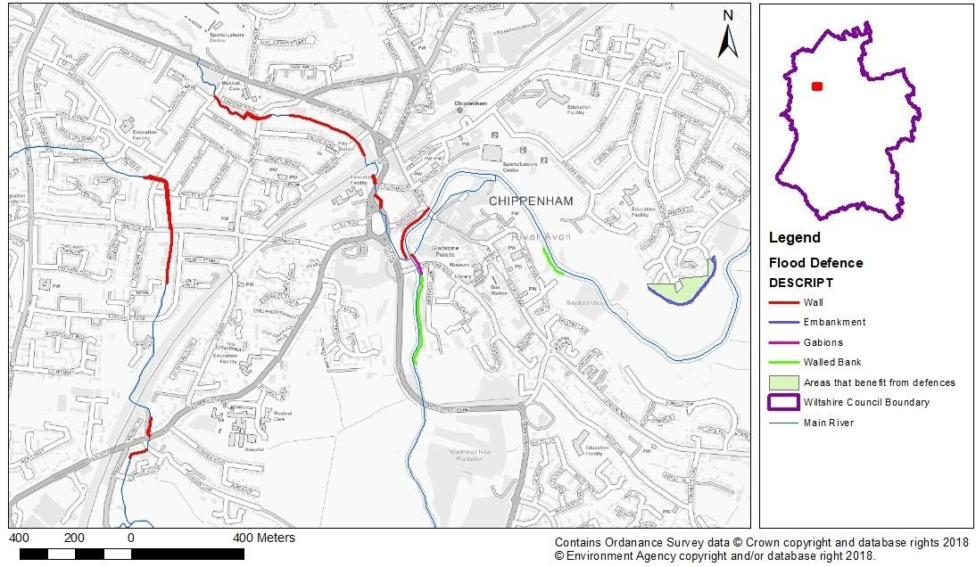
Chippenham, North-West Wiltshire

The Main River within Chippenham is The River Avon. A large section of the river, within the town centre, has defences which include walls, gabions and river bank walls. Away from the river (east of the map) there is an embankment area which serves to protect an area of the town. Within Chippenham, there is also Ladyfield Brook (west) and Hardenuish Brook (north) which are both lined with walls as a form of flood defence.

Wiltshire Council Level 1 SFRA v5.0 48
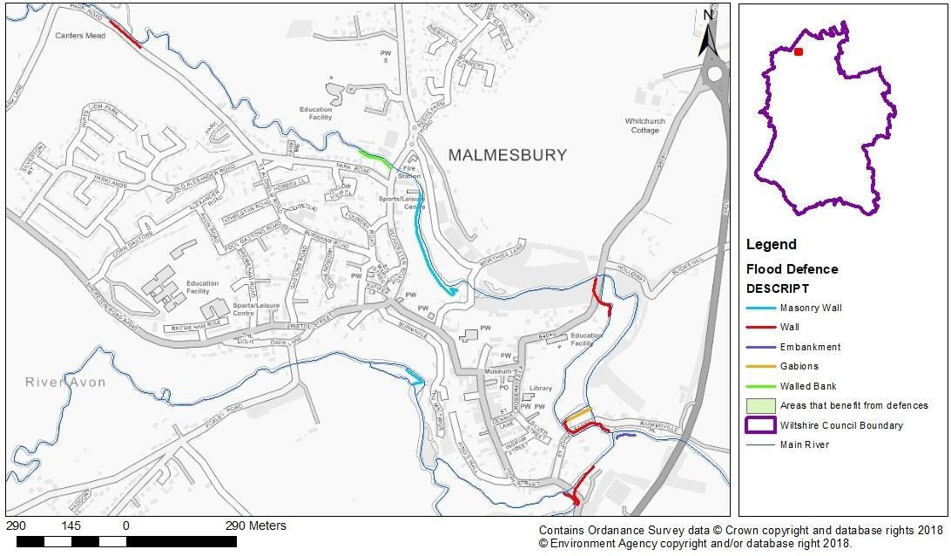
Malmesbury, North Wiltshire

The River Avon flows through Malmesbury, and the town is protected via several different flood defences. A large proportion of the defences are walls including masonry walls and river bank walls. There are is also a section of the river that is reinforced through the use of gabions. An embankment has also been installed (south-east on the map).

Wiltshire Council Level 1 SFRA v5.0 49
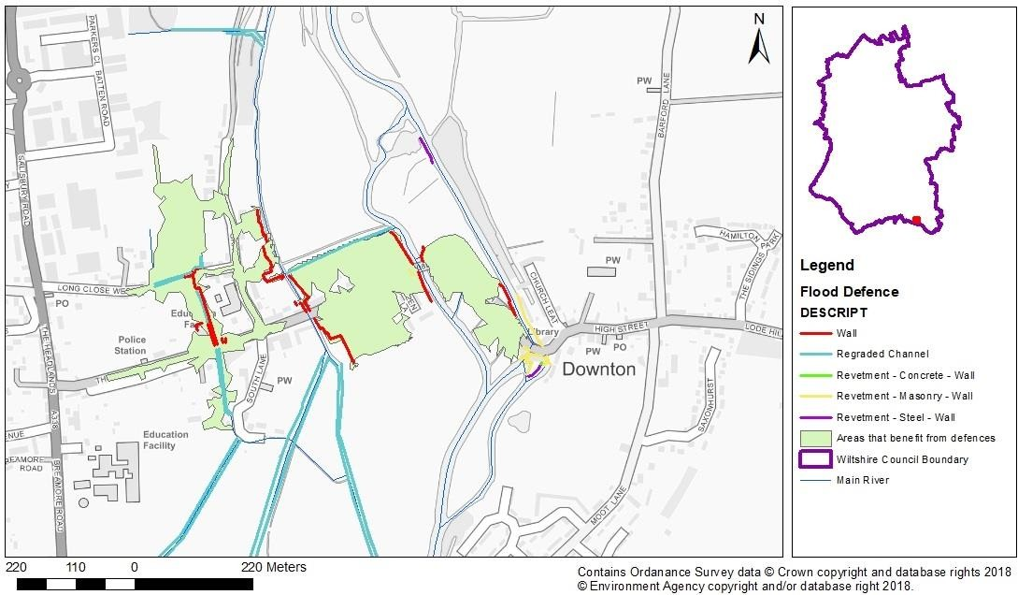
Downton, South Wiltshire

In the village of Downton, there are multiple channels that pose a risk of flooding. The Newcourt Carrier has substantial stretches of regraded channel as well as constructed walls. Similarly, the Bunny also has regraded channel and sections of walls. The River Avon has other types of defence including revetments (concrete, steel and masonry). These defences act together to protect a large amount of the central areas of the village.

Wiltshire Council Level 1 SFRA v5.0 50
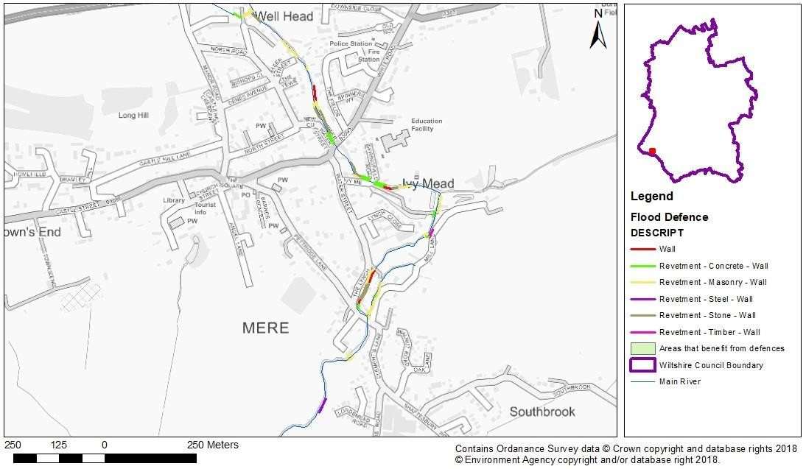
Mere, South-West Wiltshire

The water course through Mere is Shreen Water. Along this segment of the river there are various forms of flood defence. The most common form is revetments however there are multiple types within the area. There are also flood defence walls in place.

Wiltshire Council Level 1 SFRA v5.0 51
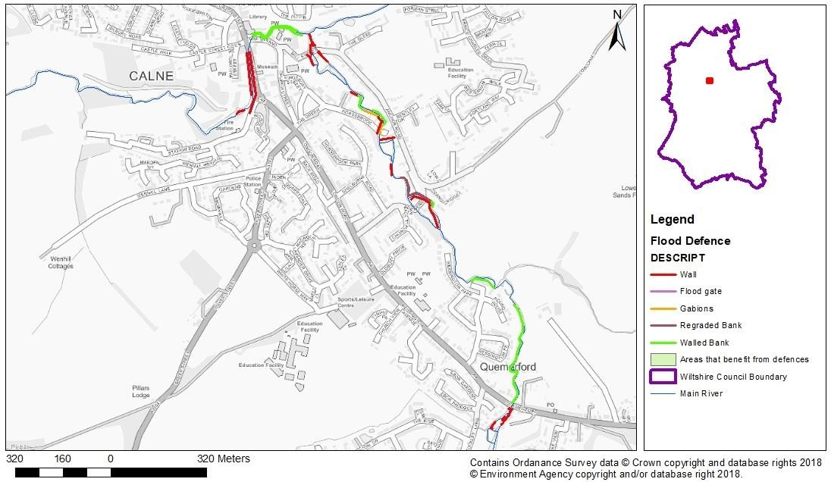
Calne, North Wiltshire

The River Marden flows through Calne. Throughout the town there are various defences. A large wall segment is installed on both sides of the river whereby it is close to the A4 (New Road). Similarly, river bank walls are also installed. A segment of the river has been regraded as well as the installation of gabions. Within the area there is also a flood gate positioned near Church Street in the centre of Calne.

Wiltshire Council Level 1 SFRA v5.0 52

- The sequential risk-based approach
  - Introduction
The sequential, risk-based approach outlined in the NPPF and the Planning Practice Guidance is designed to ensure areas with little or no risk of flooding (from any source) are developed, in preference to areas at higher risk. The aims are to keep development outside medium and high flood risk areas (Flood Zones 2 and 3), and that within Flood Zone 1, development is situated away from areas at risk from all other sources of flooding. This includes ordinary watercourses, surface water, reservoirs, groundwater and sewer flooding.
The flood risk management hierarchy underpins the risk-based approach and is the basis for making all decisions involving development and flood risk. When using the hierarchy, account should be taken of:
    - the nature of the flood risk (the source of the flooding);
    - the spatial distribution of the flood risk (the pathways and areas affected by flooding);
    - climate change impacts; and
    - the degree of vulnerability of different types of development (the receptors).
Development proposals should be guided by the application of the Sequential Test using the maps produced for this SFRA. The information in this SFRA should be used as evidence and, where necessary, reference should also be made to relevant evidence in other documents referenced in this report. The Flood Zone maps and flood risk information on other sources of flooding contained in this SFRA should be used where appropriate to apply the Sequential Test.
Where other sustainability criteria outweigh flood risk issues, the decision-making process should be transparent. Information from this SFRA should be used to justify decisions to allocate land in areas at high risk of flooding.
The flood risk management hierarchy is summarised in Figure 5.1.

Step 3: Manage Step 4: Mitigate
Step 1: Assess

SFRA
Site-specific FRAs
Step 2: Avoid

Apply Sequential Test
Sequential approach within sites

      - Flood defences.
      - No overall increase in risk
e.g. SuDS
- Flood resilient design and construction

Figure 5.1 Flood risk hierarchy

  - Applying the Sequential Test and Exception Test in the preparation of a local plan
When preparing a Local Plan, the Local Planning Authority should demonstrate it has considered a range of site allocations, using Strategic Flood Risk Assessments to apply the Sequential and Exception Tests where necessary.

    - Sequential Test
The Sequential Test should be applied to the whole LPA area to increase the opportunities to allocate development in areas not at risk of flooding. The Planning Practice Guidance 'Applying the Sequential Test in the preparation of a Local Plan' describes the process.
Wiltshire Council will carry out the Sequential Test for all sites that have come forward through the local plan process, taking into account all sources of flooding, and an appropriate allowance for climate change. The climate change allowances have been
Wiltshire Council Level 1 SFRA v5.0 53
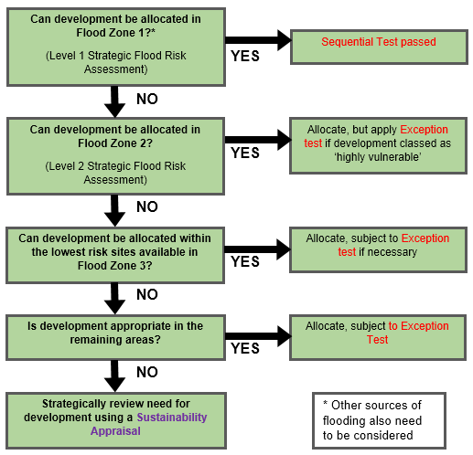
considered in the modelling of this study. The findings will be considered in balance with other criteria, outlined either within a Sequential Test document or as part of the Sustainability Appraisal process.

Figure 5.2 Applying the Sequential Test in preparation of a Local Plan
The first stage of the Sequential Test will identify all potential sites located within Flood Zone 1, and at low risk of flooding from all other sources, in order that they can be taken forward for consideration for inclusion in the Local Plan at the Preferred Option Stage (Figure 5.2). In Wiltshire, for a site to be considered at low risk of flooding, it meets the following conditions, determined by the Council:
      - Site is within Flood Zone 1
      - Site is not within Flood Zone 3 plus climate change
      - Less than 10% of the site is at risk from surface water flooding in the 1 in 1,000- year event
      - Less than 10% of the site is within highest risk category in JBA Groundwater map (groundwater is <0.025m below the surface in the 1 in 100-year event)
      - Less than 75% of the site is within the second highest risk category in JBA Groundwater map (groundwater is between 0.025m and 0.5m below the surface in the 1 in 100-year event)
      - Site is not within an area highlighted on the Historic Flood Map
      - Site is not at risk of reservoir flooding
      - Site does not contain a Main River

Wiltshire Council Level 1 SFRA v5.0 54









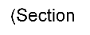
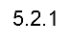


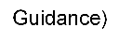



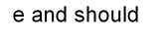


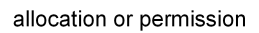





      - Site does not contain an Ordinary Watercourse (as shown on OS mapping)
      - Site is not within 100m of a canal
      - Site is not in a Critical Drainage Area.
The above criteria take into account the potential to mitigate low levels of surface water and groundwater risk through appropriate design, and therefore are not likely to represent a significant constraint to development.
It is possible that all the necessary development required over the plan period cannot be accommodated by sites identified above as low risk from all sources (noting that the sustainability appraisal process may discount some low risk sites on other grounds), and additional sites may be required to enable delivery of the level of development set out in the Local Plan.
The next stage will be to undertake a Level 2 SFRA to provide further detail on the flood risk (including flood hazards and depths, actual flood risk and residual flood risk to sites), the potential for using sequential design of the site to move development away from flood risk and provide evidence for the application of the Exception Test if required.
Whilst it is not mandatory to provide a Level 2 SFRA, where a Level 1 SFRA indicates that sites outside flood risk areas cannot accommodate the extent of development proposed, local authorities are advised to consider progressing to Level 2 in order to provide further detail and development solutions for prescribed sites and for the application of the Exception Test, if required.
In Wiltshire, where several potential development sites are defended by recent flood alleviation schemes, the residual flood risk to these sites should be assessed within a Level 2 SFRA.

    - Exception Test
If, following an application of the Sequential Test, it is not possible for the development to be located in areas with a lower probability of flooding, the Exception Test must then be applied if required.
The guidance also explains how the Exception Test should be applied in the preparation of a Local Plan (Figure 5.3), as shown in Diagram 3 of the Planning Practice Guidance.

Notes: Based on Diagram 3 of NPPF Planning Practice Guidance: Flood Risk and Coastal Change (paragraph 028, Reference ID: 7-021-20140306) March 2014
In Flood Zone 3a essential infrastructure should be designed and constructed to remain operational and safe in times of flood.

Wiltshire Council Level 1 SFRA v5.0 55

In Flood Zone 3b (functional floodplain) essential infrastructure that has to be there and has passed the Exception Test, and water-compatible uses, should be designed and constructed to: remain operational and safe for users in times of flood; result in no net loss of floodplain storage; not impede water flows and not increase flood risk elsewhere.
Figure 5.3 Applying the Exception Test in the preparation of the Local Plan
The requirements for the Exception Test depend on the proposed type/vulnerability of the development and the Flood Zone, as set out in Table 3 of the Planning Practice Guidance.
Vulnerability classifications for different types of development are given in Table 2 of the PPG. The majority of the allocations to be made in Wiltshire are housing (More Vulnerable, but Highly Vulnerable for basement dwellings), with some employment (Less Vulnerable). Some developments may contain different elements of vulnerability and the highest vulnerability category should be used, unless the development is considered in its component parts.
It should be noted that Table 3 of the Planning Practice Guidance is focussed on fluvial and coastal Flood Zones, and has not, as of February 2019, been updated to reflect the 2018 update of the NPPF, which aims to steer development to areas of the lowest flood risk considering all sources both now and in the future. In the context of Wiltshire, it is important that the risks from other sources, particularly surface water and groundwater, are addressed.
The Exception Test should only be applied following the application of the Sequential Test. For the Exception Test to be passed:
- it must be demonstrated that the development provides wider sustainability benefits to the community that outweigh flood risk (informed by the evidence in the SFRA)
- a site-specific flood risk assessment must demonstrate that the development will be safe for its lifetime taking account of the vulnerability of its users, without increasing flood risk elsewhere, and, where possible, will reduce flood risk overall.
Where required, Wiltshire Council will carry out the Exception Test for potential sites. The Sequential Test, the Exception Test if required and the sustainability appraisal processes will be iterative in nature and inform the site selection process within the Local Plan.

Applying the Sequential Test and Exception Test in the preparation of a Minerals and Waste Plan
Waste and mineral planning authorities need to take account of flood risk when allocating land for development. The sequential approach should be applied to the allocation of sites for waste management and, where possible, to mineral extraction and processing.
Landfill and sites used for waste management facilities for hazardous waste are classified as 'more vulnerable' development, whereas waste treatment facilities are 'less vulnerable' development.
Minerals can only be worked where they naturally occur, and the NPPF recognises that there may not be alternative sites in areas of lower flood risk, particularly in the case of sand and gravel, which are deposited on fluvial floodplains. This is acknowledged in the classification of sand and gravel working as 'water-compatible' development, whereas other minerals working and processing facilities are 'less vulnerable' development. Essential ancillary development required for sand and gravel extraction, such as mineral processing equipment and site offices, are also defined as 'water-compatible-development' however is subject to a specific flood warning and evacuation plan.
Under the NPPF, the Exception Test is not required for water compatible development uses, which includes the sand and gravel extraction sites within Wiltshire.
However, mineral working should not increase flood risk elsewhere. Extraction sites must be designed, worked and restored appropriately, with consideration to impacts on wider flood risk. Restored mineral workings may offer enhancement of the natural environment such as storage of flood water, amenity and biodiversity. Mineral workings are often large developments and may provide opportunities for applying the sequential approach at the

Wiltshire Council Level 1 SFRA v5.0 56

site level, with ancillary facilities such as offices and accommodation, located in areas of lowest flood risk.
PPG (Para 067) states that where sand and gravel extraction is proposed in the functional floodplain (Flood Zone 3b), it is required to be designed and constructed to:
- Remain operational and safe for users in times of flood
- Result in no net loss of floodplain storage
- Not impede water flows and not increase flood risk elsewhere.
It is recommended that development associated with extraction, such as stockpiles, should be accommodated outside the functional floodplain.

Applying the Sequential Test and the Exception Test to individual planning applications
The Local Plan will include sufficient allocation to meet the need for development over the plan period. However, in addition to these sites, planning applications may come forward in other locations. The Local Plan will need to include policies where proposals such as these can be properly assessed.
In these circumstances, the Local Plan should contain policies which set out how sites not identified in the Local Plan will require the Sequential Test to be applied on an individual site basis. The evidence presented within the SFRA Level 1 is intended to support the decision-making process.
Developers should use evidence provided in this SFRA to apply the Sequential Test as well as provide evidence to show that they have adequately considered other reasonably available sites. This should include other sites allocated within the Wiltshire Local Plan and Wiltshire Minerals and Waste plans as suitable for the proposed development.
When assessing sites not identified in the Local Plan, the following procedure should be followed:
- Identify whether the Sequential Test is required. Applications for some minor development and changes of use should not be subject to the sequential or exception tests. This includes householder development, small non-residential extensions (with a footprint of less than 250m2) and changes of use; except for changes of use to a caravan or chalet site, or to a mobile home or park home site, where the sequential and exception tests should be applied as appropriate.
- If the Sequential Test is required, the LPA should agree the area of search with the applicant. This should be guided by the requirement for the proposed development in a particular area.
- Determine whether there are any other 'reasonably available' sites within Flood Zone 1 and away from other sources of flood risk, or whether the sequential approach can be used to move all of the development within the site boundary to Flood Zone 1 and away from other sources of flood risk.
- If there are found to be other reasonably available sites at a lower risk of flooding, then the development has failed the Sequential Test and planning permission should be refused. If there are no other reasonably available sites, then the development can be deemed as passing the Sequential Test and the Exception Test may be required as set out in Table 3 of the PPG.
The Council does not require the Sequential or Exception Tests to be applied for minor development, changes of use or development sites which have been allocated in the Local Plan through the sequential test. However, applications for these development types should still meet all requirements for site-specific flood risk assessments, as set out in section 6, including consideration to Local Plan policies on flood risk, and the requirements of the LFRMS.

Wiltshire Council Level 1 SFRA v5.0 57

Guidance for Planners and Developers: Flood Risk

When is an FRA required?
The requirement for a site-specific FRA is set out in Paragraph 164 of the NPPF (footnote 50). The Flood Risk Assessment: Local Planning Authorities50 guidance and Flood Risk Assessment for Planning Applications51 guidance describe when a FRA is needed as part of a planning application, how it should be prepared and how it is processed. In Wiltshire, an FRA is required in the following circumstances:
    - In Flood Zone 1
      - All developments greater than 1 ha.
      - Land that may be subject to other sources of flooding (surface water, groundwater, ordinary watercourses, reservoirs and sewers) where its development would introduce a more vulnerable use e.g. change of use from commercial to residential. The FRA must consider the vulnerability of the site to flooding from other sources, as well as the effect of the new development on flood risk elsewhere.
      - All developments located in an area which has been highlighted as having critical drainage problems by the Environment Agency
    - All developments located within Flood Zone 2 or 3 or 3a plus climate change. This includes standing advice52 for minor developments (minor non-residential extensions: industrial/commercial/leisure etc extensions with a footprint less than 250m2, alterations: development that does not increase the size of buildings e.g. alterations to external appearance, householder development: for example, sheds, garages, games rooms etc. within the curtilage of the existing dwelling, in addition to physical extensions to the existing dwelling itself. This definition excludes any proposed development that would create a separate dwelling within the curtilage of the existing dwelling e.g. subdivision of houses into flats).
It is advisable that sites which do not fall within the above requirements should still carry out an appropriate level of assessment, relative to the scale of development and flood risk to the site.
Advice should be sought from the LPA, the LLFA (Wiltshire Council) and/or the Environment Agency, as appropriate, at the pre-planning application stage to determine the need for a site-specific FRA. The Environment Agency charge a fee for this advice. The LLFA also have a charging schedule for pre-application discussions, which can include flood risk matters.
Wiltshire Council will be consulted on the flood risk and surface water drainage aspects of all major development proposals. The Environment Agency will be consulted under the following circumstances53:
Flood Zone 1:
    - If the development is within 20m of a main river;
    - In an area with critical drainage problems, other than minor development as notified by the Environment agency
—————————————————————————————————————————————
- Flood risk assessment: local planning authorities, Department for Environment, Food and Rural Affairs (2017). Accessed online at:
https://www.gov.uk/guidance/flood-risk-assessment-local-planning-authorities on: 18/09/2018
- Flood risk assessment for planning applications, Department for Environment, Food and Rural Affairs (2017).. Accessed online at:
https://www.gov.uk/guidance/flood-risk-assessment-for-planning-applications on: 18/09/2018 52 Flood risk assessment: standing advice, Environment Agency (2017). Accessed online at:
https://www.gov.uk/guidance/flood-risk-assessment-standing-advice#minor-extensions-standing-advice on: 02/01/2019
- Flood risk assessment: local planning authorities, Environment Agency (2017). Accessed online at: https://www.gov.uk/guidance/flood-risk-assessment-local-planning-authorities on: 02/02/2019
Wiltshire Council Level 1 SFRA v5.0 58

Flood Zone 2:
  - If the development is within 20m of a main river;
  - For any development other than minor development, if the development’s flood risk
vulnerability is:
    - Essential infrastructure
    - Highly vulnerable
    - More vulnerable and it’s a landfill or waste facility or is a caravan site
    - Less vulnerable and it’s one of the following: land or building used for agriculture or forestry; a waste treatment site; a mineral processing site, a water treatment plant; or a sewage treatment plant.
Flood zone 3:
  - If the development is within 20m of a main river;
  - For all developments other than a minor development
  - For developments involving a change of use and as a result the flood risk vulnerability has either changed:
    - To more vulnerable or highly vulnerable
    - From water compatible to less vulnerable

Requirements for Flood Risk Assessments
The aim of an FRA is to demonstrate that the development is protected to the 1 in 100-year (1% AEP) event and is safe during the design flood event, including an allowance for climate change and urban creep. This includes an assessment of mitigation measures required to safely manage flood risk.
FRAs should follow government guidance on development and flood risk, complying with the approach recommended by the NPPF (and its associated guidance) in appraising, managing and reducing the consequences of flooding both to and from a development site.
An FRA should first assess in detail the level of flood risk to the site, including but not limited to:
    - The area liable to flooding from all sources of flood risk, including rivers and watercourses (fluvial), surface water (pluvial), groundwater, reservoirs, canals and sewers.
    - The probability of flooding occurring now and over time.
    - The extent and standard of existing flood defences and their effectiveness over time.
    - The likely depth of flooding.
    - The rates of flow likely to be involved.
    - The likelihood of impacts to other areas, properties, habitats and protected species.
    - The effects of climate change.
    - The nature and currently expected lifetime of the development proposed. Proposals for the design of the site should:
    - Be performed in accordance with the requirements of the Sequential Test and, when
necessary, the Exception Test.
    - Not increase flood risk, either upstream or downstream, of the site, taking into account the impacts of climate change.
    - Not increase surface water volumes or peak flow rates that would result in increased flood risk to the receiving catchments.

Wiltshire Council Level 1 SFRA v5.0 59

    - Ensure that where development is necessary in areas of flood risk (after application of the Sequential and Exception Tests and the sequential approach), it is made safe from flooding for the lifetime of the development, taking into account the impact of climate change.
    - Use opportunities provided by new development to reduce flood risk and provide betterment within the site and elsewhere.
    - Seek to use SuDS, green infrastructure and natural flood management, such as increasing floodplain connectivity and enhancing natural flood storage, to provide connectivity for the movement of flood water, habitats and protected species.
    - Identify exceedance routes.
Planning Applications should use, and be assessed against, the latest flood risk data and guidance available. These include the Flood Zone mapping, flood risk assessment requirements and climate change allowances made available by the Environment Agency, as well as flood risk management policies and guidance from Wiltshire Council, as Lead Local Flood Authority.

Assessing the Impact of Climate Change

    - River (fluvial) flooding
A climate change outline for the 1 in 100-year event (Flood Zone 3a plus climate change) for the period up to 2115 has been provided in Appendix D. The climate change allowance that has been applied to this study has produced a Flood Zone 3a + CC extent which combines both the 1 in 100-year plus 35-40% and 70-85% (dependent on region) climate change modelled flood extents. Further detail on the choice of climate change scenario used for this SFRA is given in Section 3.3.4.
However, climate change affects the frequency, as well as the extent of flooding. For example, a storm which currently has a 1 in 50-year return period may increase to a 1 in 20-year return period.
The impact of an event with a given probability is also likely to become more severe. As water depths, velocities and flood hazard increase, so will the risk to people and property.
Although qualitative statements can be made as to whether extreme events are likely to increase or decrease over the UK in the future, there is still considerable uncertainty regarding the magnitude of the localised impact of these changes.

    - Surface water (pluvial) flooding
Climate change is predicted to increase rainfall intensity in the future by a range of between 20% and 40% (the recommended national precautionary sensitive range for 2085 to 2115). This will increase the likelihood and frequency of surface water flooding across the entire county, however it is likely to particularly affect impermeable urban areas that are already susceptible such as Salisbury, Trowbridge and Chippenham.
Mapping showing the impact of climate change on surface water flood risk in the 1 in 100 year plus 40% event is shown in Appendix F.

    - Groundwater flooding
The effect of climate change on groundwater flooding, and those watercourses where groundwater has a large influence on winter flood flows is more uncertain. Milder wetter winters may increase the frequency of groundwater flooding incidents in areas that are already susceptible, but warmer drier summers may counteract this effect by drawing down groundwater levels to a greater extent during the summer months.
Mapping showing the risk of flooding from groundwater is shown in Appendix G.

Wiltshire Council Level 1 SFRA v5.0 60

Reducing Flood Risk through site layout and design
Flood risk should be considered at an early stage in deciding the layout and design of a site to provide an opportunity to reduce flood risk within the development. The NPPF states that a sequential, risk-based approach should be applied to try to locate more vulnerable land use away from all sources of flood risk.
In terms of fluvial risk, all built development should ideally be sited within Flood Zone 1, leaving higher risk Flood Zones undeveloped (e.g. open space) preserving flow routes and flood storage. If this is not possible, then Table 3 of the NPPF indicates appropriate development within each Flood Zone.
Areas at risk from surface water or locations at risk of groundwater emergence should also be protected from development to ensure flow routes are not blocked, preventing water from building up to potentially dangerous depths. The RoFSW maps, groundwater monitoring and detailed surface water or groundwater modelling should be used to inform the site design at the master-planning stage. The Council promotes innovative and flexible design where it is in keeping with the character of the area. Development proposals will be assessed and considered on a site by site basis.
Waterside areas, SuDS, or areas along known surface water flow routes can act as Green Infrastructure. These can be used for recreation, amenity and environmental purposes, allowing the preservation of flow routes and flood storage, and at the same time, providing valuable social and environmental benefits contributing to other sustainability objectives. Landscaping should ensure safe access to higher ground from these areas and avoid the creation of isolated islands as water levels rise.
More flood-compatible development (e.g. vehicular parking, recreational space) may be located in higher risk areas. In assessing the acceptability of vehicular parking in floodplains account should be taken of the nature of parking, flood depths and hazard, including evacuation procedures and flood warning.
There is a requirement to have a buffer of at least 8 metres between the top of the bank of any Main River, and any Environment Agency assets, and the built environment (PPG: Flood Risk and Coastal Change, Paragraph 068). The built environment includes formal landscaping, sport fields, footpaths, lighting and fencing, and the buffer should be managed for native biodiversity. If this buffer is not provided, the development is likely to be subject to an objection by the Environment Agency. The Council will also seek to retain a reasonable clearance along Ordinary Watercourses.
Safe access and escape routes from the development must be provided during the 100- year plus climate change event, from any source of flooding. For some sites, these may need to be demonstrated through an emergency Flood Plan.

Mitigation Measures
In accordance with the Flood Risk Management Hierarchy in Figure 5.1, mitigation measures should be considered as a last resort to address flood risk issues, where the Sequential and Exception Tests have demonstrated that development is necessary for wider sustainability benefits.
Consideration should first be given to minimising risk by planning sequentially across a site. Once risk has been minimised as far as possible, only then should mitigation measures be considered.
The minimum acceptable standard of protection against flooding for new residential property within flood risk areas is 1 in 100-year (1%) plus climate change annual probability for fluvial and pluvial flooding. An allowance for climate change over the lifetime of the development must be made when assessing each of these scenarios. The measures chosen will depend on the nature of the flood risk.
Where a site is at risk of other forms of flooding, including canals and surface water, property mitigation measures must consider the maximum flood extent from these sources.

Wiltshire Council Level 1 SFRA v5.0 61

    - Building Design and Raised Floor Levels
The raising of floor levels within a development avoids damage occurring to the interior, furnishings and electrics in times of a flood. Finished Floor Levels (FFL) are usually recommended in line with the Environment Agency's guidance on flood resilience and resistance measures, which requires a minimum FFL of 300mm above the general ground level of the site, and 600mm above the modelled 1 in 100-year (1%) Annual Exceedance Probability (AEP) fluvial water level with allowance for climate change. This additional height that the floor level is raised above the maximum water level is referred to as the “freeboard”. Additional freeboard may be required because of risks relating to blockages to the channel, culvert or bridge and should be considered as part of an FRA.
The allowance of 600mm above the 1 in 100-year (1% AEP) flood extent also applies to sites at risk of canal flooding, where there further hydraulic modelling of the residual risk of a breach or overtopping event has been undertaken.
If residual surface water flood risk remains following the site drainage design, the likely flow routes and depths across the site should be modelled. The site should be designed so that these flow routes are preserved and building design should provide resilience against this residual risk. FFLs should also be 600mm above the modelled 1 in 100-year (1%) AEP surface water level with allowance for climate change where available. If no surface water model is available, FFLs should be 300mm above ground level.
When raising FFLs, consideration must be given to ensuring that the development is still accessible to all.
Single storey buildings such as ground floor flats or bungalows are especially vulnerable to rapid rise of water. This risk can be reduced by use of multiple storey construction and raised areas that provide an escape route. However, access and egress would still be an issue, particularly when flood duration covers many months.
Similarly, the use of basements should be avoided in areas at risk from any sources of flooding. Habitable uses of basements within Flood Zone 3 should not be permitted, whilst basement dwellings in Flood Zone 2 will be required to pass the Exception Test. All proposals for basements must demonstrate that they will be resistant to groundwater flooding and will not locally impact on groundwater levels to the detriment of existing neighbouring properties.

    - Development and Raised Defences
If development is proposed behind, or in an area benefitting from, defences, the Exception Test will be required. Detailed modelling of a breach and/or overtopping of defences may be required to demonstrate that the development will remain safe in such an event. Consideration should be given to the potential safety of the development, finished floor levels and the potential for safe access and escape routes in the event of rapid inundation of water due to a defence breach with little warning.
Construction of localised raised floodwalls or embankments to protect new development is not acceptable, as a residual risk of flooding will remain. The Environment Agency do not support funding of any flood defences built to enable future development in areas at risk of flooding.
Compensatory storage must be provided where new raised defences remove storage from the floodplain. However, it is preferable for schemes to involve an integrated flood risk management solution.
Temporary or demountable defences are not acceptable forms of flood protection for a new development, but they might be appropriate as part of an agreed emergency plan or to address circumstances where the consequences of residual risk are severe. In addition to the technical measures, the proposals must include details of how the temporary measures will be erected and decommissioned, details of the responsibility for maintenance and the cost of replacement when they deteriorate.

Wiltshire Council Level 1 SFRA v5.0 62

    - Developer contributions
In some cases, and following the application of the Sequential Test, it could potentially be necessary for the developer to make a contribution to the improvement of flood management provision that would benefit both proposed new development and the existing local community. Where development has a direct impact on flood risk, the Council may require developer contributions to be made, under Section 106 of the Town and Country Planning Act. Elsewhere, Community Infrastructure Levy funding may be made available for the provision of flood risk management infrastructure that would benefit the wider community.

    - Modification of Ground Levels
Modifying ground levels to raise the land above the required flood level is an effective way of reducing flood risk to a particular site, in circumstances where the land does not act as conveyance for flood waters. However, care must be taken at locations where raising ground levels could adversely affect existing communities, property or protected habitat.
There should be no interruption to flood flows or loss of flood storage as a result of any proposed development. Flood storage compensation may be appropriate for sites on the edge of the existing floodplain or within a flood cell.
Compensatory flood storage should be provided, and would normally be on a level for level, volume for volume basis on land that does not currently flood but is adjacent to the floodplain (in order for it to fill and drain). It should be in the vicinity of the site and within the red line of the planning application boundary.
Any proposal for modification of ground levels will need to be assessed as part of a detailed flood risk assessment and must demonstrate that there is no adverse impact on the hydrological and hydrogeological setting.

    - Groundwater Mitigation
Groundwater flooding has a complex, and very different flood mechanism to any other and for this reason many conventional flood defence and mitigation methods are not suitable. An available option to manage groundwater flood risk would be through building design (development form), ensuring Finished Floor Levels are raised 600mm above the water levels caused by a 1 in 100-year plus climate change event. Site design would also need to preserve any flow routes followed by the groundwater overland to ensure flood risk is not increased downstream. Obstruction of sub-surface flows by buried services and basements should be avoided.
Infiltration SuDS can cause locally increased groundwater levels and subsequently may increase flood risk on or off the site. High groundwater levels would also cause them not to operate to their design capacity. Developers should provide evidence that this has been considered in the design and ensure that this will not be a significant risk. The depth of the proposed SuDS must be kept to a minimum and developers should make allowance for wide shallow SuDS such as wetlands and detention basins.
When redeveloping existing buildings, it may be acceptable to install pumps in basements as a resilience measure. However, for new development this is not considered an acceptable solution and basements should be avoided in high groundwater zones.
The management of groundwater also requires consideration during the construction process, as there is a risk that groundworks can lead to releases of groundwater, and/or provide a pathway for the contamination of groundwater.

    - Sewer Flooding Mitigation
Where development is proposed within, or further up the network from, areas where sewer flooding has been recorded, it is recommended that the relevant water and sewerage company is consulted as early as possible in the planning process, as there may be network capacity issues which need to be dealt with.

Wiltshire Council Level 1 SFRA v5.0 63

When redeveloping existing buildings, the installation of some permanent or temporary flood-proofing and resilience measures could protect against both surface water and sewer flooding. Non-return valves prevent water entering the property from drains and sewers. Non-return valves can be installed within gravity sewers or drains within a property’s private sewer upstream of the public sewerage system. These need to be agreed with the relevant water and sewerage company and must be regularly maintained. Consideration must also be given to attenuation and flow ensuring that flows during the 100-year plus climate change storm event are retained within the site if any flap valves shut. This must be demonstrated with suitable modelling techniques.

    - Flood Resilience of Heritage Buildings and Assets
Heritage buildings and other assets may be particularly vulnerable to flooding, as a result of their age, materials and construction techniques. In the case of highly sensitive heritage assets, it may simply not be possible to rebuild or replace them in the event of flood damage.
Resilience measures need to be carried out in sympathy with the special architectural or historic interest of a building. Where flood resilience or defence measures are planned to or within the curtilage of a listed building, they may require listed building consent from the local planning authority. Planning consent may be required for works within a Conservation Area. In the case of Scheduled Ancient Monuments, consent may be required from the Secretary of State.
Historic England have published detailed advice on flooding and historic buildings54.

Water Framework Directive and Natural Flood Risk Management
All new development close to rivers and culverts should consider the opportunity presented to improve and enhance the river environment and contribute to national, county and local biodiversity targets.
Requirements of the WFD should be accounted for in the site layout and design. Developments should look at opportunities for river restoration and enhancement, and projects which reconnect rivers with their floodplains. These ideas and plans should be incorporated into the development plans from an early stage. Options include backwater creation, de-silting, de-culverting and naturalising the channel through in-channel habitat enhancements and removal of structures.
When designed properly, such measures can have benefits such as reducing the costs of maintaining hard engineering structures, reducing flood risk, improving water quality and increasing biodiversity. Social benefits are also gained by increasing green space and access to the river. Advice on river restoration, de-culverting and providing other environmental enhancements on development sites is available from the Environment Agency55.
In Wiltshire, achievement of WFD requirements is variable. The River Till, Lower River Wylye, River Ebble, some of the tributaries to the Bristol Avon and the Kennet and Avon Canal are among the waterbodies that have achieved overall “good” status. The remaining river reaches are classified as moderate or poor, and two have an overall status of “bad” (Derry Brook and the River Loddon).
Natural Flood Management (NFM), also known as Working with Natural Processes (WWNP), involves implementing measures that help protect, restore and emulate the natural functions of catchments, floodplains, rivers and the coast56. NFM schemes also provide
—————————————————————————————————————————————
- Historic England (2015) Flooding and Historic Buildings. Second Edition. Accessed online at: https://historicengland.org.uk/images-books/publications/flooding-and-historic-buildings-2ednrev/heag017-flooding- and-historic-buildings/ on 11/03/2019.
- Building a better environment: A guide for developers, Environment Agency (2006). Accessed online at: http://www.environment-agency.gov.uk/static/documents/1_GETH1106BLNE-e-e(1).pdf on: 01/10/2018 56 Working with Natural Processes: Summary, Environment agency (2017). Accessed online at:
https://assets.publishing.service.gov.uk/government/uploads/system/uploads/attachment_data/file/654429/Working
_with_natural_processes_summary.pdf on: 19/09/2018
Wiltshire Council Level 1 SFRA v5.0 64

ecological and water quality benefits which can aid the achievement of Water Framework Directive targets. The effectiveness of NFM is highly dependent on the setting; the right NFM measure in the correct topographical setting.
A series of strategic maps indicating the relative suitability of areas in England for NFM measures has been produced by the Environment Agency. The 'Mapping Areas of Potential for Working with Natural Processes' maps identify the potential for a range of options, including:
  - floodplain reconnection;
  - run-off attenuation features;
  - gully blocking;
  - woodland planting covering floodplain planting, riparian planting and wider catchment woodland.
This mapping is available through the Environment Agency’s Spatial Data Catalogue57 in GIS format, and is also hosted in an interactive online format by JBA Consulting58.
The mapping identifies locations throughout the study area where there may be potential for floodplain reconnection, with the highest density of locations in the Upper Thames catchment in the north of Wiltshire. Possible methods could include daylighting culverts, creating floodplain spillways and returning modified sections of watercourses to their former, often more sinuous courses.
Runoff attenuation features include measures such as swales, ponds and sediment traps, and suitable locations are linked to accumulations of surface water identified by the Risk of Flooding from Surface Water map.
Opportunities for woodland planting aimed at improving soil structure, increasing infiltration and increasing evapotranspiration exist in the north west of Wiltshire and in the Upper Nadder catchment. Opportunities for floodplain woodland planting exist along many of the watercourses throughout Wiltshire.
The WWNP mapping is designed as a screening tool to identify locations where NFM measures might be effective. Further investigation is always required combining the latest datasets, local knowledge and, where required, hydraulic modelling.
The Environment Agency have published guidance59 on how to use the WWNP mapping and evidence base to make the case to implement NFM measures.

Existing watercourses and assets
Permanent or temporary works within or adjacent to a watercourse require a consent from the relevant authority, under the Land Drainage Act 1991. A Flood Risk Activity Environmental Permit60 must be obtained from the Environment Agency for any works carried out within the channel, banks or within 8m from the edge of a main river. For works within 8m of an ordinary watercourse, a Land Drainage Consent must be requested from Wiltshire Council. For discharges into any river (including main) or watercourse, the flow rate must also be agreed with Wiltshire Council.
Proposed developments which are adjacent to Environment Agency assets, including Main River channels, must demonstrate a minimum clearance of 8m from these assets to permit

—————————————————————————————————————————————
- Spatial Data Catalogue, Environment Agency (2017). Accessed online at: https://environment.data.gov.uk/ds/catalogue/#/catalogue on: 19/09/2018
- Mapping the Potential for Working with Natural Processed, JBA Consulting, (2018). Accessed online at: http://wwnp.jbahosting.com/ on: 19/09/2018
- Working with Natural Processes – Using the evidence base to make the case for Natural Flood Management, Environment Agency (2017). Accessed online at: https://assets.publishing.service.gov.uk/government/uploads/system/uploads/attachment_data/file/654435/Working
_with_natural_processes_using_the_evidence_base.pdf on: 19/09/2018
- Flood risk activities: environmental permits, Environment Agency (2018). Accessed online at: https://www.gov.uk/guidance/flood-risk-activities-environmental-permits on: 01/10/2018
Wiltshire Council Level 1 SFRA v5.0 65

maintenance and renewal. The Council will ensure a similar buffer width is retained alongside ordinary watercourses, to allow sufficient space for access and maintenance.
The Environment Agency and Wiltshire Council have a presumption against allowing further culverting and building over culverts on watercourses. All new developments with culverts running through the site should seek to de-culvert rivers for flood risk management and conservation benefit. Existing watercourses and drainage channels should be retained, offering risk management authorities benefits in terms of maintenance, future upgrading, biodiversity and pollution prevention. The CIRIA (2010) Culvert Design and Operation Guide provides guidance in this area.
Where developers are riparian owners, they should also assess existing assets (e.g. bridges, culverts, river walls, embankments) and renew them to last the lifetime of the development. Enhancement opportunities should be sought when renewing assets, e.g. bioengineered river walls, raising bridge soffits to account for climate change. Any works should be designed to be maintenance free, but there is an obligation to the riparian owner to undertake maintenance when required. Practical guidance on the responsibilities of riparian owners is provided by the Environment Agency.61
The responsible parties for ownership and maintenance of all watercourses within a proposed development site must be specified. Both short and long-term maintenance requirements should be taken into account.

—————————————————————————————————————————————
- Owning a watercourse, Environment Agency (2018). Accessed online at: https://www.gov.uk/guidance/owning-a-watercourse on: 08/01/2019
Wiltshire Council Level 1 SFRA v5.0 66

7 Guidance for planners and developers: Surface water runoff and drainage

Introduction
Sustainable Drainage Systems (SuDS) are drainage features which attempt to replicate natural drainage patterns, through capturing rainwater at source, and releasing it slowly into the ground or a water body. They can help to manage flooding through controlling the quantity of surface water generated by a development and improve water quality by treating urban runoff. SuDS can also deliver multiple benefits, through creating habitats for wildlife and green spaces for the community.
The Level 1 SFRA provides surface water drainage considerations to inform Local Plan policy, and the review of planning applications as part of the Development Management process. Technical guidance on SuDS design is provided by Wiltshire Council, as Lead Local Flood Authority, as well as the Defra Non-Statutory Technical Standards62 and CIRIA SuDS Manual63.
Since April 201564, management of the rate and volume of surface water has been a requirement for all major development sites, through the use of SuDS.

Local SuDS Design Guidance

    - SuDS Suitability
SuDS can be integrated into the design of all new development within Wiltshire. The effectiveness of SuDS within a site is defined by site characteristics including (but not limited to) topography, geology, soil permeability, water table, existing water flows across the site, land ownership and extent of site coverage necessary to effectively manage surface water runoff and drainage.
Site characteristics can vary greatly over small areas and therefore each site should be individually investigated to ensure suitability of the proposed infiltration technique.
Opportunities for SuDS in densely urbanised areas of Wiltshire such as Salisbury and Chippenham may appear limited. However, there are a range of suitable, space-efficient options for managing surface water, such as green roofs, rainwater harvesting systems, rills and permeable paving, which can provide benefits in terms of efficient use of water resources, amenity, biodiversity and overall water quality.

    - SuDS Design
The CIRIA SuDS Manual details the industry standards for the design of SuDS and should be consulted in all surface water drainage designs.
A comprehensive understanding of the hydrological processes within a catchment (i.e. the nature and capacity of the existing drainage system) is essential in the design of SuDS. The site drainage must be designed around the natural flow routes (both onsite, and entering the site) at the masterplanning stage, keeping water on the surface to provide maximum benefits and must not contribute to flooding off site.

—————————————————————————————————————————————
- Non-statutory technical standards for sustainable drainage systems, Defra (March 2015). Accessed online at: https://www.gov.uk/government/uploads/system/uploads/attachment_data/file/415773/sustainable-drainage- technical-standards.pdf on: 26/09/2018
- The SuDS Manual (C753), CIRIA (2015). Accessed online at: http://www.ciria.org/Memberships/The_SuDs_Manual_C753_Chapters.aspx on: 26/09/2018
- House of Commons: Written Statement (HCWS161) Written Statement made by: The Secretary of State for Communities and Local Government (Mr Eric Pickles) on 18 Dec 2014. Department for Communities and Local Government (2014). Accessed online at:
https://www.parliament.uk/documents/commons-vote-office/December%202014/18%20December/6.%20DCLG- sustainable-drainage-systems.pdf on: 26/09/2018

Wiltshire Council Level 1 SFRA v5.0 67

Details of the operation and maintenance requirements for the surface water drainage system, and the party responsible for this maintenance should be provided and guaranteed for the lifetime of the development. There is a presumption against Wiltshire Council (as the LLFA) adopting and maintaining SuDS draining properties, however certain SuDS for highway drainage may be adopted in Wiltshire Council’s role as a highway authority.
Planning and managing the construction of SuDS is a key consideration, and a construction management plan should accompany SuDS proposals. Further construction guidance and considerations are detailed in the CIRIA Guidance on the Construction of SuDS65.

    - Runoff Rates and Storage Volumes
The Defra Non-Statutory Technical Standards for Sustainable Drainage provide the following requirements for developments on greenfield and previously developed sites:
      - Peak flow and volume control for post development runoff in relation to pre development runoff.
      - Flooding must not occur on any part of the site for a 1 in 30-year rainfall event.
      - Flooding must not occur during a 1 in 100-year plus climate change rainfall event in any part of: a building (including a basement); or in any utility plant susceptible to water (e.g. pumping station or electricity substation) within the development.
      - Rainfall in excess of a 1 in 100-year plus climate change rainfall event must be managed via exceedance routes that minimise the risks to people and property.
For residential development, which has an assumed design life of 100 years, the ‘upper end’ (2080s) climate change allowance of 40% must be applied to storage volumes for the 1 in 30-year and the 1 in 100-year rainfall events. The upper end ‘2050s’ allowance of 20% may be appropriate for developments with a short to medium-term design life, such as employment sites.
An allowance in calculations must also be made for ‘urban creep’, the impact of permeable surfaces in a development (e.g. front gardens), gradually becoming paved over to form impermeable extensions (such as patios or driveways).

    - Discharge Location
The destination of surface water that is not collected for use on site should be prioritised according to the discharge hierarchy, with infiltration preferred, followed by discharge to surface waters, such as a watercourse or lake, then discharge to a surface water sewer, and finally discharge to a combined sewer as a last resort.
New connections to existing surface water or combined sewers are the least preferred options and should only be considered where other discharge routes are proven to be infeasible. Discharge to a foul sewer is not a viable option, as it is a major contributor to sewer flooding.
The FRA and/or site drainage strategy should include confirmation from the relevant Risk Management Authority that capacity is available, and that the connection will not result in an increase in the flood risk off-site. Discharge to a highway drain system will not normally be allowed. Whatever the ultimate point of discharge, the drainage strategy should demonstrate that the outfall will remain operational during flood events, or where this is not possible that periods when the outfall are restricted are taken into account in the design of surface water storage.

    - Water Quality, Biodiversity and Amenity
Sustainable Drainage Systems (SuDS) allow the management of diffuse pollution generated by urban areas through the sequential treatment of surface water reducing the pollutants
—————————————————————————————————————————————
- Guidance on the Construction of SuDS (C768), CIRIA (2018) Accessed online at: https://www.ciria.org/Resources/Free_publications/Guidance_on_the_construction_of_SuDS_-_C768.aspx on: 26/09/2018
Wiltshire Council Level 1 SFRA v5.0 68

entering lakes and rivers, resulting in lower levels of water supply and wastewater treatment being required. This treatment of diffuse pollution at source can contribute to meeting WFD water quality targets, as well as national objectives for sustainable development.
This is usually facilitated via a SuDS Management Train of a number of components in series that provide a range of treatment processes delivering gradual improvement in water quality and providing an environmental buffer for accidental spills or unexpected high pollutant loadings from the site.
Managing pollution close to its source can help keep pollutant levels and accumulation rates low, allowing natural processes to be more effective. Treatment can often be delivered within the same components that are delivering water quantity design criteria, requiring no additional cost or land-take.
SuDS designs should control the ‘first flush’ of pollutants (usually mobilised by the first 5mm of rainfall) at source, to ensure contaminants are not released from the site. Best practise is that no runoff should be discharged from the site to receiving watercourses or sewers for the majority of small (e.g. less than 5mm) rainfall events.
Early consideration of SuDS within master planning will typically allow a more effective scheme to be designed.
The water within a SuDS component is an essential resource for the growth and development of plants and animals, and biodiversity benefits can be delivered even by very small, isolated schemes. The greatest value can be achieved where SuDS are planned as part of a wider green landscape, providing important habitat, and wildlife connectivity. With careful design, SuDS can provide shelter, food, foraging and breeding opportunities for a variety of species including plants, amphibians, invertebrates, birds, bats and other animals.
Designs using surface water management systems to help structure the urban landscape can enrich its aesthetic and recreational value, promoting health and well-being and supporting green infrastructure. Water managed on the surface rather than underground can help reduce summer temperatures, provide habitat for flora and fauna and act a resource for local environmental education programmes and working groups and directly influence the sense of community in an area.

    - Further Guidance on SuDS
Further general guidance on SuDS can be found in the documents and websites below:
      - CIRIA - there are several CIRIA guides relating to SuDS, most notably the CIRIA SuDS Manual66 and Guidance on the construction of SuDS67.
      - Defra Non-statutory Technical Standards for Sustainable Drainage Systems68.
      - Institution of Civil Engineers & ACO (2018) SuDS Route Maps: Guide to Effective Surface Water Management69.

—————————————————————————————————————————————
- The SuDS Manual (C753), CIRIA (2015). Accessed online at: http://www.ciria.org/Memberships/The_SuDs_Manual_C753_Chapters.aspx on: 26/09/2018 67 Guidance on the construction of SuDS (C768), CIRIA (2017). Accessed online at:
https://www.ciria.org/Resources/Free_publications/Guidance_on_the_construction_of_SuDS_-_C768.aspx on: 26/09/2018
- Non-statutory technical standards for sustainable drainage systems, Defra (March 2015). Accessed online at: https://www.gov.uk/government/uploads/system/uploads/attachment_data/file/415773/sustainable-drainage- technical-standards.pdf on: 26/09/2018
- SuDS Route Maps: Guide to Effective Surface Water Management, Institution of Civil Engineers & ACO (2018). Accessed online at:
https://www.ice.org.uk/getattachment/knowledge-and-resources/best-practice/sustainable-drainage-systems/ICE- ACO-SuDS-Route-Map-Booklet-Feb2018.pdf.aspx on: 26/09/2018

Wiltshire Council Level 1 SFRA v5.0 69

  - Susdrain website70 - online community for delivering sustainable drainage.
  - Local Authority SuDS Officer Organisation - Non-Statutory Technical Standards for Sustainable Drainage: Best Practice Guidance71
  - BSI Standards Publication BS8582 - Code of practice for surface water management for development sites72

Wastewater
Developers should discuss public sewerage capacity with the water utility company at the earliest possible stage. The development must not increase flood risk elsewhere, and where possible, reduce flood risk overall.
Major developments and those upstream of areas where sewer flooding is known to be a problem must carry out wastewater capacity checks and should liaise with the sewerage undertaker at an early stage. This is to prevent an increase in sewer flooding and/or spills from combined sewer overflows (CSOs) downstream in the wastewater system, as a result of the development.
The impact of an increased volume of foul water discharge on watercourses should also be considered for large sites, or where several sites are likely to be developed in the same Sewage Treatment Works (STW) catchment, particularly where the receiving STW discharges into the same watercourse as the surface water runoff from the site.

Groundwater Quality
The Environment Agency defines Groundwater Source Protection Zones (GSPZ) in the vicinity of groundwater abstraction points. These areas are defined to protect areas of groundwater that are used for potable supply, including public/private potable supply, (including mineral and bottled water) or for use in the production of commercial food and drinks. The definition of each zone is noted below:
    - Zone 1 (Inner Protection Zone) – Most sensitive zone: defined as the 50-day travel time from any point below the water table to the source. This zone has a minimum radius of 50 metres.
    - Zone 2 (Outer Protection Zone) – Also sensitive to contamination: defined by a 400- day travel time from a point below the water table. This zone has a minimum radius around the source, depending on the size of the abstraction.
    - Zone 3 (Total Catchment) - Defined as the area around a source within which all groundwater recharge is presumed to be discharged at the source. In confined aquifers, the source catchment may be displaced some distance from the source. For heavily exploited aquifers, the final Source Catchment Protection Zone can be defined as the whole aquifer recharge area where the ratio of groundwater abstraction to aquifer recharge (average recharge multiplied by outcrop area) is
>0.75. Individual source protection areas will still be assigned to assist operators in catchment management.
    - Zone 4 (Zone of Special Interest) – A fourth zone SPZ4 or ‘Zone of Special Interest’ usually represents a surface water catchment which drains into the aquifer feeding the groundwater supply (i.e. catchment draining to a disappearing stream). In the future, this zone will be incorporated into one of the other zones, SPZ 1, 2 or 3, whichever is appropriate in the particular case, or become a safeguard zone.
—————————————————————————————————————————————
- Susdrain website: http://www.susdrain.org/
- Non-Statutory Technical Standards for Sustainable Drainage: Best Practice Guidance, Local Authority SuDS Officer Organisation. Accessed online at:
https://www.susdrain.org/files/resources/other- guidance/lasoo_non_statutory_suds_technical_standards_guidance_2016_.pdf on: 10/01/2019
- Code of practice for surface water management for development sites, BSI Standards Publication (2013). Accessed online at: http://shop.bsigroup.com/en/ProductDetail/?pid=000000000030253266 on: 26/09/2018

Wiltshire Council Level 1 SFRA v5.0 70

The EA's approach to groundwater protection73 was updated in February 2018 and is summarised below:
  - Development must be appropriate to the sensitivity of the site. Where potential consequences of a development or activity are serious or irreversible the EA will adopt the precautionary principle to manage and protect groundwater. The EA will also apply this principle in the absence of adequate information with which to conduct an assessment.
  - The Environment Agency expects developers and operators to assess the area of influence of their activities and to take account of all current and future groundwater uses and dependent ecosystems. Developers and operators are expected to assess and mitigate the potential impact on groundwater throughout planning, construction, operation, and decommissioning phases of the development or operation.

Source  Protection Zone | Management advice / EA position statement
Zone 1 – Inner Protection Zone | G2 – Inside SPZ1 all sewage effluent discharges to ground must have an environmental permit.  G4 – Inside SPZ1 the EA will object to any new trade effluent, storm overflow from sewage system or other significantly contaminated discharges to ground where the risk of groundwater pollution is high and cannot be adequately mitigated.  G12 – Discharge of clean roof water to ground is acceptable both within and outside SPZ1, provided all roof water down-pipes are sealed against pollutants entering the system from surface runoff, effluent disposal or other forms of discharge. The method of discharge must not create new pathways for pollutants to groundwater or mobilise contaminant already in the ground. No permit is required if these criteria are met.  G13 – Where infiltration SuDS are proposed for anything other than clean roof drainage in a SPZ1, a hydrogeological risk assessment should be undertaken, to ensure that the system does not pose an unacceptable risk to the source of supply.  SuDS schemes must be suitably designed.
Zone 2 – Outer Protection  Zone | A hydrogeological risk assessment is not a requirement for SuDS schemes, however they should still be “suitably designed”, for instance following best practice guidance in the CIRIA SuDS Design Manual.
Zone 3 –  Total Catchment | A hydrogeological risk assessment is not a requirement for SuDS  schemes, however they should still be “suitably designed”, for instance following best practice guidance in the CIRIA SuDS Design Manual.

Under this guidance, the scheme and its treatment stages must be appropriate to the sensitivity of the location and subject to a relevant risk assessment, considering the types of pollutants likely to be discharged, design volumes and the dilution and attenuation properties of the aquifer. Unless the supporting risk assessments show that SuDS schemes in SPZ1 will not pose an unacceptable risk to drinking water abstraction, the EA will object to the use of infiltration SuDS under position statement G10 (developments posing an unacceptable risk of pollution).

—————————————————————————————————————————————
- The Environment Agency’s approach to groundwater protection, Environment Agency (2018). Accessed online at: https://assets.publishing.service.gov.uk/government/uploads/system/uploads/attachment_data/file/692989/Envirnm ent-Agency-approach-to-groundwater-protection.pdf on: 02/01/2018
Wiltshire Council Level 1 SFRA v5.0 71

7.4.1 Groundwater Source Protection Zones in the study area
In Wiltshire, there are several larger areas, alongside many smaller areas, that are groundwater source protection zones. A significant area in the north of the county is included in an SPZ. Throughout central and southern areas, there are several SPZ's however there are divided into multiple smaller fragmented areas (relative to the north).

Wiltshire Council Level 1 SFRA v5.0 72

8 Flood Warning and Emergency planning

Warning and Informing the Public
The Government details procedures74 for the issuing of guidance and information to the public prior to, during and following an incident. It is also essential that advice for organisations which raise awareness and promote self-help prior to and during a flooding event are maintained. The Wiltshire and Swindon Local Resilience Forum75 provide information on preparing for and responding to flooding (as well as other civil emergencies).
The Local Resilience Forum (LRF) was established in response to the Civil Contingencies Act 2004 and is aligned to the local police district. The aim of the forum is to ensure that relevant agencies and organisations plan and work together to ensure a co-ordinated response to emergencies that could have a significant impact. The LRF is made up of local Authorities, Environment Agency and health authorities, emergency services and others, and is responsible for planning and responding to emergencies, including flooding incidents. The Council’s Emergency Planning service does not duplicate the work of the LRF but concentrates instead on ensuring that they have the best available data and information on flood risk and how they will deal with an emergency. The Council’s Weather and Emergency Team and the Drainage Team work with the Council’s consultants and contractors to respond to emergency events as required, which includes responding to flooding events.
Wiltshire Council has also established two Operational Flood Working Groups (OFWGs) for the North and South of Wiltshire and divided along catchment boundaries. They are established as forums for stakeholders interested in local flood risk management. Permanent stakeholders include Wessex Water, Thames Water, the Highways Authority, Network Rail and the Environment Agency.
The EA Flood Warning System is utilised for Main Rivers with an overall aim of providing 2 hours warning time for any river flood event. Groundwater flood information can be accessed via Floodline; a groundwater service, specifically for Wiltshire and Swindon that is undergoing development. The EA utilise four warning levels (flood alert, flood warning, severe flood warning, and warning no longer in force) which are accessible to the public. Flood Alert and Warning areas in Wiltshire are mapped in Appendix K.
A key service is the Flood Information Service, provided by the EA, covering main rivers within Wiltshire. This is a free service that residents and businesses can sign up to by phone, email or text message if their home or business is at risk of flooding. Traditionally, the Environment Agency issues Flood Warnings to specific areas when flooding is expected, and more frequently Flood Alerts to larger areas, when flooding is possible.
There are several other key sources that should be considered prior to a flood event as well as throughout. Wiltshire Council itself provides updated information, through their websites, which details any disruption including road closures. Additionally, there are multiple third-party sources which can be accessed for information such as Highways Agency Information Line, AA Road Watch, Met Office website, Local radio, and during major events, regional/national television often broadcast warnings and situational updates. Any information which is specific to a local area is passed through the Flood Warden network.

Response Activation Process
Figure 8.1 shows the forecast/actual impact associated with EA flood alerts and Met Office weather warnings. These impacts result in a series of key actions, through Wiltshire Council, which are conducted in response. The actions highlight that there are several organisations involved in flood response and emergency prevention.

—————————————————————————————————————————————
- Preparation and planning for emergencies, UK Government (2018). Accessed online at: https://www.gov.uk/guidance/preparation-and-planning-for-emergencies-the-capabilities-programme#warning-and- informing-the-public on: 09/10/2018
- Wiltshire and Swindon Local Resilience Forum: http://wiltshireandswindonprepared.org.uk/ Accessed on: 09/10/2018
Wiltshire Council Level 1 SFRA v5.0 73
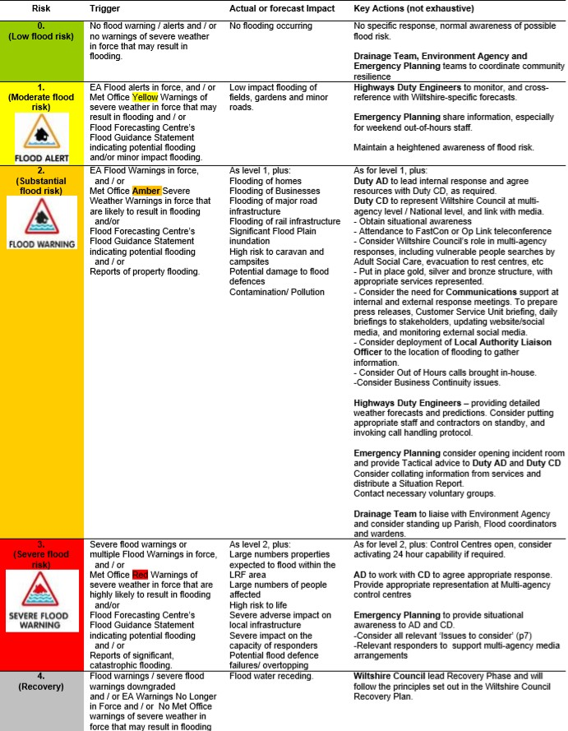

Figure 8.1 Wiltshire Council Summary Action Card

Wiltshire Council Level 1 SFRA v5.0 74

Emergency Planning
The Council, as a member of the Local Resilience Forum (LRF), work closely with other organisations, including the EA, health and emergency services, to improve the response to emergencies, including flooding. The Council usually takes the lead in dealing with recovery from any flooding incident.
The Council has developed operational plans for the Severe Weather and Drainage team, which focus on those areas most at risk of flooding. Information on the extent of possible flooding and vulnerable highways and services are made available for use by operational staff in the event of flooding incidents. This information is updated in the event of incidents or as further information become available.
The Council encourages and supports town and parish councils to prepare emergency and flood plans, specifically if they have previously experienced or are at risk of flooding. Support is provided for the use of Flood Wardens to help local communities to cope with flooding incidents, including the provision of equipment and training where appropriate. The Council encourages residents, businesses and communities to make use of the EA’s free flood warning service to those who are at risk of flooding.
Emergency planners in Wiltshire receive their flood warnings from both the EA and the Met Office. Both providers utilise a text and email service however the EA also operate a further pager which is used when distributing flood alerts, warnings and severe flood warnings. Planners will not conduct action unless a flood warning or severe warning is received. There are 20 operational plans within the county which are based in the most at-risk sites. Emergency planning aids the council through the various stages of an emergency event to ensure the most successful outcome. Multi-agency response becomes active following five flood warnings for Wiltshire, receipt of one Severe Flood Warning or Red Flood Guidance Statement for Wiltshire (released in response to prediction of a high consequence event).
Emergency planning also involves the Recovery Phase which ensures that communities can restore to normality; this is initiated as soon as possible following the initial response.

Wiltshire Council Level 1 SFRA v5.0 75

9 Assessment of flood risk in potential development areas

Introduction
At the time of the production of the Level 1 SFRA, Wiltshire Council were undertaking a site screening and selection exercise to identify potential allocations for the Local Plan. GIS boundaries were provided for the sets of sites identified in Table 9-1, in order to enable a comprehensive site screening for flood risk. The sites provided represented the latest available information as of 11th December 2018. Note that sites which may have already been rejected for other planning reasons were included, as it is important that the Sequential Test identifies the reason that low flood risk sites were rejected.
Table 9-1 Types of sites screened for flood risk

Type of site | Number of sites screened
Strategic Housing and Employment Land Availability Assessment (SHELAA), including Wiltshire Housing Site  Allocation Plan (WHSAP) omission sites | 1,408
Wiltshire Local Plan Review (WLPr) submitted sites | 136
Strategic allocations (including those not built out) | 111
Neigbourhood Plan allocated sites | 72
TOTAL | 1,727

Site flood risk summary
Flood risk from all sources was assessed for each of the 1,727 sites. This information is provided in a 'summary sheet' format in Appendix P, and gives more detailed information regarding the risks posed to each development site.
The following information is provided for each potential development area:
    - % of site within each Flood Zone (3b, 3a, 3a plus climate change and 2)
    - % of site within Risk of Flooding from Surface Water (total % at surface water risk up to 30-year, 100-yr and 1000-yr)
    - Historic flooding (based on the Environment Agency's Historic Flood Map)
    - % within Risk of Flooding from Reservoirs maximum extent
    - % of site within JBA Groundwater flood map categories
    - Presence of watercourse mapped in Detailed River Network layer (watercourses under 3km² may not have Flood Zones)
    - The sites were also considered against the Environment Agency's Areas Benefiting from Defences dataset to determine if the site benefits from formal flood defences.
    - Whether the site is within 100m of a canal

Cumulative impact of development

    - Principle
Cumulative impacts are defined as the effects of past, current and future activities on the environment. Under the 2018 NPPF, strategic policies and their supporting Strategic Flood Risk Assessments (SFRAs), are required to ‘consider cumulative impacts in, or affecting, local areas susceptible to flooding’ (para. 156).
When allocating land for development, consideration should be given to the potential cumulative impact on flood risk within a catchment. Development increases the impermeable area within a catchment, which if not properly managed, can cause loss of floodplain storage, increased volumes and velocities of surface water runoff, and result in heightened downstream flood risk. Whilst individual developments should only have a
Wiltshire Council Level 1 SFRA v5.0 76

minimal impact on the hydrology and flood risk of an area, the cumulative effect of multiple developments may be more severe.
The cumulative impact should be considered throughout the planning process, from the allocation of sites within the Local Plan, to the planning application and development design stages. Once preferred options are identified, their cumulative impact can be considered in more detail within a Level 2 SFRA, where necessary. In addition, site-specific FRAs must consider the cumulative impact of the proposed development on flood risk within the wider catchment area.
In consultation with the Environment Agency, conditions set by the Council should support the implementation of SuDS and appropriate flood mitigation measures. As a minimum, development should have a neutral impact on flood risk, and where possible it should improve existing issues, to ensure that flood risk is not exacerbated either within, or outside of, the Council's administrative area.

    - Methodology
The assessment of cumulative impact was designed through a collaborative process involving Wiltshire Council planning policy and LLFA officers. Consideration was given to assessing the potential percentage of change within a catchment using the sites screened (see section 9.2 above), however it was decided that this could be subject to rapid changes depending upon other planning and political decisions which could quickly make the Level 1 assessment out of date. It was, therefore, agreed that the proposed mix of metrics used to calculate potential impact from cumulative development should provide a balance between modelled data and observed flooding data as recorded by the Parish Councils, Wiltshire Councils and the Water and Sewerage Companies. In addition, it was considered important to identify those catchments where an increase in flows (as a result of development) would have the greatest impact on downstream flood risk.
For the purpose of this assessment the WFD river catchments defined in the River Basin Management Plans were used to divide Wiltshire into manageable areas on which to base a cumulative impact assessment. The Local Land and Property Gazetteer, a GIS layer of all residential and non-residential properties was used to count risk receptors.
Predicted Flood Risk:
The risk metrics calculated for predicted (modelled) flood risk were:
      - Percentage of properties within the combined 1 in 100-year fluvial, pluvial and groundwater flood risk extent. The Risk of Flooding from Surface Water 1 in 100- year extent was merged with Flood Zone 3a and with the JBA Groundwater Flood Map to create a combined layer showing predicted flood risk (water levels 0.25mBGL to 0.0mBGL).
      - Percentage of properties at risk of flooding as a result of increased runoff from upstream. This assessment compared the percentage of properties at risk in a combined (fluvial and pluvial) 1 in 100-year outline, with the percentage at risk in a combined 1 in 1,000-year outline. This was used as a simple way to identify vulnerability of properties to an increase in flows as a result, of upstream development.
Historic Flood Risk:
The risk metrics calculated for historic flood risk were:
      - Percentage of properties with recorded flood incidents from Parish records.
      - Percentage of properties with recorded flood incidents from Wiltshire Council “out- of-hours” records.
      - Whether sewer flooding has been recorded within the catchment (yes/no)

Wiltshire Council Level 1 SFRA v5.0 77

Scoring:
A relative risk score of 1 to 3 (low to high) was applied to each flood risk metric (Table 9-2) and summed to give an overall relative flood risk score for each WFD catchment (Table 9-3).
Table 9-2 Individual components of relative flood risk score

Score | % properties within combined 1 in 100-year fluvial, pluvial and groundwater flood risk extent | % properties at risk of flooding as a result of increased runoff from upstream | %  properties included in Parish Records | % properties included in recorded out of hours incidents | Sewer Flooding (Yes/No)
1 – Low risk | < 5% | < 5% | ≤ 0.5% | ≤ 0.5% | No
2 –  Medium risk | 5 to 10% | 5 to 10% | 0.5 to 1% | 0.5 to 1% | Yes
3 – High risk | >10% | >10% | > 1% | > 1% | N/A

Table 9-3 Translating total score to cumulative impact score

Total Score | Cumulative Impact Score
≤ 5 | LOW
6 to 8 | MEDIUM
≥ 9 | HIGH

The relative flood risk in each catchment is shown in Appendix N and Figure 9.1. The overall analysis provides a context for further appropriate consideration of catchment-scale flood risk issues, once the Local Plan reaches Pre-Submission (draft site allocation) stage.
In addition to assessment at the SFRA level, it is recommended that site-specific FRAs are required to include consideration of the cumulative effects of the proposed development. It should be demonstrated that flood risk downstream will not be made worse by the combination of effects from more than one development allocation.
Discussions held with Wiltshire Council officers identified a wide range of possible policy responses to the assessment of cumulative impact. Table 9-2 summarises these: please note that these are considered to be draft policies that may evolve over time as new evidence emerges.

Wiltshire Council Level 1 SFRA v5.0 78
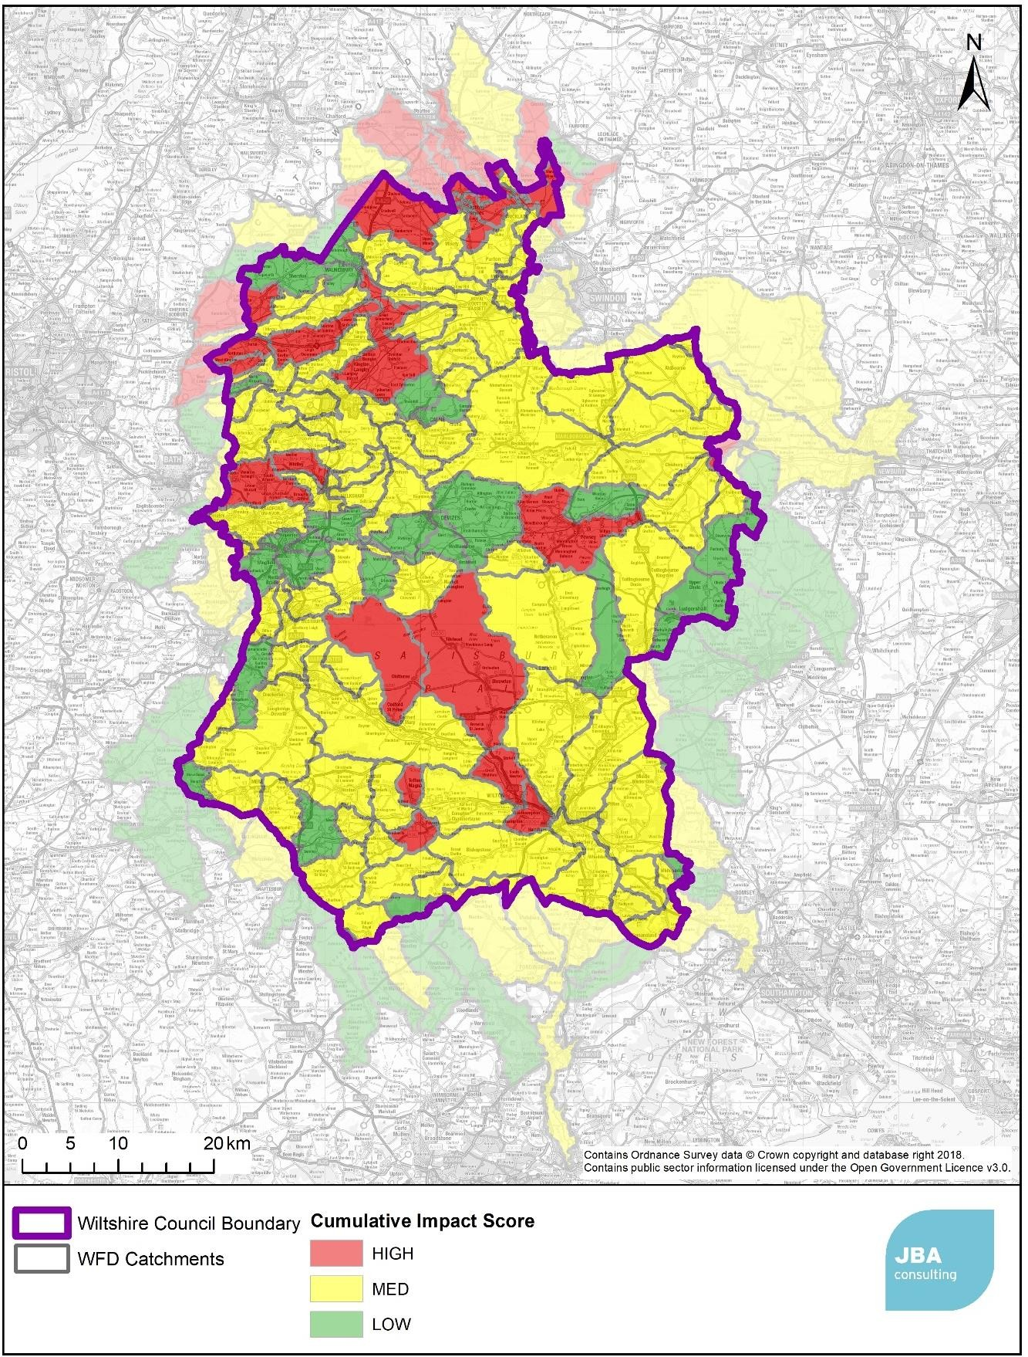

Figure 9.1 Relative Flood Risk score by WFD catchment

    - Planning Policy Considerations for Catchments
Planning policy considerations have been identified for the catchments where cumulative development is likely to have the greatest impact on flood risk to communities.
Wiltshire Council Level 1 SFRA v5.0 79
Table 9:2 Draft policy recommendations for addressing cumulative impact in all developments

Aspect | Cumulative impact score
 | High | Medium | Low
Runoff peak flow and volume management | Both greenfield and brownfield developments to achieve 20% betterment over greenfield runoff (for peak flow* and volume**) post development to counter cumulative impacts. | Both greenfield and brownfield developments to achieve greenfield runoff (for peak flow* and volume**) post development.  Where it is not reasonably practicable*** for a brownfield development to achieve greenfield runoff, post development runoff (for peak flow* and volume**) should achieve a maximum of greenfield plus 50%. | Both greenfield and brownfield developments to achieve greenfield runoff (for peak flow* and volume**) post development.  Where it is not reasonably practicable*** for a brownfield development to achieve greenfield runoff, post development runoff (for peak flow* and volume**) should achieve a maximum of greenfield plus 50%&.  Where it is not reasonably practicable*** for a brownfield development to achieve this, post development runoff (for peak flow* and  volume**) should be no greater than pre-development runoff.
Level 2 SFRAs  / SWMPs | Undertake a Level 2 SFRA to consider further how the cumulative effects of potential peak rates and volumes of water from development sites would impact on peak flows, duration of flooding and timing of flood peaks on receiving watercourses. Such studies could provide further justification for greater restrictions through local planning policy with regards peak flow and volume control of surface water runoff from development sites that are over and above those required by national policy and guidance. They could also identify where there are opportunities for allocated sites to provide on-site / off-site betterment  e.g. online / offline flood storage, and where land should be safeguarded for | Level 2 SFRAs as required  Surface Water Management Plans as required | Surface Water Management Plans as required
Wiltshire Council Level 1 SFRA v5.0 80
Aspect | Cumulative impact score
 | current and future flood management in line with NPPF Para 157b.
Critical Drainage Areas | Wiltshire Council may designate these catchments as critical drainage areas, as required. This would mean that a site-specific flood risk assessment would be required for all developments,  regardless of their size. | N/A | N/A
SuDS | To incorporate SuDS and provide details of adoption, operational standards and ongoing maintenance standards that on all development sites. This will ensure effective flood risk management for the lifetime of the development. Proposals will be required to provide reasoned justification and clear evidence for not using SuDS techniques. Preference will be given to systems that no only control the quantity and quality of surface water runoff, but also provide multifunctional benefits, such as amenity and biodiversity creation and the enhancement of green infrastructure, where practicable (In line with NPPF  paragraphs 163c and 165).
Development and flood risk management investment | That the LLFA and other RMAs should use the information in the SFRA to inform a long-term pipeline of flood alleviation studies and schemes to determine where further developer contributions on / off site would be beneficial.
New settlements | New settlement areas should be accompanied by an overall surface water drainage strategy. This should cover:  How the cumulative impacts of potential peak rates and volumes of water from development sites would impact on peak flows, duration of flooding and timing of flood peaks on receiving watercourses. This should be used to develop and implement appropriate drainage sub catchments and specific runoff rate and volume requirements for each phase of the development.  The risk of flooding from all sources, including for rainfall events greater than the design standard of the surface water drainage system should be taken into account to ensure there is no flood risk to new properties and that exceedance flows in extreme events are safely routed around those properties.  The consideration of how SuDS, natural flood management techniques, green infrastructure and green-blue corridors can be designed into the development master plan to facilitate drainage flood risk management and ensure wider benefits such as biodiversity, amenity, water quality and recreation are realised.  Based on the above, a drainage phasing plan should be developed, based on the SuDS treatment train method (considering firstly how water can be infiltrated / stored at a plot level, then conveyed through the site and any regional storage needs at a settlement level).  The provision of drainage during the construction phase shall be based on the drainage phasing plan to ensure adequate drainage is provided and implemented throughout the development life.  The LLFA, Environment Agency and LPA should be consulted during the development of the surface water management masterplan and Strategy.  Water cycle studies, either for the Local Plan or specific strategic allocations, should be considered where there is a significant change in population planned. A 10% increase in population within a wastewater treatment works catchment would be a suitable trigger, or otherwise at the advice of the Environment Agency.
Wiltshire Council Level 1 SFRA v5.0 81
Aspect | Cumulative impact score
IPR | Shared intellectual property rights (IPR) to all surface water management data and documents developed during the planning process.

* For the 1 in 1-year rainfall event and the 1 in 100 year rainfall event
** For the 1 in 100-year, 6 hour rainfall event
*** Clear justification and evidence are required to prove “not reasonably practicable.” Reasonably practicable is defined in the NPPG for Flood Risk and Coastal Change as referring to the Defra SuDS Non-Statutory Technical Standards, and should take into account design and construction costs, including the opportunity costs of providing land for drainage components and the maintenance and operating costs.
& Due to the considerable uncertainty in determining existing brownfield runoff rates, we have opted for setting post development target rates using greenfield runoff rates as the baseline. This approach simplifies calculations and reduces the burden of evidence (surveys etc) that developers are required to submit in support of their proposed post development runoff rates.

Wiltshire Council Level 1 SFRA v5.0 82


10 Development management recommendations

Overview
There are a number of policy considerations relating to flood risk management in Wiltshire which are described in sections 2, 5 and 9. This chapter sets out recommendations for considering and assessing flood risk in the study area.

Development management policy
The following recommendations have been identified for flood risk policy for new development. The first recommendations are relevant to all development regardless of the Flood Zone they are in. The remaining recommendations are relevant to specific Flood Zones (note some policies are relevant to more than one flood zone and hence will have been repeated).
Recommendations relevant for all development
    - Where Flood Zones do not currently exist for smaller watercourses and drains (those with a catchment area less than 3km2), the RoFSW map can give a broad indication of the potential flow path and flood extent from these watercourses. At the planning application stage, developers should be expected to undertake more detailed hydrological and hydraulic assessments of the watercourses to verify flood extents, inform development zoning within the site and prove, if required, whether the Sequential and Exception Tests can be satisfied. These assessments should also identify the existing risk of flooding to adjacent land and properties to establish whether there is a requirement to secure land to implement strategic flood risk management measures to alleviate existing and future flood risk
    - An FRA is required for all developments over 1 ha and should be proportionate to the degree of flood risk, as well as the scale, nature and location of the development. The LLF and Environment Agency should be consulted to confirm the level of assessment required and to provide any information on any known local issues.
    - The LPA should consult the Environment Agency’s ‘Flood Risk Standing Advice (FRSA) for local planning authorities’, when reviewing planning applications for proposed developments at risk of flooding
    - Developers should demonstrate through a Surface Water Drainage Strategy, that the proposed drainage scheme, and site layout and design, will prevent properties from flooding from surface water, allowing for climate change effects. They should also show that flood risk elsewhere will not be exacerbated by increased levels of surface runoff. Consideration must also be given to residual risk and operation and maintenance of sustainable drainage and surface water systems
    - Surface water runoff management should be undertaken, through the utilisation of appropriate SuDS techniques, prioritising the use of surface SuDS features which provide additional benefits (e.g. biodiversity, amenity space)
    - Normally no buildings should be constructed within 8 metres of the banks of watercourses. This is to allow access for maintenance, as well as providing an ecological corridor
    - Consideration should be given to flood risk that crosses LPA boundaries and a cross- boundary approach taken where appropriate. For example, fluvial flood risk from the River Avon which crosses LPA boundaries.
Recommendations for Flood Zone 1
Fluvial flood risk is not a significant constraint to development within Flood Zone 1. However, there are a number of locations in Zone 1 where flooding from other sources, including Ordinary Watercourses, or drains that are not shown on Environment Agency flood maps, surface water as defined by the RoFSW mapping, or groundwater may be an issue. This should be reviewed and assessed during the preparation of planning applications as
Wiltshire Council Level 1 SFRA v5.0 83
appropriate. There is also residual risk, in some locations, from reservoirs within the Council’s areas.
Detailed FRA is required for all developments
- over 1 ha, or
- which has been identified by the Environment Agency as having critical drainage problems, or
- land identified in a strategic flood risk assessment as being at increased flood risk in future, or
- land that may be subject to other sources of flooding, where its development would introduce a more vulnerable use.
Reference should be made to the Local Flood Risk Management Strategy and Groundwater Management Strategy and consideration given to requirements for the management of local flood risk.
Recommendations for Flood Zone 2
Most development can be acceptable in Flood Zone 2, subject to demonstration the sequential test is passed. Highly Vulnerable development is the exception, and is only permitted if it has passed the Exception Test.
- A FRA is required for all developments within this zone.
- Development design should incorporate mitigation measures to manage any flood risk to the development, including residual risk. Finished Floor Levels should typically be 600mm above the 1 in 100-year (1% AEP) flood level, plus an allowance for climate change (agreed with the Environment Agency and the LPA).
- The layout of buildings and access and egress routes should adopt a sequential approach, steering buildings towards areas of lowest risk within the site.
Recommendations for Flood Zone 3a
Development in Flood Zone 3a is significantly constrained by flood risk. Highly Vulnerable development is not permitted within this zone and More Vulnerable development and Essential Infrastructure are only permitted subject to demonstration that the sequential test is passed and that the Exception Test can be passed. ‘Less vulnerable’ development is acceptable subject to demonstration that the sequential test is passed.

Wiltshire Council Level 1 SFRA v5.0 84
- A FRA is required for all developments within this zone.
  - It should be demonstrated that flood defences provide an acceptable standard of protection, including an allowance for climate change for the lifetime of the development.
  - Residual risks should be assessed, and the Environment Agency consulted regarding whether there is a need for a breach analysis to map a rapid inundation zone.
- The layout of buildings and access routes should adopt a sequential approach, steering buildings towards areas of lowest risk within the site. Where rapid inundation zones have been identified, development should be avoided in these areas.
- Development should not impede flow routes, reduce floodplain storage or consume flood storage in a ‘flood cell’ within a defended area. If the development does result in a loss of storage, compensatory floodplain storage should be provided on a ‘level for level’ and ‘volume for volume’ basis.
- If existing defences are to be upgraded as part of the development, an assessment should be undertaken to ensure it does not result in an increase in flood risk elsewhere.
- Development design should incorporate mitigation measures, to manage any flood risk to the development, including residual risk for the lifetime of the development. FFLs should typically be 600mm above the 1 in 100-year (1% AEP) flood level, plus an allowance for climate change.
- It is recommended that all types of new development behind flood defences is avoided, where possible, due to the residual risks of breach and overtopping
- Consideration should be given to the type of building that will be permitted, for example single-storey buildings and basements should be avoided.

Recommendations for Flood Zone 3b (Function Floodplain)
Development is highly constrained within Flood Zone 3b. Only Essential Infrastructure and Water Compatible uses are permitted in this zone, and only if the Exception Test has been passed in the case of essential infrastructure (subsequent to application of the Sequential Test).
Functional floodplain is vital for the conveyance and storage of floodwater. Development within this zone will potentially impede the flow of floodwater as well as result in a loss of flood storage, increasing flood risk both within the area and further downstream. Consideration should be given to ‘rolling back’ development in this zone, withdrawing development from the floodplain and allowing it to return to a natural floodplain. This has an additional benefit of reducing flood risk to communities further downstream.
For the purpose of the SFRA, the defended case 1 in 20-year return period (5% Annual Exceedance Probability) event informs the Functional Floodplain within the Council’s area. However, where flood outlines of Flood Zone 3b are not available, Flood Zone 3a should be considered as Flood Zone 3b unless, following further work as part of a site-specific FRA, and in consultation with the Environment Agency, it can be proven as Flood Zone 3a.

Wiltshire Council Level 1 SFRA v5.0 85
- Essential infrastructure should only be allocated in this zone if no reasonable alternative sites are available in areas of lower flood risk.
- An FRA is required for Essential Infrastructure within this zone and should include evidence to demonstrate the Exception Test has been passed. Should the site pass the Exception Test, it should be designed and constructed to:
  - remain operational and safe for users in times of flood
  - result in no net loss of floodplain storage
  - not impede water flows and not increase flood risk elsewhere
- Water-compatible development can be allocated in this zone.
- Development should not impede flow routes or reduce floodplain storage. If the development does result in a loss of storage, compensatory floodplain storage should be provided on a ‘level for level’ and ‘volume for volume’ basis.
- Development design should incorporate mitigation measures, to manage any flood risk to the development, including residual risk. Floor levels should typically be 600mm above the 1 in 100-year (1% AEP) flood level, plus an allowance for climate change.

Wiltshire Council Level 1 SFRA v5.0 86

11Summary and conclusions

Summary
JBA Consulting was commissioned by Wiltshire Council to undertake a Level 1 Strategic Flood Risk Assessment (SFRA). Wiltshire Council are reviewing the Wiltshire Core Strategy (adopted in January 2015), with the reviewed Plan becoming the Wiltshire Local Plan. The SFRA forms part of a comprehensive and robust evidence base for the Local Plan which will set out a vision and framework for development in Wiltshire up to 2036 and will be used to inform the sequential test and decisions on the location of future development. The SFRA will also be used to assess planning applications, and flood risk mapping information will be made available for developers for carrying out flood risk assessments.

Use of SFRA data
The SFRA has been developed using the best available information at the time of preparation. This relates both to the current risk of flooding from all sources, the potential impacts of future climate change and the cumulative impact of development.
It is important to remember that information on flood risk is being updated continuously. This is particularly true now that the LLFA has taken responsibility for carrying out and recording Section 19 Flood Investigation Reports under the FWMA. The Environment Agency has a rolling programme of flood modelling and mapping studies, and updates to the Flood Map are made quarterly. Where new mapping studies are carried out this will also affect the definition of the functional floodplain (Flood Zone 3b) and Flood Zone 3a + climate change. It is important that the Environment Agency is consulted to determine whether updated information is available prior to commencing a detailed Flood Risk Assessment.
The SFRA is a ‘living’ evidence document and hence it will be periodically updated when new information on flood risk, flood warning or new planning guidance or legislation becomes available. New information on flood risk may be provided by Wiltshire Council, Wessex Water, Southern Water, Thames Water and the Environment Agency. It is recommended that the SFRA is reviewed internally on an annual basis, allowing a cycle of review, by checking with the above bodies for any new information to allow a periodic update.

Wiltshire Council Level 1 SFRA v5.0 87
88

Appendices

    - Appendix: Community Areas

Wiltshire Council Level 1 SFRA v5.0
89

This page is intentionally left blank.

Wiltshire Council Level 1 SFRA v5.0
90

    - Appendix: Flood Zones 2 and 3a

Wiltshire Council Level 1 SFRA v5.0
91

This page is intentionally left blank.

Wiltshire Council Level 1 SFRA v5.0
92

    - Appendix: Flood Zone 3b

Wiltshire Council Level 1 SFRA v5.0
93

This page is intentionally left blank.

Wiltshire Council Level 1 SFRA v5.0

    - Appendix: Impact of climate change on Flood Zone 3a

Wiltshire Council Level 1 SFRA v5.0 94
95

This page is intentionally left blank.

Wiltshire Council Level 1 SFRA v5.0

    - Appendix: Risk of Flooding from Surface Water

Wiltshire Council Level 1 SFRA v5.0 96
97

This page is intentionally left blank.

Wiltshire Council Level 1 SFRA v5.0

    - Appendix: Impact of climate change on Risk of Flooding from Surface Water

Wiltshire Council Level 1 SFRA v5.0 98
99

This page is intentionally left blank.

Wiltshire Council Level 1 SFRA v5.0

    - Appendix: Risk of Flooding from Groundwater

Wiltshire Council Level 1 SFRA v5.0 100
101

This page is intentionally left blank.

Wiltshire Council Level 1 SFRA v5.0

    - Appendix: Risk of Flooding from Reservoirs

Wiltshire Council Level 1 SFRA v5.0 102
103

This page is intentionally left blank.

Wiltshire Council Level 1 SFRA v5.0

    - Appendix: Risk of Flooding from Sewers

Wiltshire Council Level 1 SFRA v5.0 104
105

This page is intentionally left blank.

Wiltshire Council Level 1 SFRA v5.0

    - Appendix: Recorded flood history in Wiltshire

Wiltshire Council Level 1 SFRA v5.0 106
107

This page is intentionally left blank.

Wiltshire Council Level 1 SFRA v5.0

    - Appendix: Flood Alert and Warning areas

Wiltshire Council Level 1 SFRA v5.0 108
109

This page is intentionally left blank.

Wiltshire Council Level 1 SFRA v5.0
Register
110

    - Appendix: Wiltshire Council Asset

Wiltshire Council Level 1 SFRA v5.0
111

This page is intentionally left blank.

Wiltshire Council Level 1 SFRA v5.0

    - Appendix: Risk of Flooding from Canals and Recorded Incidents

Wiltshire Council Level 1 SFRA v5.0 112
113

This page is intentionally left blank.

Wiltshire Council Level 1 SFRA v5.0

    - Appendix: Cumulative Impact Assessment Results

Wiltshire Council Level 1 SFRA v5.0 114
115

This page is intentionally left blank.

Wiltshire Council Level 1 SFRA v5.0

    - Appendix: Measures from the Flood Risk Management Plans covering Wiltshire
      - Summary of measures in the South West River Basin District that apply to Wiltshire

Measu re ID | Location | Measure name | Measure details | Measure owner
ACT4815 | Hampshire Avon Catchment | Avon Hampshire  /Hampshire Avon/ Development Planning | We will work with the relevant planning authority at both the strategic and planning application stages to steer development to areas at the least risk of flooding. Where practicable we will seek to re- establish and enhance natural river corridors through new development in line with the Water Framework Directive. We shall seek the inclusion of policies in planning documents for development in areas at risk of flooding to be resilient and for the implementation of SuDS. Advice on planning consultations shall ensure the location and layout of development does not increase  flood risk to others and where possible reduces flood risk. | EA
ACT4972 | Salisbury | Avon Hampshire  /Hampshire Avon/ Salisbury Flood Alleviation  Scheme | Evaluate possible options, at a local scale, to better manage flood risk in Salisbury city centre. | EA
ACT4973 | Wilton | Avon Hampshire  /Hampshire Avon/Wilton Flood  Alleviation Scheme | Improve the existing flood defences and investigate other measures to reduce flood risk in the community. | EA
ACT4974 | Tisbury | Avon Hampshire  /Hampshire  Avon/Tisbury Flood Gate | Investigate options to replace the vertical flood gate at Tisbury as part of the capital maintenance programme. | EA
ACT5364 | Hampshire Avon catchment | Avon Hampshire  /Hampshire Avon/Asset Management | Continue to use and update as necessary System Asset Management Plans (SAMPS) to assess appropriate maintenance regimes of existing flood defence assets, prioritise expenditure on the highest risk areas and assets,  improve condition of assets to achieve the targets agreed with | EA

Wiltshire Council Level 1 SFRA v5.0 116
117

Measu re ID | Location | Measure name | Measure details | Measure owner
 |  |  | Government, and notify defects identified in third party assets.
ACT5365 | Hampshire Avon Catchment | Avon Hampshire  /Hampshire Avon/ Community Flood  Resilience | Improve awareness and resilience in communities at risk by providing advice and guidance to help them reduce the impact of flooding. | EA
ACT5366 | Hampshire Avon Catchment | Avon Hampshire  /Hampshire Avon/Critical Infrastructur e | Continue to work with partner organisations to identify and investigate options to improve the flood resilience of critical infrastructure, e.g. roads, rail, electricity, gas, oil, water and  telecommunications. | EA
ACT5367 | Hampshire Avon Catchment | Avon Hampshire  /Hampshire Avon/Deliver Flood Warning Service | We will continue to provide a timely and accurate flood warning service to communities identified at risk of flooding. This will include the provision of additional flood warning telemetry in improve the resilience  and effectiveness of the flood warning service. | EA
ACT5368 | Hampshire Avon Catchment | Avon Hampshire  /Hampshire Avon  /Groundwate r Flood Warning | We will continue to work with other flood risk management authorities and community groups to develop a flood warning service for communities at risk of groundwater flooding. This will include improved access to borehole level data, the provision of a five-day groundwater forecast service, and location specific flood warnings. We will continue to provide advice and guidance to partner authorities and communities  at risk of groundwater flooding. | EA
ACT5369 | Hampshire Avon Catchment | Avon Hampshire  /Hampshire Avon/Local Resilience  Forum | Continue to work with Local Resilience Forum partners, providing advice and information as necessary, including future reviews of Multi-  Agency Flood Plans, to help reduce the impact of flooding. | EA
ACT5370 | Hampshire Avon Catchment | Avon Hampshire  /Hampshire Avon/Propert y Level  Protection | Deliver property level protection (PLP) in communities which have a history of flooding and will not benefit from a community flood defence scheme, as part of a  prioritised programme. | EA
ACT5372 | Hampshire Avon Catchment | Avon Hampshire  /Hampshire Avon  /Modelling | Undertake a prioritised programme of hydraulic modelling to ensure our flood risk information remains up to date and fit for purpose to support | EA

Wiltshire Council Level 1 SFRA v5.0

Measu re ID | Location | Measure name | Measure details | Measure owner
 |  |  | our flood risk management activities.

      - Summary of measures within the Thames River Basin District that cover Wiltshire

Measure ID | Location | Measure name | Measure details | Measure owner
ACT3494 | Gloucester and the Vale | Making Space for Water – Upper Thames | Taking the catchment approach to enhance and expand the floodplain, biodiversity action plan (BAP) habitat, restore urban watercourses and  continue with the consenting pilot. | EA
ACT3495 | Gloucester and the Vale | Conveyance in urban locations  – upper Thames | Continue with current regime of inspections and clearance set out in the system asset management plan (SAMP). Review the effectiveness of maintenance and seek to reduce costs where possible. Transfer skills and knowledge to the community so they can undertake maintenance through their riparian ownership  responsibilities with support from the Environment Agency. | EA
ACT3496 | Gloucester and the Vale | Effectiveness of maintenance – Upper Thames | Continue with current regime of inspections and clearance set out in the system asset management plan (SAMP). Review the effectiveness of maintenance and seek to reduce costs where possible. Transfer skills and knowledge to the community so they can undertake maintenance through their riparian ownership responsibilities with support from the  Environment Agency. | EA
ACT3498 | Gloucester and the Vale | Short-term land use actions - Upper Thames | We will work with the relevant planning authority at both the strategic and planning application stages to steer development to areas at the least risk of flooding. Where practicable we will seek to re- establish and enhance natural river corridors through new development in  line with the Water Framework Directive. | EA
ACT3500 | Gloucester and the Vale | Maintain defences - Upper Thames | Continue maintenance to ensure the standard of protection provided by flood defences are maintained | EA
ACT5741 | Gloucester and the Vale and Kennet and  Tributaries | Deliver the recovery programme after the winter floods in 2014 | Deliver the recovery programme and ensure assets are repaired after the winter floods in 2014 | EA

Wiltshire Council Level 1 SFRA v5.0 118
119

Measure ID | Location | Measure name | Measure details | Measure owner
ACT5758 | Gloucester and the Vale | Working with our partners we will promote an awareness of flood risk amongst communities – Gloucestershire and the Vale | Work with local resilience forum (LRF) partners, through a planned programme, to raise the resilience of communities, individuals and businesses. This could include: encouraging communities to produce/ test/ review community emergency/flood plans; registering for our free flood warning service; raising awareness on local flood warning  services; self-help measures and community-based projects. | EA
ACT5759 | Gloucester and the Vale | By working with our partners, we will improve local emergency planning – Gloucestershire  and The Vale | Work with local resilience forum (LRF) partners to prepare for/ respond to/ recover from and review/ improve multi agency response to flooding. | EA
ACT5760 | Gloucester and the Vale | Review Flood Warning and Alert areas – Gloucestershire  and The Vale | Review impacts of flood map changes and flood incident extents on flood alert and flood warning areas and re- map as appropriate | EA
ACT3534 | Kennet and tributaries catchment | Maintenance remains efficient and effective - Kennet and tributaries | Continue with current regime of inspections and clearance set out in the system asset management plan (SAMP). Review the effectiveness of maintenance and seek to reduce costs where possible. Transfer skills and knowledge to the community so they can undertake maintenance through their riparian ownership responsibilities with support from the  Environment Agency. | EA
ACT3536 | Kennet and tributaries catchment | Short-term land use planning actions - Kennet and tributaries | We will work with the relevant planning authority at both the strategic and planning application stages to steer development to areas at the least risk of flooding. Where practicable we will seek to re- establish and enhance natural river corridors through new development in line with the Water Framework  Directive. | EA
ACT3537 | Kennet and tributaries  catchment | Flood resilience adaptation - Kennet and  tributaries | Work with developers to ensure any redevelopment reduces flood risk.  Gain environmental improvements, where appropriate. | EA
ACT3540 | Kennet and tributaries  catchment | Water level management - Kennet and  tributaries | Taking the catchment approach to enhance and expand the floodplain, biodiversity action plan (BAP) habitat  and restore urban watercourses. | EA

Wiltshire Council Level 1 SFRA v5.0

Measure ID | Location | Measure name | Measure details | Measure owner
ACT5678 | Kennet and tributaries catchment | By working with our partners, we will improve local emergency planning -  Kennet and tributaries | Work with local resilience forum (LRF) partners to prepare for/ respond to/ recover from and review/ improve multi agency response to flooding. | EA
ACT5679 | Kennet and tributaries catchment | Work with LRF partners to prepare and improve multi agency response to flooding -  Kennet and tributaries | Work with LRF partners to prepare for/ respond to/ review/ improve multi agency response to flooding | EA
ACT5680 | Kennet and tributaries catchment | Review flood warning and alert areas -  Kennet and tributaries | Review impacts of flood map changes and flood incident extents on flood alert and flood warning areas and re- map as appropriate | EA

      - Summary of measures in the Severn River Basin District that cover Wiltshire
Measure ID | Location | Measure name | Measure details | Measure owner
ACT1105 | Locations throughout catchment | BA/EA/MTP/Wessex trash screens | Updating 15 trash screens to improve safety | EA
ACT1106 | Locations throughout catchment | BA/EA/MTP/Wessex web cams | Installation of GPRS Webcams to monitor the state of an asset and to provide visual inspections without the need to send  resources. | EA
ACT1107 | Locations throughout catchment | BA/EA/MTP/Wessex resilience measures | Provide contribution towards individual property resilience | EA
ACT1108 | Locations throughout the catchment | BA/EA/MTP/Wessex PLP | Deliver PLP protection to approximately 100 properties. | EA
ACT1109 | Bradford on Avon, Wiltshire | BA/EA/MTP/BOA  defences | Review existing modelling and assess options for potential scheme | EA
ACT989 | Royal Wootton Bassett, Wiltshire | BA/EA/Wootton Bassett/reservoir | Pursue partnership funding opportunities to improve or maintain the reservoir and trash screens protecting the  railway line | EA
ACT990 | Dauntsey, Wiltshire | BA/EA/Dauntsey  /engagement | Carry out community  engagement and help implement a PLP scheme | EA
Wiltshire Council Level 1 SFRA v5.0 120

Measure ID | Location | Measure name | Measure details | Measure owner
ACT991 | Malmesbury, Wiltshire | BA/EA/Malmesbury/ FDS options | Improve our knowledge of flooding mechanisms in and around Malmesbury and  investigate potential schemes. | EA
ACT992 | Malmesbury, Wiltshire | BA/EA/Malmesbury/ Flood warning | Improve flood warning lead times on the Sherston Avon at Malmesbury | EA
ACT993 | Chippenham, Wiltshire | BA/EA/Chippenham/ radial gate | Investigate options for replacing radial gate | EA
ACT994 | Trowbridge, Wiltshire | BA/EA/Trowbridge  /climate change | Pursue development opportunities to manage flood risk and address climate change | EA
ACT995 | Melksham, Wiltshire | Avon Hampshire  /Hampshire Avon/Modelling | Investigate options for replacing floodgate | EA
ACT996 | Melksham, Wiltshire | BA/EA/Melksham  /flood warning | Develop flood warning procedures at Melksham to improve thresholds and lead  times. | EA
ACT997 | Bradford on Avon,  Wiltshire | BA/EA/BOA  /engagement | Carry out community engagement and help  implement a PLP scheme | EA

Note: Property Flood Protection (PLP) is now referred to as Property Flood Resilience (PFR)

Wiltshire Council Level 1 SFRA v5.0 121

    - Appendix: Level 1 site screening results

Wiltshire Council Level 1 SFRA v5.0 122
123

This page is intentionally left blank.

Wiltshire Council Level 1 SFRA v5.0

    - Appendix Q: Recorded flood history

Event date | Mechanism | Areas worst affected | Source of information
November 1894 | Fluvial flooding caused by exceedance of  channel capacity (no raised defences) | River Avon through Chippenham | Environment Agency Recorded Flood Outline
January 1925 | Fluvial flooding caused by exceedance of channel capacity (no raised defences) | River Avon (Sherston to Easton Grey, Staverton to Shurnold, Melksham, Limpley Stoke, Sutton Benger, Lacock to Beanacre, Chippenham, Christian Malford, Bradford-on-Avon, Newnton, Malmesbury) River Biss (Trowbridge, Dilton Marsh to Heywood), Brinkworth Brook (Royal Wootton Bassett), By Brook (Yatton Keynell to Long Dean, Drewetts Mill to Slaughterford, Castle Combe, Bathford to Batheaston), Gauze Brook (Hullavington, Box), Semington Brook (Seend Mill to Marston, Littleton Pannell), South Brook, Summerham Brook (Rowde), Woodbridge Brook (Lea), Rodbourne Brook (Rodbourne Bottom), Cowage Brook (Ratford), Luckington Brook  (Luckington). | Environment Agency Recorded Flood Outline
March 1932 | Fluvial flooding caused by exceedance of  channel capacity (no raised defences) | River Avon (Bradford- on-Avon, Limpley Stoke, Lacock to  Beanacre, Sutton Benger, Melksham, | Environment Agency Recorded Flood Outline

Wiltshire Council Level 1 SFRA v5.0 124
125

Event date | Mechanism | Areas worst affected | Source of information
Malmesbury, Chippenham and Calne), Semington Brook (Littleton, Bulkington, Littleton Pannell), Summerham Brook (Rowde), Gauze Brook (Sherston, Corston, Dauntsey, Hullavington), River Biss (Bitham, Heywood, Trowbridge), Charlton Stream (Charlton, Garsden), Brinkworth Brook (Royal Wootton Bassett), By Brook (Bathford, Widdenham Farm to
Box), South Brook (Shaw)
March 1947 | Fluvial flooding caused by exceedance of channel capacity (no  raised defences) | River Thames at Cricklade and Ashton Keynes | Environment Agency Recorded Flood Outline
June 1952 | Fluvial flooding caused by exceedance of channel capacity (no  raised defences) | River Avon, south of Chippenham | Environment Agency Recorded Flood Outline
June 1954 | Fluvial flooding caused by exceedance of channel capacity (no  raised defences) | River Avon, Sherston, Great Summerford, Dauntsey | Environment Agency Recorded Flood Outline
January 1959 | Fluvial flooding caused by exceedance of channel capacity (no  raised defences) | Hampshire Avon and Frome, though Wilton, Salisbury and Downton | Environment Agency Recorded Flood Outline
December 1960 | Fluvial flooding caused by exceedance of channel capacity (no raised defences) | River Avon (Kellaways, Melksham, Chippenham, Bradford-on-Avon), Bourn and Dauntsey Brook (Dauntsey),  Semington Brook (Bulkington, | Environment Agency Recorded Flood Outline
Wiltshire Council Level 1 SFRA v5.0
126

Event date | Mechanism | Areas worst affected | Source of information
Whaddon Green), Hardenhuish Brook, Brinkworth Brook, (Brinkworth), Midford Brook (Monkton, Midford), Somerset Frome (Farleigh,
Hungerford)
December 1965 | Fluvial flooding caused by exceedance of channel capacity (no raised defences) | River Avon (Malmesbury), Ladyfield Brook (Chippenham), Somerset Frome  (Freshford to Witham Friary) | Environment Agency Recorded Flood Outline
February 1967 | Fluvial flooding caused by exceedance of channel capacity (no  raised defences) | Ladyfield Brook (Chippenham) | Environment Agency Recorded Flood Outline
July 1968 | Fluvial flooding caused by exceedance of channel capacity (no raised defences) | Ladyfield Brook (Chippenham, Rowden), By Brook (Castle Combe to Colerne), Somerset Frome (Freshford Mill, Farleigh, Hungerford, Tellisford), River Avon (Melksham, Conkwell Wood M Combe), Byde Mill  Brook (Thingley to Lacock) | Environment Agency Recorded Flood Outline
September 1968 | Fluvial flooding caused by exceedance of channel capacity (no  raised defences) | River Key (Cricklade), River Ray (By Blunsdon Station), Swill Brook, Ashton  Keynes | Environment Agency Recorded Flood Outline
December 1972 | Fluvial flooding caused by exceedance of channel capacity (no  raised defences) | River Biss, Trowbridge | Environment Agency Recorded Flood Outline
February 1974 | Fluvial flooding caused by exceedance of channel capacity (no  raised defences) | River Biss, (Trowbridge, Melksham), Ladyfield Brook, (Chippenham) | Environment Agency Recorded Flood Outline

Wiltshire Council Level 1 SFRA v5.0
127

Event date | Mechanism | Areas worst affected | Source of information
September 1974 | Fluvial flooding caused by exceedance of  channel capacity (no raised defences) | Forest Brook (Melksham) | Environment Agency Recorded Flood Outline
August 1977 | Fluvial flooding caused by exceedance of channel capacity (no raised defences)  Local Drainage / Surface Water | River Avon through Cricklade and Marston Meysey | Environment Agency Recorded Flood Outline
March 1979 | Fluvial flooding caused by exceedance of channel capacity (no  raised defences) | River Kennet (From Beckhampton to Marlborough, Axford, Chilton Foliat), River  Avon (Melksham) | Environment Agency Recorded Flood Outline
May 1979 | Fluvial flooding caused by exceedance of channel capacity (no  raised defences) | Lambrok Stream (Southwick), River Biss (Trowbridge) | Environment Agency Recorded Flood Outline
December 1979 | Fluvial flooding caused by exceedance of channel capacity (no raised defences) | River Avon (Bradford- on-Avon, Christian Malford, Great Somerford to Dauntsey, Chippenham, Malmesbury, Angrove Wood, Lacock to Beanacre, Kellaways, River Biss (Trowbridge, Upper Studley, Ladydown Mill), Somerset Frome (Freshford), Challymead Brook (Melksham), Bitham  Brook (Dursley) | Environment Agency Recorded Flood Outline
March 1981 | Fluvial flooding caused by exceedance of channel capacity (no  raised defences) | River Avon, Lacock to Beanacre | Environment Agency Recorded Flood Outline
March 1982 | Fluvial flooding caused by exceedance of  channel capacity (no raised defences) | River Avon from Lacock to Limpley Stoke, Hampshire  Avon from Salisbury to Downton | Environment Agency Recorded Flood Outline

Wiltshire Council Level 1 SFRA v5.0
128

Event date | Mechanism | Areas worst affected | Source of information
December 1985 | Fluvial flooding caused by exceedance of  channel capacity (no raised defences) | By Brook (Colham Mill, Castle Combe) | Environment Agency Recorded Flood Outline
January 1986 | Fluvial flooding caused by exceedance of channel capacity (no  raised defences) | River Avon (Warleigh to Limpley Stoke) | Environment Agency Recorded Flood Outline
February 1990 | Fluvial flooding caused by exceedance of channel capacity (no raised defences) and local drainage /  surface water | River Avon (Staverton), Summerham Brook (Rowde), Surface water (Westwood, Rowde, Corton) | Environment Agency Recorded Flood Outline
September 1992 | Fluvial flooding caused by exceedance of channel capacity (no raised defences) and local drainage / surface water | River Avon (Melksham, Malmesbury), Swill Brook (Eastcourt), Thames (Ashton Keynes, Cricklade), River Ray (Purton Stoke), River Kennet (Beckhampton to Marlborough, Littlecote)  Surface water (Cricklade) | Environment Agency Recorded Flood Outline
October 1993 | Fluvial flooding caused by exceedance of channel capacity (no  raised defences) | River Thames, (Cricklade), River Kennet (Beckhampton) | Environment Agency Recorded Flood Outline
January 1995 | Groundwater / high water table (Ephemeral watercourses) | River Dun (Middle Winterslow, West Grimstead, River Blackwater (Whiteparish) River  Anton, (Lugershall) | Environment Agency Recorded Flood Outline
March 1995 | Groundwater / high water table (Ephemeral  watercourses) | River Dun (West Winterslow) | Environment Agency Recorded Flood Outline
January 1999 | Fluvial flooding caused by exceedance of channel capacity (no  raised defences) | River Avon (Bradford- on-Avon, Sherston, Dauntsey, Avoncliff, Freshford, Christian  Malford, Dodford | Environment Agency Recorded Flood Outline
Wiltshire Council Level 1 SFRA v5.0
129

Event date | Mechanism | Areas worst affected | Source of information
Farm, Lacock to Lackham, Beanacre, Staverton, Great Somerford, Chippenham, Lower Seagry, Whaddon, Melksham), Midney Brook (Monkton
Coombe)
October 2000 | Fluvial flooding caused by exceedance of channel capacity (overtopping of defences) and Fluvial flooding, caused by exceedance of channel capacity (no  raised defences) | River Avon (Malmesbury, Bradford-on-Avon), Midford Brook (Monkton Combe) | Environment Agency Recorded Flood Outline
November 2000 | Fluvial flooding caused by exceedance of  channel capacity (no raised defences) | River Avon, (Limpley Stoke), Easterton Brook (Easterton) | Environment Agency Recorded Flood Outline
December 2000 | Groundwater / high water table (Ephemeral  watercourses) | River Dun (Pitton) | Environment Agency Recorded Flood Outline
December 2012 | Groundwater / high water table (Ephemeral  watercourses) | River Chalton (Lugershall) | Environment Agency Recorded Flood Outline
July 2007 | Fluvial flooding caused by exceedance of channel capacity (no raised defences) and local drainage / surface water | River Kennet (Winterbourn Bassett), Swill Brook (Crudwell), surface water (Crudwell), River Avon (Malmesbury)  Dauntsey Brook (Dauntsey), | Environment Agency Recorded Flood Outline
January 2008 | Fluvial flooding caused by exceedance of channel capacity (no  raised defences) | River Key (Purton Stoke), Swill Brook (Crudwell) | Environment Agency Recorded Flood Outline
March 2008 | Fluvial flooding  caused by exceedance of | Bourne Brook (Dauntsey), | Environment  Agency Recorded Flood Outline

Wiltshire Council Level 1 SFRA v5.0
130

Event date | Mechanism | Areas worst affected | Source of information
channel capacity (no raised defences) and obstruction /
blocked culvert
December 2008 | Fluvial flooding caused by exceedance of channel capacity (overtopping of  defences) | River Biss (Yarnbrook) | Environment Agency Recorded Flood Outline
February 2009 | Fluvial flooding caused by exceedance of channel capacity (no  raised defences) | River Avon (Lower Seagry to Holt), Brinkworth Brook (Brinkworth) | Environment Agency Recorded Flood Outline
April 2012 | Fluvial flooding caused by exceedance of channel capacity (overtopping of  defences) | River Avon (Sutton Benger to Limpley Stoke) | Environment Agency Recorded Flood Outline
November 2012 | Fluvial flooding caused by exceedance of channel capacity (no raised defences) | River Avon (Malmesbury, Little Somerford, Sutton Benger, East Tytherton, West Kingston, Castle Combe, Bradford-on- Avon, Chippenham, Kellaways, Shaw, Corston, Dauntsey, Holt, Lacock) Luckington Brook (Luckington), Cowage Brook (Preston), Semington Brook  (Keevil), | Environment Agency Recorded Flood Outline
December 2013 | Fluvial flooding caused by exceedance of channel capacity (no raised defences) | Norton Brook (Norton), Bourne Brook (Dauntsey), Hampshire Avon (North Newnton), River Nadder (Donhead St Andrew), Semington Brook (Worton), River Avon (Bradford-  on-Avon) | Environment Agency Recorded Flood Outline
January 2014 | Fluvial flooding  caused by exceedance of | River Avon (Christian  Malford, Chippenham to Staverton), | Environment  Agency Recorded Flood Outline
Wiltshire Council Level 1 SFRA v5.0
131

Event date | Mechanism | Areas worst affected | Source of information
 | channel capacity (no | Semington Brook
 | raised defences) | (Bulkington to
 |  | Seend), Hampshire
 |  | Avon (Pewsey,
 |  | Milston to Salisbury,
 |  | Salisbury to
 |  | Downton), River
 |  | Wylye (Codford St
 |  | Mary to Salisbury,
 |  | Berwick St James),
 |  | River Nadder (Barford
 |  | St Martin), River
 |  | Ebble (Bishopstone),
 |  | River Bourne
 |  | (Winterbourne Earls
 |  | to Salisbury)
February | Fluvial flooding | Hampshire Avon | Environment
2014 | caused by exceedance of | (Salisbury, Wilton), River Dun (Pitton), | Agency Recorded Flood Outline
 | channel capacity (no | River Test (west
 | raised defences) | Grimstead to West
 | and groundwater / | Dean), Groundwater
 | high watertable | (Oxenwood)

Wiltshire Council Level 1 SFRA v5.0

    - Appendix: Stakeholder Consultation
An informal consultation was held, inviting comment on the draft report from all local planning authorities neighbouring Wiltshire, as well as other risk management authorities and planning stakeholders. Responses and actions are summarised below in Table R-1. Note that, where section numbers have changed, the comments have been amended to refer to the section numbering in this final version of the report.
Table R-1: Consulted organisations

Organisation | Comments received? | Comments actioned?
Local Planning Authorities
Bath and North East Somerset Council | “We are in the process of identifying new sites for development through the emerging Local Plan. We would like to be informed and would be interested to work with you to assess cumulative impact of potential development sites particularly on River Avon when you consider in more detail within a Level 2 SFRA, where necessary para 9.3.1)” | To be considered in scope of any Level 2 SFRA covering the River Avon  catchment.
Cotswold District Council | No | N/A
East Dorset District Council | No | N/A
Mendip District Council | No | N/A
New Forest National Park Authority | No | N/A
North Dorset District Council | No | N/A
South Gloucestershire Council | No | N/A
South Somerset District Council | Response received – “no comment.” | N/A
Swindon Borough Council | Response received – “no comment.” | N/A
Test Valley District Council | Response received – “no comment.” | N/A
Vale of White Horse District Council | No | N/A
West Berkshire Council | “The inclusion of paragraph 5.3 is supported.” | N/A
Risk Management Authorities
Environment Agency | Comments received from the EA are listed below. For clarity, comments on document formatting issues have been removed, but were all actioned.

Wiltshire Council Level 1 SFRA v5.0 132
133

Organisation | Comments received? | Comments actioned?
 | Paragraph 6.4 (6th paragraph) We suggest adding ‘…. a buffer of at least 8 metres between the top of the bank of any Main river and any Environment Agency  assets, and the built environment…….’.  Paragraph 6.5.1 (1st, 2nd & 3rd paragraphs) 1st paragraph We are pleased to note a freeboard of 600mm above the modelled 1% AEP plus an allowance for climate change will be required when setting minimum finished floor levels. This approach is consistent with Environment Agency flood risk standing advice.  2nd paragraph However, here reference is made to a 300mm freeboard above the 1% AEP flood extent for finished floor levels for sites at risk of flooding from canals. For consistency, we recommend a 600mm freeboard.  3rd paragraph Similarly, for surface water flood risk, for consistency we recommend a 600mm freeboard.  Paragraph 6.5.5 (1st paragraph) Similarly, for groundwater risk, for consistency we recommend a 600mm freeboard.  Paragraph 11.2 Recommendations for Flood Zone 2 We recommend, for clarity and consistency with other parts of the document, adding the following text ‘subject to demonstration the sequential test is passed’ after ‘Most development can be acceptable in Flood Zone 2…….’. Also, in the ‘Green Box’, again for clarity and consistency with other parts of the document, we recommend adding wording not dissimilar to ‘typically 600mm’ within the sentence ‘Finished floor levels should be typically 600mm above the 1 in 100-year (1% AEP) flood level….’.  Recommendations for Flood Zone 3a We recommend, for clarity and consistency with other parts of the document, adding the following text ‘subject to demonstration that the sequential test is passed’ at appropriate locations. For example, referencing that ‘Less vulnerable’ development is acceptable subject to demonstration that the sequential test is passed. Moreover, that ‘More Vulnerable and Essential Infrastructure’ development are only permitted subject to demonstration that the sequential test is passed, and the Exception Test can be passed. In the ‘Green Box’, again for clarity and consistency with other parts of the document, we recommend adding wording not dissimilar to ‘typically 600mm’ within the sentence ‘Finished floor levels should be typically 600mm above the 1 in 100- year (1% AEP) flood level….’. | Added.  Standardised on 600mm freeboard.  Standardised on 600mm freeboard.  Added.  Added
Wiltshire Council Level 1 SFRA v5.0
134

Organisation | Comments received? | Comments actioned?
 | Recommendations for Flood Zone 3b In the ‘Green Box’, again for clarity and consistency with other parts of the document, we recommend adding wording not dissimilar to ‘typically 600mm’ within the sentence ‘Finished floor levels should be typically 600mm above the 1 in 100-year (1% AEP) flood level….’.  Paragraphs 3.7, 4.4.2 and 12.2 Reference is made to Section 19 reports carried out by the LLFA. It may be worth considering including a very brief summary of each report, perhaps the key flood risk findings, and including a ‘signpost’ to where the Section 19 reports are published on the Council’s website. | Added  Section 19 reports have been  signposted.
Canal and River Trust | “Thank you for informally consulting the Canal & River Trust. The Trust own and manage the Kennet & Avon canal as it flows through Wiltshire and we are supportive of the aim to re-open the Wilts & Berks canal too. The Trust has considered the document, and in particular appendix M which deals with both canals, and section  3.4.5 of the main document. We have previously provided the council with SFRA information in relation to the Kennet & Avon Canal are have no comments to make at this time.” | N/A
Southern Water | No | N/A
Thames Water | Section 7.3 Wastewater  Thames Water support this section in principle as it refers to sewer flooding.  The National Planning Practice Guidance (NPPG) states that a sequential approach should be used by local planning authorities in areas known to be at risk from forms of flooding other than from river and sea, which includes "Flooding from Sewers".  Flood risk policies should therefore make reference to ‘sewer flooding’ and an acceptance that flooding can occur away from the flood plain as a result of development where off site sewerage infrastructure and capacity is not in place ahead of development.  It is also important to consider the net increase in wastewater demand to serve the development and also any impact that developments may have off site, further down the network. Local/Neighbourhood Plans should therefore seek to ensure that there is adequate wastewater infrastructure to serve all new developments. Thames Water will work with developers and local authorities to ensure that any necessary infrastructure reinforcement is delivered ahead of the occupation of development. Where there are infrastructure constraints, it is important not to under estimate the time required to deliver necessary infrastructure. For example: local network upgrades take around 18 months and Sewage Treatment & Water  Treatment Works upgrades can take 3-5 years.
Wiltshire Council Level 1 SFRA v5.0
135

Organisation | Comments received? | Comments actioned?
 | The provision of water treatment (both wastewater treatment and water supply) is met by Thames Water’s asset plans and from the 1st April 2018 network improvements will be from infrastructure charges per new dwelling.
From 1st April 2018, the way Thames Water and all other water and wastewater companies charge for new connections has changed. The changes mean that more of Thames Water’s charges will be fixed and published, rather than provided on application, enabling you to estimate your costs without needing to contact us. The services affected include new water connections, lateral drain connections, water mains and sewers (requisitions), traffic management costs, income offsetting and infrastructure charges.
Information on how off site network reinforcement is funded can be found here https://developers.thameswater.co.uk/New-connection- charging
Thames Water therefore recommends that developers engage with them at the earliest opportunity (in line with paragraph 26 of the revised NPPF) to establish the following:
* The developments demand for Sewage/Wastewater Treatment and network infrastructure both on and off
site and can it be met; and
 | * The surface water drainage requirements and flood risk of the development both on and off site and can it be met.
 | Thames Water offer a free Pre-Planning service which confirms if capacity exists to serve the development or if upgrades are required for potable water, waste water and surface water requirements. Details on Thames Water’s free pre planning service are available at: https://www.thameswater.co.uk/preplanning
 | In light of the above comments and Government guidance Thames Water consider that Local/Neighbourhood Plans should include a specific policy on the key issue of the provision of water and sewerage/wastewater infrastructure to service development. This is necessary because it will not be possible to identify all of the water/sewerage infrastructure required over the plan period due to the way water companies are regulated and plan in 5 year periods (Asset Management Plans or AMPs). Thames Water recommend that Local/Neighbourhood Plans include the following policy/supporting text:
 | PROPOSED NEW WATER/WASTEWATER INFRASTRUCTURE TEXT  “Where appropriate, planning permission for  developments which result in the need for off-site | Wiltshire Council to consider for

Wiltshire Council Level 1 SFRA v5.0
136

Organisation | Comments received? | Comments actioned?
 | upgrades, will be subject to conditions to ensure the occupation is aligned with the delivery of necessary infrastructure upgrades.”  “The Local Planning Authority will seek to ensure that there is adequate water and wastewater infrastructure to serve all new developments. Developers are encouraged to contact the water/waste water company as early as possible to discuss their development proposals and intended delivery programme to assist with identifying any potential water and wastewater network reinforcement requirements. Where there is a capacity constraint the Local Planning Authority will, where appropriate, apply phasing conditions to any approval to ensure that any necessary infrastructure upgrades are delivered ahead of the occupation of the relevant phase of development.”  General Comments: Water & Wastewater Infrastructure  When reviewing development and flood risk it is important to recognise that water and/or sewerage infrastructure may be required to be developed in flood risk areas. By their very nature water and sewage treatment works are located close or adjacent to rivers (to abstract water for treatment and supply or to discharge treated effluent). It is likely that these existing works will need to be upgraded or extended to provide the increase in treatment capacity required to service new development. Flood risk sustainability objectives should therefore accept that water and sewerage infrastructure development may be necessary in flood risk areas.  General Comments: Surface water runoff and drainage  With regard to surface water drainage it is the responsibility of the developer to make proper provision for drainage to ground, watercourses or surface water sewer. It is important to reduce the quantity of surface water entering the sewerage system in order to maximise the capacity for foul sewage to reduce the risk of sewer flooding.  Thames Water recognises the environmental and economic benefits of surface water source control, and encourages its appropriate application, where it is to the overall benefit of their customers. However, it should also be recognised that SUDS are not appropriate for use in all areas, for example areas with high ground water levels or clay soils which do not allow free drainage. SUDS also require regular maintenance to ensure their effectiveness.  Limiting the opportunity for surface water entering the foul and combined sewer networks is of critical importance to Thames Water. Thames Water have advocated an approach to SuDS that limits as far as | inclusion as Local Plan policy.  No action – this is in line with NPPG for water compatible development and essential infrastructure.
Wiltshire Council Level 1 SFRA v5.0
137

Organisation | Comments received? | Comments actioned?
 | possible the volume of and rate at which surface water enters the public sewer system. By doing this, SuDS have the potential to play an important role in helping to ensure the sewerage network has the capacity to cater for population growth and the effects of climate change.  SUDS not only help to mitigate flooding, they can also help to:  - improve water quality  - provide opportunities for water efficiency  - provide enhanced landscape and visual features  - support wildlife  - and provide amenity and recreational benefits.  With regard to surface water drainage, Thames Water request that the following paragraph should be included in Local/Neighbourhood Plans: “It is the responsibility of a developer to make proper provision for surface water drainage to ground, water courses or surface water sewer. It must not be allowed to drain to the foul sewer, as this is the major contributor to sewer flooding.” | Wiltshire Council to consider for inclusion as Local Plan policy.
Wessex Water | General
 | We note and support references to Sewers for Adoption 8 and the Drainage and Wastewater Management Plans (DWMP). Please also note that Wessex Water has published a DWMP web portal https://www.wessexwater.co.uk/environment/drainage- and-wastewater-management-plan which we reference below in recommended text to supplement Section 6.5.5 | Reference to portal added in section 2.14
 | We believe it could be made clearer, in some sections within the document, as to whether the requirements refer to all development or just major development, in particular:
 | 1. Page 5 - Planning policies should focus on supporting the Lead Local Flood Authority (LLFA) in ensuring that all developments build Sustainable Drainage Systems (SuDS) into their design and ensure that, right from the concept stage, master planning integrates SuDS and makes space for water within the  site design. | No change as this section is focussed on introducing national policy and guidance rather than making recommendations.
 | - Table 9:2 Draft policy recommendations for addressing cumulative impact  - 10.2 Development Management Policy - The following recommendations have been identified for flood risk policy for new development | Table heading changed to “…in all developments”  These recommendations are based on site size and Flood Zone,

Wiltshire Council Level 1 SFRA v5.0
138

Organisation | Comments received? | Comments actioned?
 | We support the requirements of Table 9:2 and hope these will be embraced. Some example case studies may assist in visualising and validating the requirements. | in accordance with NPPF  Valid comment. Could be developed and maintained independently of the  SFRA.
 | References to the NPPF should be reviewed in the light of the recently published revised version, i.e. Paragraph 103 of the NPPF (2.8.2) is now Paragraph 163 | Corrected.
 | 3.4.6 – MoD Corsham is not an inset agreement; the site is served by private sewers connecting to the public sewer “outside of the wire”. Replace “particularly on MoD sites, for example MoD Corsham, with: “other inset agreements exist in Wiltshire including Land at Old Sarum in Salisbury” | Corrected
 | We are obtaining data to provide evidence where high groundwater causes sewer flooding to assist in the sequential test and cumulative impacts, hopefully this can be weaved into the document. For now we recommend additional text to clarify sewer flooding by groundwater inundation:  Section 3.4.6 - Sewer  During periods of high groundwater, inundation of the foul sewer systems can take place resulting in sewer flooding on the surface. The areas mainly affected in the Wessex Waters region are the towns and villages in South Wiltshire, villages in the Vale of Pewsey, villages to the north-east of Malmesbury and villages to the north and east of Chippenham. | Text added and adapted.
 | Wessex Water has identified those catchments at high and medium risk of Foul Sewer Inundation and the information is shared with the LLFA for planning consultation purposes.
 | Any sewer flooding incidents in Wessex Water caused by groundwater inundation are included in the Sewer Flood Risk Map presented in (future Appendix)
 | Section 4.6 – Groundwater Flood Risk
 | High groundwater levels can also result in inundation of the foul sewer systems and sewer flooding at the surface. Wessex Water has identified those catchments at high and medium risk of Foul Sewer Inundation. | Text added and s3.4.6 referenced.
Wiltshire Council Level 1 SFRA v5.0
139

Organisation |  | Comments received? | Comments actioned?
 |  | Section 6.5.5 – Groundwater Mitigation
 |  | Following the extensive groundwater flooding during the wet winters of 2012/2013 and 2013/2014, Wessex Water prepared Infiltration Reduction Plans (IRPs) for catchments at risk of groundwater inundation of the foul sewer systems. The IRPs have been agreed with the Environment Agency (EA) and are ongoing, with programmes of work to identify infiltration in the catchment and carry out sealing of the foul sewers to reduce the risk of inundation. Wessex Water has also prepared a number of Operational Management Action Plans (OMAPs) which can be initiated if there is a risk of property flooding. The mitigatory actions either involve tankering or in extreme circumstances, overpumping to relieve foul sewer surcharging. More information is contained on the Wessex Water Drainage and Wastewater Management Portal. | Section 6.5.5 is aimed at new development. Text has been adapted and made relevant to all water companies in s3.4.6.
 |  | 7.2.4 Discharge Location
 |  | Please clarify the RMA responsibilities in the last paragraph; the LLFA, developer and sewerage undertaker will need to agree a discharge rate. As it stands the paragraph could suggest the decision rests with the sewerage undertaker. | Paragraph amended.
 |  | 10.2 Development management policy
 |  | Recommendations for Flood Zone 1 Sewer flooding may also be an issue. | Not changed – this is covered by “land that may be subject to other sources of flooding”
 |  | Appendix I
 |  | Please add WaSC boundaries and specify period of flood data (WW provided data 2015-2018) | We do not have detailed wastewater company outlines (only water outlines are published). We have, however,  added indicative WaSC boundaries to the key plan.
Veolia Projects | Water | No | N/A

Wiltshire Council Level 1 SFRA v5.0
140

Organisation | Comments received? | Comments actioned?
Other Stakeholders
Historic England | “We note that the assessment does not refer to the potential impact of flooding on heritage assets or how initiatives to manage the risk of flooding might best respond to sensitive heritage matters.” | New section 6.5.7 added on Flood Resilience of Heritage Buildings and Assets.
Natural England | No | N/A
Wiltshire Wildlife Trust | No | N/A

Wiltshire Council Level 1 SFRA v5.0
141

This page is intentionally left blank.

Wiltshire Council Level 1 SFRA v5.0



Offices at
Coleshill Doncaster Dublin Edinburgh Exeter Glasgow
Haywards Heath Isle of Man Limerick
Newcastle upon Tyne Newport Peterborough Saltaire
Skipton Tadcaster Thirsk Wallingford Warrington

Registered Office South Barn Broughton Hall SKIPTON
North Yorkshire BD23 3AE
United Kingdom

+44(0)1756 799919
info@jbaconsulting.com www.jbaconsulting.com Follow us:

Jeremy Benn Associates Limited Registered in England 3246693
JBA Group Ltd is certified to: ISO 9001:2015
ISO 14001:2015
OHSAS 18001:2007

